**MINISTRY OF EDUCATION AND TRAINING**

**FPT UNIVERSITY**

Capstone Project Document

**The Laboratory Tests   
Management System**

|  |  |
| --- | --- |
| **Group 6** | |
| **Group members** | Bạch Minh Đức – SE61791  Châu Minh Ý– SE61419  Trần Tuấn Dũng – SE61982  Nguyễn Hữu Lâm – SE61234 |
| **Supervisor** | Hồ Hoàn Kiếm |
| **Ext. Supervisor** | N/A |
| **Capstone Project Code** | eLTMS |

- Ho Chi Minh City, 14 September 2018 -

# Table of Contents

Table of Contents 1

List of Tables 1

Introduction 2

1. Project Information 2

2. Introduction 2

3. Current Situation 2

4. Problem Definition 2

5. Proposed Solution 3

5.1. Feature functions 3

5.2. Advantages and disadvantages 3

6. Functional Requirements 4

7. Roles and Responsibility 5

# List of Tables

Table 1 - Roles and Responsibility 5

# **Introduction**

## **Project Information**

* Project name: **Building the laboratory tests management system**
* Project Code: **eLTMS**
* Product Type: **Website & Mobile Application**
* Start Date: **September 10th, 2018**
* End Date: **December 14th, 2018**

## **Introduction**

Hospital are the essential part of our lives, providing best medical facilities to people suffering from various ailments, which may be due to change in climatic conditions, increased work-load, emotional trauma stress etc. It is necessary for the hospitals to keep track of its day-to-day activities & records of its patients, doctors, nurses, ward boys and other staff personals that keep the hospital running smoothly & successfully.

But keeping track of all the activities and their records on paper is very cumbersome and error prone. It also is very inefficient and a time-consuming process Observing the continuous increase in population and number of people visiting the hospital. Recording and maintaining all these records is highly unreliable, inefficient and error-prone. It is also not economically & technically feasible to maintain these records on paper.

Thus, keeping the working of the manual system as the basis of our project. We have developed “The Laboratory Tests Management System”.

The main objective of this project is to analyses the concept and process of laboratory tests in the hospital, from which to build up the website to manage all patient information of laboratory tests and help doctor, users, and laboratory technician easy to control their job. It also aims at providing low-cost reliable automation of the existing systems. The system also provides excellent security of data at every level of user-system interaction and provides robust & reliable storage and backup facilities.

## **Current Situation**

Nowadays, In Vietnam, Except for the large hospitals on the upline have laboratory system, which help doctor conjecture and treat patients in the best way. Other hospital or clinics on the downline do not have this system, If the doctor want to conjecture and treat patients in the best way, they must require patients go to hospital on upline and check their health on the laboratory systems, after that, patient will come back and listen the diagnosis.

But all of hospitals on upline is over-load now. If the patients want to check health, they must take time consuming to change hospital, take time consuming to wait because large numbers overload of patients. Not only time but also money, they must spend money for this moving and laboratory system.

With our laboratory management system, we will help patients and doctor with life easier.

## **Problem Definition**

Below are disadvantages of current situation:

* Patients spend too much time, effort to get the health result.
* Doctor do not have the best support tools for offering the best treatment options.
* Hospitals, clinics have difficulty in managing records, reviews.

## **Proposed Solution**

Our solution is to build systems capable of placing and managing time (Calendar Manager) to resolve the current situations, we also design the system to be scalable, so we can deploy this system to a multiple insurance services company in future.

eLTMS includes web application and mobile applications with following functions:

### **Feature functions**

* Web application:
  + Register Appointment: User can register a new account on website. A staff will reply by SMS message for authentication to confirm calendar management
* Mobile application:
  + Register Appointment: User can register a new account on mobile. A staff will reply by SMS message for authentication to confirm calendar management.

### **Advantages and disadvantages**

* Advantages:
  + Patient is easier in manage time for appointment.
  + Hospitals/Clinics can control facilities, machines and supplies.
  + Hospitals can record the types of illnesses, disease trends, which can be used for deciding how to treat, how to disease prevention.
  + Hospitals/Clinics can maximize the free time of each laboratory.
  + High Automation.
* Disadvantages:
  + Human must still interfere with system in some cases.

## **Functional Requirements**

Function requirements of the system are listed as below:

* Base Component:
* Login.
* Register.
* User (Patient) component:
  + New account request / Feedback about account request.
  + Book Appointment/ View Booked Appointment/Edit-Cancel Appointment.
  + View test result-View suggestion, note.
  + Edit, Update profile account.
* Receptionist component:
* View detail appointment.
* Change status of appointment.
* View list patient who has testing following day.
* Cashier component:
* New account creates for user (Patient).
* View list patient who has testing following day
* Manage Laboratory (Operate with patient by appropriate/real time)
* Change status of appointment.
* Nurse component:
* Change status of appointment.
* Change status of lab-testing.
* Warehouse-keeper component:
* Manage items on system.
* Import and control quantity on the system.
* Stock control, stock out, stock in
* Doctor component:
* Check the disease.
* Suggest Medication (types and quantities)
* Some good advice for patient.
* Write note and conclusion
* Request re-testing
* Laboratory Technician component:
* Import the test result in the system.
* Mapping code of specimen.
* Create New Group of Specimen.
* Create New Type of Specimen.
* Manager component:
* Manage Service of Lab Test.
* Manage Staff account (Add, Edit and Delete).
* View and Check Result Test.
* View Feedback.

## **Roles and Responsibility**

|  |  |  |  |  |
| --- | --- | --- | --- | --- |
| No | Full Name | Role | Position | Contact |
| 1 | Hồ Hoàn Kiếm | Project Manager | Supervisor | Kiemhh@fpt.edu.vn |
| 2 | Bạch Minh Đức | Developer | Leader | Ducbmse61791@fpt.edu.vn |
| 3 | Châu Minh Ý | Developer | Member | Ycmse61419@fpt.edu.vn |
| 4 | Trần Tuấn Dũng | Developer | Member | Dungttse61982@fpt.edu.vn |
| 5 | Nguyễn Hữu Lâm | Developer | Member | Lamnhse61234@fpt.edu.vn |

Table 1 - Roles and Responsibility

1. **Software Project Management Plan**

**Problem Definition**

**Name of this Capstone Project**

* Official name: **The Laboratory Management System**
* Vietnamese name: **Hệ thống quản lý phòng xét nghiệm**
* Abbreviation: **eLTMS**

**Problem Abstract**

Hospital is the essential part of our lives providing best medical facilities for people to suffer from various ailments, which may be due to change in climatic conditions, increased work-load, emotional trauma stress etc. It is necessary for the hospitals to keep track of its day-to-day activities & records of its patients, doctors, nurses, ward boys and other staff personals that keep the hospital running smoothly & successfully.

But keeping track of all the activities and their records on paper is very cumbersome and error prone. It also is very inefficient and a time-consuming process Observing the continuous increase in population and number of people visiting the hospital. Recording and maintaining all these records are highly unreliable, inefficient and error-prone. It is also not economically & technically feasible to maintain these records on paper.

Thus, keeping the working of the manual system as the basis of our project. We have developed “The Laboratory Tests Management System”.

The main objective of this project is to analyze the concept and process of laboratory tests in the hospital from it building up the website to manage all patient information of laboratory tests and helping doctor, users, and laboratory technician easily to control their job. It also aims to provide low-cost reliable automation of the existing systems. Not only does the system provides excellent security of data at every level of user-system interaction, but also it provides robust & reliable storage and backup facilities.

**Project Overview**

**Current Situation**

Nowadays, In Vietnam, Except for the large hospitals on the up-line has laboratory system, which helps doctor conjecture and treat patients in the best way. Other hospitals or clinics on the down line do not have this system, If doctor want to conjecture and treat patients in the best way, they must require patients go to hospital on up-line and check their health on the laboratory systems, after that, patient will come back and listen the diagnosis.

But all of hospitals on up-line is over-load now. If patients want to check their health, they must waste time to change hospital and wait because large numbers overload of patients. Not only time but also money, they must spend money for this moving and laboratory system.

With our laboratory management system, we will help patients and doctor with life easier.

Below are disadvantages of current situation:

* Patients spend too much time, effort to get the health result
* Doctor do not have the best support tools for offering the best treatment options
* Hospitals, clinics have difficulty in managing records, reviews

**The Proposed System**

Our solution is to build systems capable of placing and managing time (Calendar Manager) to resolve the current situations, we also design the system to be scalable, so we can deploy this system to a multiple insurance services company in future.

**Website and mobile application for user**

* **User component (Patient):**
* Register
* Login
* Book an appointment
* View booked appointment
* Edit-Cancel appointment
* View testing result
* View suggestion, note
* Edit, Update profile account
* Feedback about service

**Website for administrator**

* **Hospital Receptionist component:**
* View details of appointment
* View list patient who has appointment by date
* Change status of appointment
* View patient’ information
* **Department Receptionist component:**
* Create new appointment for user (Patient)
* View list appointments by date
* Change status of appointment
* View patient’ information
* **Nurse component:**
* View details of appointment
* Change status of appointment
* Change status of lab testing
* View patient’s information
* **Laboratory Technician component:**
* Manage sample group
* Manage sample
* **Doctor component:**
* Check for the disease
* Write note (advice to patient) and conclusion
* Request re-testing
* View patient’ information
* **Manager component:**
* Manage service of system
* Manage staff’s account
* View patient’ information
* View testing result
* View Feedback

**Web Services**

* Provide RESTful APIs for web and mobile application
* Handle request, process data and send response to client site

**Boundaries of the System**

* Allow user to book appointment for testing, view result history of testing, view or edit contact information
* Allow admin to manage patients, appointments, staffs
* The language of this system is Vietnamese
* User’s devices (computer, smartphone) must connect to the Internet
* The complete product includes:
  + Website & mobile application for users (patient)
  + Website for administrators
  + Web services

**Future plans**

Current system is concentrated on core business flow. Therefore, some supporting features are restricted for the development team. These features may be expanded in the future:

* Support more categories
* Develop stronger security to reduce the risk for the system and users
* Develop getting detailed statistics for testing by month, year
* Develop system on mobile for admin

**Development Environment**

**Hardware requirement**

* For server

|  |  |  |
| --- | --- | --- |
| Hardware | Minimum Requirements | Recommended |
| Internet Connection | Cable, Wi-Fi (6 Mbps) | Cable, Wi-Fi (16 Mbps) |
| Operating System | Window Server 2012 | Window Server 2012 |
| Computer Processor | Intel® Core i3-8100 (3.6Ghz/6MB Smart Cache) | Intel® Core  i7-8850H (2.6Ghz/9MB Smart Cache) |
| Computer Memory | 8GB RAM | 16GB RAM |

*Table 1 - Hardware requirement for server*

* For web development:

|  |  |  |
| --- | --- | --- |
| **Hardware** | **Minimum Requirements** | **Recommended** |
| **Internet Connection** | Cable, Wi-Fi (4 Mbps) | Cable, Wi-Fi (8 Mbps) |
| **Operating System** | Windows 7 or above | Windows 7 or above |
| **Computer Processor** | Intel® Core  i3-6300 (3.8Ghz/4MB Smart Cache) | Intel® Core i5-6500 (3.6Ghz/6MB Smart Cache) |
| **Computer Memory** | 4GB RAM | 8GB RAM |

*Table 2 - Hardware requirement for web development*

* For mobile development:

|  |  |  |
| --- | --- | --- |
| **Hardware** | **Minimum Requirements** | **Recommended** |
| **Internet Connection** | Wi-Fi (2 Mbps),3G-4G | Wi-Fi (4 Mbps), 3G-4G |
| **Operating System** | Android 4.4.2 | Android 6.0 |
| **Memory** | 4GB RAM | 8GB RAM |

*Table 3 - Hardware requirement for mobile development*

**Software requirement**

|  |  |
| --- | --- |
| **Software** | **Name / Version** |
| **Operating system** | Windows 7 or above |
| **Environment** | C#.NET, Spring framework, jQuery, Bootstrap |
| **Modeling tool** | Offline: StarUML  Online: draw.io |
| **IDE** | Visual Studio 2017, Android studio |
| **DBMS** | SQL Server 2014 |
| **Source control** | SourceTree, Git |
| **Web browser** | Chrome 42 or above |

*Table 4 - Software requirement*

**Project organization**

**Software Process Model**

In this project, we choose Scrum which is an agile framework that allows step by step to set up a plan successfully. We choose this model because of the following reasons:

* Time-saving: daily meetings ensure that the process is at correct stage, as established at the beginning of the project
* Easy to use: suitable model for small and medium project
* Fast response to changes: product owner may change requirements or extend / reduce scope and we can adapt better
* 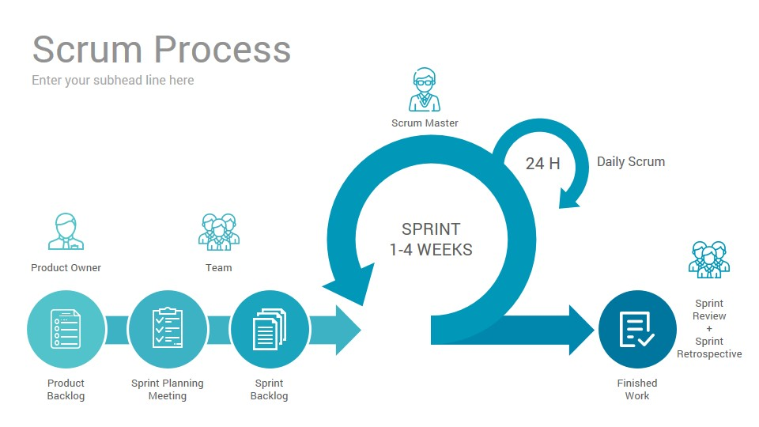Encourage teamwork: roles and tasks are divided and assigned efficiently

*Figure 1 - Scrum Model*

**Roles and responsibilities**

|  |  |  |  |
| --- | --- | --- | --- |
| **No** | **Full name** | **Role in Group** | **Responsibilities** |
| **1** | **Hồ Hoàn Kiếm** | Supervisor/Project Manager | * Specify user requirements * Control the development process * Support in technique and business logic. |
| **2** | **Bạch Minh Đức** | Team leader, scrum master, BA, Developer, Tester | * Clarify requirements * Design database * Design GUI * Code * Write document and report * Create test plan * Testing. |
| **3** | **Châu Minh Ý** | Scrum member, BA, Developer, Tester | * Clarify requirements * Design database * Design GUI * Code * Write document and report * Create test plan * Testing |
| **4** | **Trần Tuấn Dũng** | Scrum member, BA, Developer, Tester | * Clarify requirements * Design database * Design GUI * Code * Write document and report * Create test plan * Testing |
| **5** | **Nguyễn Hữu Lâm** | Scrum member, BA, Developer, Tester | * Clarify requirements * Design database * Design GUI * Code * Write document and report * Create test plan * Testing |

*Table 5 - Roles and Responsibilities Details*

**Tools and Techniques**

|  |  |
| --- | --- |
| **Tool / Technique** | **Name / version** |
| **Frontend** | HTML,CSS, Javascript, Bootstrap |
| **Mobile** | Java |
| **Backend** | C#, .NET Framework |
| **DBMS** | SQL Server 2014 |
| **Source control** | SourceTree, Git |
| **Modeling tool** | Offline: StarUML  Online: draw.io |
| **Web browser** | Chrome 42 or above |

*Table 6 - Tools and Techniques*

**Project Management Plan**

**Software development life cycle**

Below are all the major tasks that need to be performed sequentially during the development of the system

|  |  |  |  |  |
| --- | --- | --- | --- | --- |
| **Phase** | **Description** | **Deliverables** | **Dependencies and Constrains** | **Risk** |
| **Requirements Definition** | Collect requirements from customer  Identify and clarify requirements for the system in general | Introduce of proposed system  Software requirement specification  Project task plan  Report No.1 Software Project Management Plan | N/A | Missing requirement  Unclear scope of project  Lack of member share and understand |
| **System and Software Design** | Identify hardware and software requirements  Decide software architect and clarify software detail design  Design database | Report No.2 Software Project Management Plan.  Report No. 3 Software Requirement Specification | Depend on Requirements definition | Misunderstood or unclear system’s requirement  Lack of practical experience leading to unreasonable design |
| **Implementation and Unit Testing** | Code the project following the requirement  Fix bug of project  Testing | Web application  Mobile application  Report No. 4 Software Design Description | Base on Requirement analysis. | Lack of practical experience  Missing the deadlines  Get many bug  Delay task |
| **Integration and System Testing** | Perform integration test and system test | Report No. 5 System Implementation & Test | Implementation and Unit Testing are finished | Lack of testing experience leading to lack of test cases  Get many bug to fix |
| **Operation and Maintenance** | Deploy the system  Create the user’s manuals  Do routine maintenance activities | Report No.6 Software User’s Manual | Integration and System Testing are finished | User’s manual may be difficult for user to understand and confuse |

*Table 7 - Software development life cycle*

**Phase Detail**

**Phase 1: Requirements Definition**

|  |  |  |
| --- | --- | --- |
| **Task** | **Description** | **Author** |
| **Report 1** | Writing Report 1 | Nguyễn Hữu Lâm  Bạch Minh Đức |
| **Collect requirements from MEDIC** | Go to MEDIC, observe, asking for result papers and information book | Bạch Minh Đức  Trần Tuấn Dũn |
| **Identify and clarify requirements for the system in general** | Design booking algorithms for almost cases. Explain for the team Discuss together | Bạch Minh Đức  Trần Tuấn Dũng  Châu Minh Ý  Nguyên Hữu Lâm |

*Table 8 - Phase 1: Requirements Definition*

**Phase 2: System and Software Design**

|  |  |  |
| --- | --- | --- |
| **Task** | **Description** | **Author** |
| **Identify hardware and software requirements.** | Find out the approriate hardware and software for the system | Bạch Minh Đức  Trần Tuấn Dũng  Châu Minh Ý  Nguyên Hữu Lâm |
| **Report 2** | Writing Report 2 | Châu Minh Ý  Nguyên Hữu Lâm |
| **Database/Design** | Draw database diagram.  Implement it with My SQL Server Insert data Write some queries and test | Bạch Minh Đức  Trần Tuấn Dũng  Châu Minh Ý  Nguyên Hữu Lâm |
| **Diagrams Design** | Entity Relationship  Class Diagram  Use-case Diagram Activity Diagram Sequence Diagram | Bạch Minh Đức  Trần Tuấn Dũng  Châu Minh Ý  Nguyên Hữu Lâm |
| **Report 3** | Writing Report 3 | Bạch Minh Đức  Nguyên Hữu Lâm |

*Table 9 - Phase 2: System and Software Design*

**Phase 3: Implementation and Unit Testing**

|  |  |  |
| --- | --- | --- |
| **Task** | **Description** | **Author** |
| **Implements all functions of system** | Coding all the components | Bạch Minh Đức  Trần Tuấn Dũng  Châu Minh Ý  Nguyên Hữu Lâm |
| **Create test plan** | Planning for testing | Bạch Minh Đức  Trần Tuấn Dũng  Châu Minh Ý  Nguyên Hữu Lâm |
| **Perform Unit testing** | Write Unit test cases  Implement Unit tests | Bạch Minh Đức  Trần Tuấn Dũng  Châu Minh Ý  Nguyên Hữu Lâm |
| **Unit Testing** | Write test cases for APIs, Web, Mobile- Run test cases | Bạch Minh Đức  Trần Tuấn Dũng  Châu Minh Ý  Nguyên Hữu Lâm |
| **Report 4** | Write Report 4 | Châu Minh Ý  Nguyên Hữu Lâm |

*Table 10 - Phase 3: Implementation and Unit Testing*

**Phase 4: Integration and System Testing**

|  |  |  |
| --- | --- | --- |
| **Task** | **Description** | **Author** |
| **Perform integration test and system test** | Write test cases and test the system | Bạch Minh Đức  Trần Tuấn Dũng  Châu Minh Ý  Nguyên Hữu Lâm |
| **Report 5** | Write Report 5 | Bạch Minh Đức  Châu Minh Ý |

*Table 11 - Phase 4: Integration and System Testing*

**Phase 5: Operation and Maintenance**

|  |  |  |
| --- | --- | --- |
| **Task** | **Description** | **Author** |
| **Deploy the system** | Deploy the system | Bạch Minh Đức  Trần Tuấn Dũng  Châu Minh Ý  Nguyên Hữu Lâm |
| **Create the user’s manual** | Write user’s manual | Bạch Minh Đức  Trần Tuấn Dũng  Châu Minh Ý  Nguyên Hữu Lâm |
| **Do routine maintenance activities** | Do routine maintenance activities for client system | Bạch Minh Đức  Trần Tuấn Dũng  Châu Minh Ý  Nguyên Hữu Lâm |
| **Report 6** | Write Report 6 | Châu Minh Ý |

*Table 12 - Phase 5: Operation and Maintenance*

**Task sheet**

All Task sheet could be found here: https://goo.gl/QJn2AU

**All Meeting Minutes**

N/A

**Naming**

* + Using camel case for variables and methods
  + Using capitalized for classes and interfaces
  + Using uppercase words separated by underscores for constants
  + Variable, class and interface names should be nouns. Method names should be verbs

**Comment**

* Using /* */ for block comments
  + Using // for line comments

**Indentation**

* Four spaces should be used as the unit of indentation. The exact construction of the indentation (spaces vs. tabs) is unspecified. Tabs must be set exactly every 8 spaces (not 4)

**Declaration**

* One declaration per line
* Do not put different types on the same line
* Put declarations only at the beginning of blocks
* Try to initialize local variables where they’re declared. The only reason not to initialize a variable where it’s declared is if the initial value depends on some computation occurring first
* No space between a method name and the parenthesis “(“starting its parameter list
* Open brace “{” appears at the end of the same line as the declaration statement
* Closing brace “}” starts a line by itself indented to match its corresponding opening statement, except when it is a null statement the “}” should appear immediately after the” {“
* Methods are separated by a blank line

1. **Software Requirement Specification**

**User Requirement Specification**

* 1. **Guest Requirement**
* Login
* Register
* Make appointment
  1. **Patient Requirement**
  + Make appointment
  + Edit appointment
  + Cancel appointment
  + View appointment history
  + View appointment’s test result
  1. **Hospital Receptionist Requirement**
* View appointment list
* View appointment detail
* Delete Sample Getting(s) of an appointment
* Mark appointment as “Paid”
  1. **Department Receptionist Requirement**
* View Sample Getting List
* Create appointment for offline patient
* Mark Sample Getting as “Paid”
  1. **Nurse Requirement**
* View Sample Getting list
* Mark Sample Getting As “Nurse Done”
  1. **Lab Technician Requirement**
* Manage Lab Tests, Samples, Sample Groups
  1. **Doctor Requirement**
* View Test Results
* Write Conclusion
* Require Re-doing the test
  1. **Warehouse Keeper Requirement**
* Manage Supplies
* Manage Import/Export Supplies
* Inventory

**System Requirement Specification**

* 1. **External Interface Requirement**

**User Interface**

* Design, layout, colors are suitable for a medical website.
* Primary color are white and light blue.
* Font size is required big enough for elder people can read.
* Only Vietnamese.

**Hardware Interface**

* Desktops, mobiles, tablets which can connect Wi-Fi steadily.
* Device’s screen display in acceptable brightness.

**Software Interface**

* Using browser: Chrome (v25 or above), Firefox (v46.1) or Microsoft Edge.
* Using Android devices whose version is 4.4.2 or above.

**Communication Protocol**

* Use the HTTP, HTTPS protocol for communication between web browser and web server, between mobile device and web server.
  1. **System Overview Use Case**

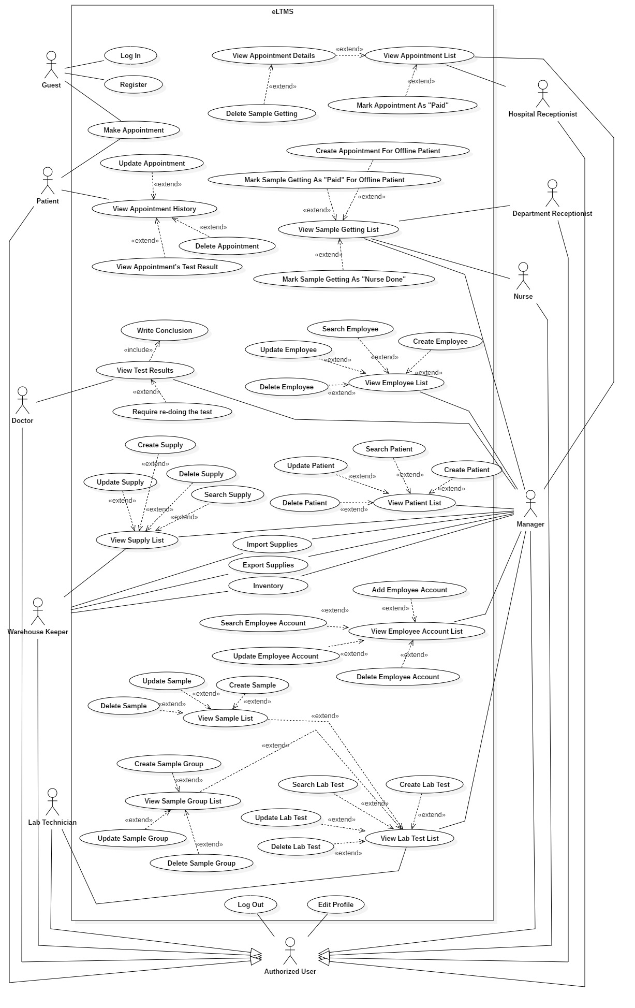

*Figure 1 - System Overview Use Case*

* 1. **List of Use Case**

**Guest Overview Use Case**

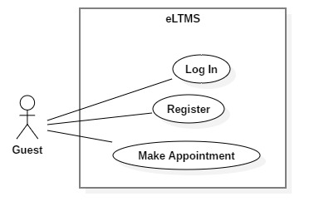

*Figure 2 - <Guest>Overview Use Case*

**<Guest> Login**

**Use Case Diagram**

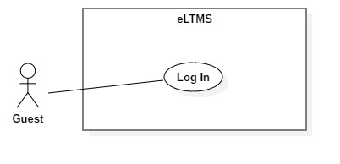

*Figure 3 - < Guest > Login*

**Use Case Specification**

|  |  |  |  |
| --- | --- | --- | --- |
| USE CASE - UC_01 | | | |
| Use Case No. | 01 | **Use Case Version** | 1.0 |
| Use Case Name | Login | | |
| Author | DucBM | | |
| Date | 1/10/2018 | **Priority** | Normal |
| Actor:   * Guest.   Summary:   * This use case allows Guest to login to the system.   Goal:   * Guests are authorized as their role.   Triggers:   * User clicks “Đăng nhập” button.   Preconditions:   * User has an account.   Post Conditions:   * Success: User logs into the system successfully and gets redirected to a specified page depends on user’s role. * Fail: System shows error message.   Main Success Scenario:   |  |  |  | | --- | --- | --- | | Step | Actor Action | System Response | | 1 | User goes to Login page. | System requires information:   * Phone: text input. * Password: password input. | | 2 | User inputs information.  User clicks “Đăng Nhập” button. | User will login to the system with roles of this account. |   Exceptions:   |  |  |  | | --- | --- | --- | | No | Cause | System Response | | 1 | Phone is invalid length. | Show error message. | | 2 | Password is invalid length. | Show error message. | | 3 | Phone and password does not match with any accounts. | Show error message. |   Relationships: N/A  Business Rules:   * Patient can only log in to user-web. * Employee (Hospital Receptionist, Department Receptionist, Nurse, Doctor, Warehouse Keeper and Manager) can only log in to admin-web. | | | |

**<Guest> Register**

**Use Case Diagram**

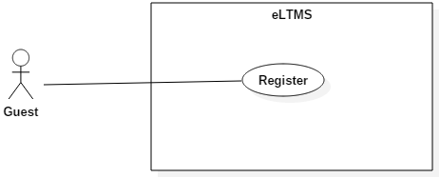

*Figure 4 - < Guest > Register*

**Use Case Specification**

|  |  |  |  |
| --- | --- | --- | --- |
| **USE CASE - UC_02** | | | |
| **Use Case No.** | 02 | **Use Case Version** | 1.0 |
| **Use Case Name** | Register | | |
| **Author** | DucBM | | |
| **Date** | 1/10/2018 | **Priority** | Normal |
| **Actor:**   * Guest.   **Summary:**   * This use case allows Guest to register account.   **Goal:**   * Create a new account for guest.   **Triggers:**   * User clicks “Đăng ký” button.   **Preconditions:**   * N/A   **Post Conditions:**   * **Success**: System saves account on database and shows success message. * **Fail**: Systemshows error message.   **Main Success Scenario:**   |  |  |  | | --- | --- | --- | | Step | Actor Action | System Response | | 1 | User goes to “Đăng ký” page. | System requires information:   * Phone: text input. * Password: password input. * Confirm password: password input * Full name: text input. * Date of birth: date input. * Email: text input. * Home address: text input. * Company address: text input. | | 2 | User inputs all required field.  Then clicks “Đăng ký” button. | User will register the system with roles of this account.  [Exception from 1 to 8]. |   **Alternative Scenario:** N/A  **Exceptions:**   |  |  |  | | --- | --- | --- | | No | Cause | System Response | | 1 | Phone is invalid. | Show error message. | | 2 | Password is invalid. | Show error message. | | 3 | Confirm password does not match | Show error message. | | 4 | Full name is empty. | Show error message. | | 5 | Date of birth is invalid | Show error message. | | 6 | Email is invalid. | Show error message. | | 7 | Home address is invalid. | Show error message. | | 8 | Company address is invalid. | Show error message. |   **Relationships:** N/A  **Business Rules:**   * Guest can only register as patient. * Phone is not null and must be verified by code. * Email is not null, correct email format. * Password is not null, in range of 8-255 characters, **includes** at least one **digit** and includes both **lowercase** and **uppercase** letters. * Date of birth is not null and not over the current date. * Full name is not null, in range of 5-50 characters. | | | |

**<Guest, Patient> Make Appointment**

**Use Case Diagram**

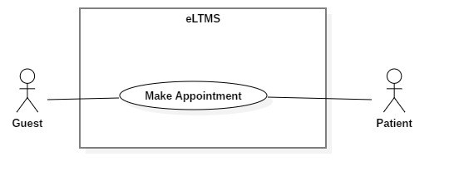

*Figure 11 - < Guest, Patient > Make Appointment*

**Use Case Specification**

|  |  |  |  |
| --- | --- | --- | --- |
| **USE CASE - UC_07** | | | |
| **Use Case No.** | 07 | **Use Case Version** | 1.0 |
| **Use Case Name** | Make Appointment | | |
| **Author** | DucBM | | |
| **Date** | 1/10/2018 | **Priority** | Normal |
| **Actor:**   * Patient   **Summary:**   * Patient makes appointment with personal information, types of LabTest, date and time.   **Goal:**   * A new appointment of the patient is made.   **Triggers:**   * User clicks on “Đặt lịch hẹn” menu item on the website or “Đặt lịch” button on mobile app.   **Preconditions:**   * N/A.   **Post Conditions:**   * **Success:** Show success message. * **Fail:** Show error message.   **Main Success Scenario:**   |  |  |  | | --- | --- | --- | | Step | Actor Action | System Response | | 1 | User clicks on “Đặt lịch hẹn”. | System requires information input:   * Full name * Phone number | | 2 | User clicks on “Bước 2”. | System displays a checkbox list of LabTest types for user to select. | | 3 | User clicks on “Bước 3”. | System displays a table that shows the selected LabTests and requires input date and time for each of them. | | 4 | User clicks on “Đặt lịch”. | System show message on a popup (success/error). |   **Exceptions:**   |  |  |  | | --- | --- | --- | | No | Cause | System Response | | 1 | Full name or phone number is empty. | Show error message. | | 2 | No LabTests are selected. | Show error message. | | 3 | A date or time is empty. | Show error message. | | 4 | Two date-times intersects. | Show error message. |   **Relationships:** N/A  **Business Rules:**   * User cannot book a Sample twice or more on the same day. * Number of bookings of a Sample-Group, on the same day, at the same slot cannot exceed the number of tables of that Sample-Group. * User cannot make an appointment with date-time in the past. * User cannot book 2 date-times which intersects each other. | | | |

**Patient Overview Use Case**

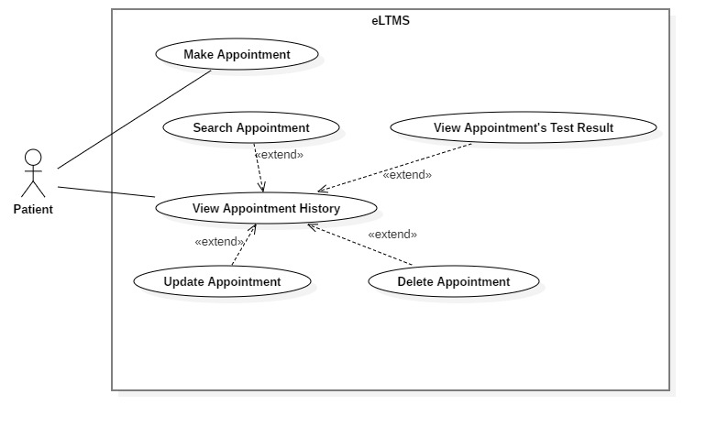

*Figure 10 - < Administrator > Overview Use Case*

**<Patient> View Appointment History**

**Use Case Diagram**

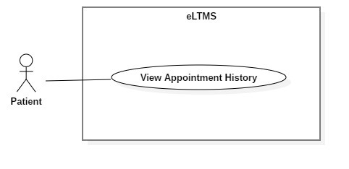

*Figure 12 - <Patient> View Appointment History*

**Use Case Specification**

|  |  |  |  |
| --- | --- | --- | --- |
| **USE CASE - UC_07** | | | |
| **Use Case No.** | 07 | **Use Case Version** | 1.0 |
| **Use Case Name** | View Appointment History | | |
| **Author** | DucBM | | |
| **Date** | 1/10/2018 | **Priority** | Normal |
| **Actor:**   * Patient   **Summary:**   * Patient views his/her appointment history including new appointment, being processed appointment and done appointment.   **Goal:**   * A list of appointments of the patient, with search, filter and pagination controls, is shown.   **Triggers:**   * User clicks on “Danh sách cuộc hẹn” on the Website/Mobile App.   **Preconditions:**   * User is logged in as Patient.   **Post Conditions:**   * **Has data**: Show a list of appointments of the patient with search, filter and pagination controls. * **Has no data**: Show “Bạn chưa có cuộc hẹn nào.” text.   **Main Success Scenario:**   |  |  |  | | --- | --- | --- | | Step | Actor Action | System Response | | 1 | User clicks on “Danh sách cuộc hẹn” on the Website or Mobile App. | System shows a list of appointments of the patient with search, filter and pagination controls. |   **Alternative Scenario:**   |  |  |  | | --- | --- | --- | | Step | Actor Action | System Response | | 1 | User clicks on “Danh sách cuộc hẹn” on the Website or Mobile App. | System shows a text: “Bạn chưa có cuộc hẹn nào.” |   **Exceptions:** N/A  **Relationships:** N/A.  **Business Rules:**   * In this list, each appointment has 3 status:   + “mới tạo”: User can edit and delete on Web. User can view detail (selected Samples, LabTests, date, time and price), edit and delete on Mobile App.   + “đang xử lý”: User can do nothing   + “hoàn tất”: User can view result on Web. User can view detail and view result on Mobile App. | | | |

**<Patient> Update Appointment**

**Use Case Diagram**

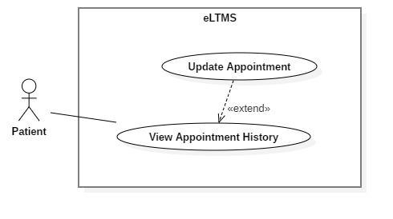

*Figure 13 - < Patient >Update Appointment*

**Use Case Specification**

|  |  |  |  |
| --- | --- | --- | --- |
| **USE CASE - UC_08** | | | |
| **Use Case No.** | 08 | **Use Case Version** | 1.0 |
| **Use Case Name** | Update Appointment | | |
| **Author** | DucBM | | |
| **Date** | 1/10/2018 | **Priority** | Normal |
| **Actor:**   * Patient   **Summary:**   * Update an appointment’s LabTest types, date and time.   **Goal:**   * LabTest types, date and time of an appointment are updated.   **Triggers:**   * User clicks Edit Button in the appointment row.   **Preconditions:**   * User is logged in as Patient.   **Post Conditions:**   * **Success**: A success message is shown. * **Fail**: An error message is shown.   **Main Success Scenario:**   |  |  |  | | --- | --- | --- | | Step | Actor Action | System Response | | 1 | User clicks on Edit Button in the appointment row. | System redirect to Edit page. Old values of LabTests are set on a checkbox list. | | 2 | User re-selects new LabTests. Then, user clicks “Bước 2” | System show a table of Samples with date and time. | | 3 | User re-selects date and time. Then, user clicks “Cập Nhật” | System processes and return message. |   **Alternative Scenario:** N/A  **Exceptions:** N/A  **Relationships:** Extended from View Appointment History use case.  **Business Rules:**   * User cannot book a Sample twice or more on the same day. * Number of bookings of a Sample-Group, on the same day, at the same slot cannot exceed the number of tables of that Sample-Group. * User cannot make an appointment with date-time in the past. * User cannot book 2 date-times which intersects each other. | | | |

**<Patient> View Appointment’s Test Result**

**Use Case Diagram**

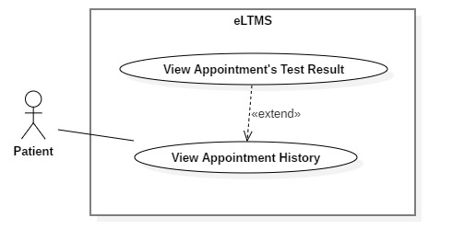

*Figure 14 - < Patient > View Appointment’s Test Result*

**Use Case Specification**

|  |  |  |  |
| --- | --- | --- | --- |
| **USE CASE - UC_10** | | | |
| **Use Case No.** | 10 | **Use Case Version** | 1.0 |
| **Use Case Name** | View Appointment’s Test Result | | |
| **Author** | DucBM | | |
| **Date** | 1/10/2018 | **Priority** | Normal |
| **Actor:**   * Patient   **Summary:**   * Patient views appointment’s test result.   **Goal:**   * Patient views appointment’s test result, a soft version of result paper.   **Triggers:**   * Patient clicks View Result Button in the appointment row.   **Preconditions:**   * User is logged in as Patient.   **Post Conditions:**   * The test result is shown.   **Main Success Scenario:**   |  |  |  | | --- | --- | --- | | Step | Actor Action | System Response | | **1** | User clicks on View Result Button on the appointment row. | System redirects to View Result page which shows:   * Test results indexes: Name, value, status (normal/low/high), result, unit * “Tải tập tin PDF” button. | | **2** | User clicks on “Tải tập tin PDF”. | A PDF version is downloaded and opened on browser. |   **Exceptions:** N/A  **Relationships:** Extended from View Appointment History use-case.  **Business Rules:**   * In the test result grid: the rows has high or low status must be highlighted (bold, italic and underlined). If high, the result number marked “H” and righ-aligned. If low, the result number marked “L” and left-aligned. | | | |

**<Patient> Delete Appointment**

**Use Case Diagram**

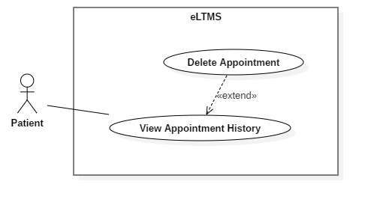

*Figure 15 - <Patient> Delete Appointment*

**Use Case Specification**

|  |  |  |  |
| --- | --- | --- | --- |
| **USE CASE - UC_12** | | | |
| **Use Case No.** | 12 | **Use Case Version** | 1.0 |
| **Use Case Name** | Delete Appointment | | |
| **Author** | DucBM | | |
| **Date** | 1/10/2018 | **Priority** | Normal |
| **Actor:**   * Patient   **Summary:**   * Delete (cancel) an appointment that patient made.   **Goal:**   * Help patients can flexibly delete the appointments that they cannot come.   **Triggers:**   * Patient clicks on Delete Button on the appointment row.   **Preconditions:**   * User is logged in as Patient.   **Post Conditions:**   * Show success message.   **Main Success Scenario:**   |  |  |  | | --- | --- | --- | | Step | Actor Action | System Response | | 1 | User clicks on Delete Button on the appointment row. | System show a confirm popup with message: “Bạn có chắc chắn muốn hủy cuộc hẹn này không?” | | 2 | User clicks “Có”. | System deletes the appointment and show popup: “Cuộc hẹn đã được hủy thành công.” |   **Alternative Scenario:**   |  |  |  | | --- | --- | --- | | Step | Actor Action | System Response | | 1 | User clicks on Delete Button on the appointment row. | System show a confirm popup with message: “Bạn có chắc chắn muốn hủy cuộc hẹn này không?” | | 2 | User clicks “Không”. | System closes the popup and come back to the appointment history list. |   **Exceptions:**   |  |  |  | | --- | --- | --- | | No | Cause | System Response | | 1 | The appointment have been deleted before user confirmed “Có”. It is deleted from another device (maybe web or mobile). | Show error message. |   **Relationships:** Extended from View Appointment History List.  **Business Rules:** N/A | | | |

**Hospital Receptionist Overview Use Case**

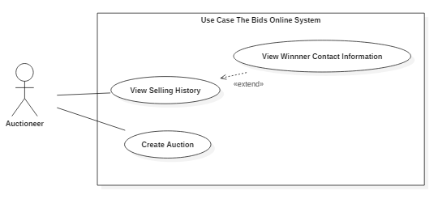

*Figure 20 - <Hospital Receptionist> Overview Use Case*

**<Hospital Receptionist, Manager> View Appointment List**

**Use Case Diagram**

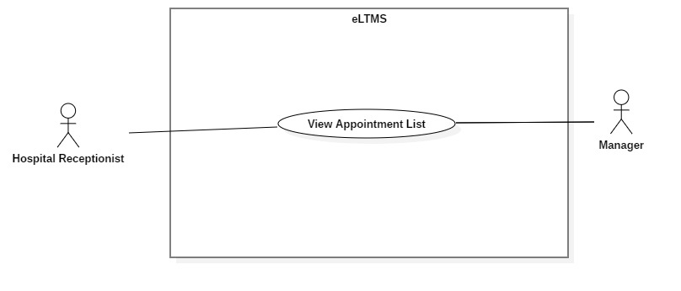

*Figure 21 - <Hospital Receptionist> View Appointment List*

**Use Case Specification**

|  |  |  |  |
| --- | --- | --- | --- |
| **USE CASE - UC_10** | | | |
| **Use Case No.** | 10 | **Use Case Version** | 1.0 |
| **Use Case Name** | View Appointment List | | |
| **Author** | YCM | | |
| **Date** | 1/10/2018 | **Priority** | Normal |
| **Actor:**   * Auctioneer.   **Summary:**   * Hospital Receptionist views a list of appointments to guide patients coming to the hospital.   **Goal:**   * Hospital Receptionist can view all appointments, search by appointment code and filter by date.   **Triggers:**   * After Hospital Receptionist logged in successfully or clicks on “Quản lý cuộc hẹn” menu item.   **Preconditions:**   * User logged in as Hospital Receptionist.   **Post Conditions:**   * A list of appointments is shown, with search, filter and pagination controls.   **Main Success Scenario:**   |  |  |  | | --- | --- | --- | | Step | Actor Action | System Response | | 1 | User clicks on “Quản lý cuộc hẹn” menu item. | A list of appointments is shown, with search, filter and pagination controls. |   **Alternative Scenario:** N/A  **Exceptions:**   |  |  |  | | --- | --- | --- | | No | Cause | System Response | | 1 | Appointment table has no data. | Show message: “Chưa có cuộc hẹn nào” |   **Relationships:** N/A  **Business Rules:**   * Initially, all IsPaid Switches are set to OFF. | | | |

**<Hospital Receptionist, Manager> View Appointment Detail**

**Use Case Diagram**

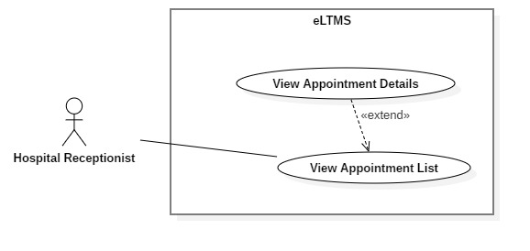

*Figure 23 - <Hospital Receptionist, Manager> View Appointment Details*

**Use Case Specification**

|  |  |  |  |
| --- | --- | --- | --- |
| **USE CASE - UC_11** | | | |
| **Use Case No.** | 11 | **Use Case Version** | 1.0 |
| **Use Case Name** | View Appointment Details | | |
| **Author** | YCM | | |
| **Date** | 1/10/2018 | **Priority** | Normal |

|  |  |  |  |  |  |  |
| --- | --- | --- | --- | --- | --- | --- |
| **Actor:**   * Hospital Receptionist. * Manager   **Summary:**   * This use-case allows Hospital Receptionist to view appointment details.   **Goal:**   * Appointment details, includes patient’s information and a list of booked Sample-Getting of the appointment, are shown.   **Triggers:**   * User clicks on “Xem chi tiết” button on the appointment row.   **Preconditions:**   * User logged in as Hospital Receptionist. * User is at View Appointment List page.   **Post Conditions:**   * **Success**: A pop up with appointment details is shown.   **Main Success Scenario:**   |  |  |  | | --- | --- | --- | | Step | Actor Action | System Response | | 1 | User clicks on on “Xem chi tiết” button on the appointment row. | A pop up appears and shows these information:   * Patient profile: Full name, phone number, gender, date of birth, email, home address, company address. * A list of booked Sample-Getting. |   **Alternative Scenario:** N/A  **Exceptions:** N/A  **Relationships:** Extend from View Appointment List use case  **Business Rules:** N/A. |

**<Hospital Receptionist, Manager> Delete Sample Getting**

**Use Case Diagram**

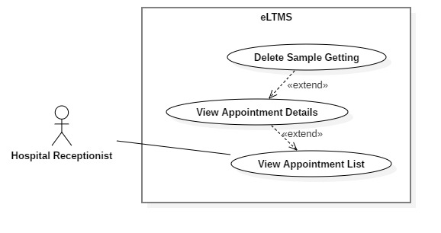

*Figure 22 - <Hospital Receptionist, Manager> Delete Sample Getting*

**Use Case Specification**

|  |  |  |  |
| --- | --- | --- | --- |
| **USE CASE - UC_10** | | | |
| **Use Case No.** | 10 | **Use Case Version** | 1.0 |
| **Use Case Name** | Delete Sample Getting | | |
| **Author** | YCM | | |
| **Date** | 1/10/2018 | **Priority** | Normal |
| **Actor**:   * Hospital Receptionist   **Summary**:   * This use-case allows Hospital Receptionist to delete Sample-Getting for online patient.   **Goal**:   * Sample-Getting of online patient is deleted.   **Triggers**:   * Hospital Receptionist clicks on Delete Button on the Sample-Getting row.   **Preconditions**:   * User logged in as Hospital Receptionist. * User is at Appointment Detail Popup.   **Post** **Conditions**:   * **Success**: Show success message. * **Fail:** Show error message.   **Main Success Scenario:**   |  |  |  | | --- | --- | --- | | Step | Actor Action | System Response | | 1 | User clicks on Delete Button on the Sample-Getting row. | System shows a popup: “Bạn có chắc chắn muốn xóa ca lấy mẫu này không?” | | 2 | User clicks “Có”. | System deleted the Sample-Getting and shows pop up: “Ca lấy mẫu đã được xóa.” |   Alternative Scenario 1:   |  |  |  | | --- | --- | --- | | Step | Actor Action | System Response | | 1 | User clicks on Delete Button on the Sample-Getting row. | System shows a popup: “Bạn có chắc chắn muốn xóa ca lấy mẫu này không?” | | 2 | User clicks “Không”. | System closes the popup and come back to the Sample-Getting list. |   **Exceptions**: N/A  **Relationships**: N/A  **Business** **Rules**:   * Price should be displayed as VND currency format. * Date should be displayed as Vietnamese date format. * For active auctions: user can sort the result by active time (newly listed/ending soon), number of bids (asc/desc), current price (asc/desc). User also can click on the row to visit auction’s detail page. * For ended auctions: user can sort the result by ended time (asc/desc), number of bids (asc/desc), current price (asc/desc). Each row provides a Contact icon for user can click and view seller’s contact information if the auction has a winner. | | | |

**<Hospital Receptionist, Manager> Mark Appointment As "Paid"**

**Use Case Diagram**

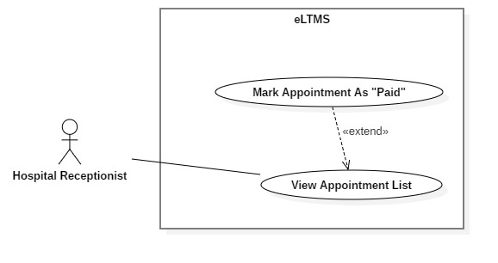

*Figure 22 - <Hospital Receptionist, Manager> Mark Appointment As Paid*

**Use Case Specification**

|  |  |  |  |
| --- | --- | --- | --- |
| **USE CASE - UC_10** | | | |
| **Use Case No.** | 10 | **Use Case Version** | 1.0 |
| **Use Case Name** | Mark Appointment As Paid | | |
| **Author** | YCM | | |
| **Date** | 1/10/2018 | **Priority** | Normal |
| **Actor**:   * Hospital Receptionist   **Summary**:   * This use-case allows Hospital Receptionist to mark the appointment as Paid.   **Goal**:   * Appointment is marked as Paid.   **Triggers**:   * User clicks on “Thanh toán” switch on the appointment row.   **Preconditions**:   * User logged in as Hospital Receptionist. * User is at Appointment List page.   **Post** **Conditions**:   * **Success**: Show success message. * **Fail:** Show error message.   **Main Success Scenario:**   |  |  |  | | --- | --- | --- | | Step | Actor Action | System Response | | 1 | User clicks on “Thanh toán” switch on the appointment row. | System show a pop up with a price list of all LabTests, and ask: “Bạn có chắc chắn muốn thanh toán không?” | | 2 | User clicks “Có”. | System processes and push notification to Nurses: “Đã thanh toán”. |   Alternative Scenario 1:   |  |  |  | | --- | --- | --- | | Step | Actor Action | System Response | | 1 | User clicks on “Thanh toán” switch on the appointment row. | System show a pop up with a price list of all LabTests, and ask: “Bạn có chắc chắn muốn thanh toán không?” | | 2 | User clicks “Không”. | Come back to Appointment List page. |   **Exceptions**: N/A  **Relationships**: N/A  **Business** **Rules**: N/A | | | |

**Department Receptionist Overview Use Case**

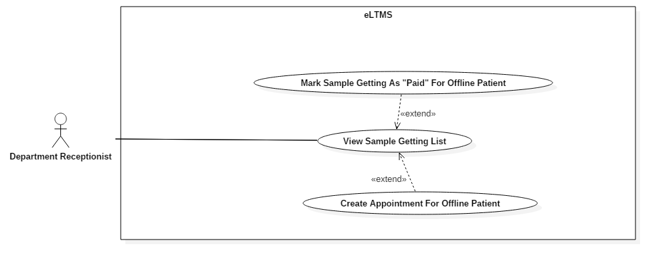

*Figure 24 - < Bidder > Overview Use Case*

**<Department Receptionist, Manager, Nurse> View Sample Getting List**

**Use Case Diagram**

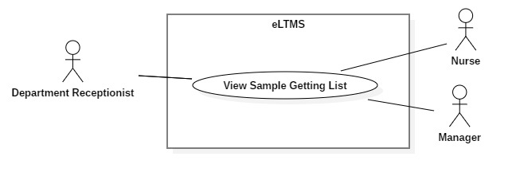

*Figure 26 - 2.3.4.1. <Department Receptionist, Manager, Nurse> View Sample Getting List*

**Use Case Specification**

|  |  |  |  |
| --- | --- | --- | --- |
| **USE CASE - UC_13** | | | |
| **Use Case No.** | 13 | **Use Case Version** | 1.0 |
| **Use Case Name** | View Sample Getting List | | |
| **Author** | YCM | | |
| **Date** | 1/10/2018 | **Priority** | Normal |
| **Actor**:   * Department Receptionist * Nurse * Manager   **Summary**:   * View a list of Sample Gettings.   **Goal**:   * A list of Sample Gettings with suitable controls is shown.   **Triggers**:   * User Logged in successfully as Department Receptionist or Manager.   **Preconditions**:   * User logged in as Department Receptionist or Manager.   **Post Conditions**:   * Success: A list of Sample Getting is shown, with search, filter and pagination controls.   **Main Success Scenario**:   |  |  |  | | --- | --- | --- | | Step | Actor Action | System Response | | 1 | Users logged in successfully as Department Receptionist, Nurse or Manager. | System shows list of Sample Getting which includes following information:   * Patient’s full name * Patient’s phone number * Patient’s home address * Sample Getting’s occurring date * Sample Getting’s occurring slot * Action button: Paid |   **Exceptions:**   |  |  |  | | --- | --- | --- | | No | Cause | System Response | | 1 | There are no data. | Show message: “Không có ca lấy mẫu nào.” |   **Relationships:** N/A  **Business Rules:**   * Initially, system displays a list of Sample-getting of the current date. | | | |

**<Department Receptionist, Manager> Mark Sample Getting As “Paid” For Offline Patient**

**Use Case Diagram**

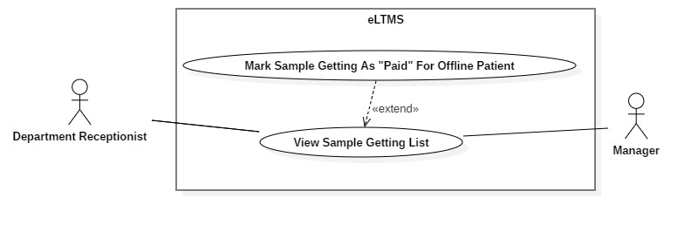

*Figure 27 - <Department Receptionist, Manager> Mark Sample Getting As “Paid” For Offline Patient*

**Use Case Specification**

|  |  |  |  |
| --- | --- | --- | --- |
| **USE CASE - UC_13** | | | |
| **Use Case No.** | 13 | **Use Case Version** | 1.0 |
| **Use Case Name** | Mark Sample Getting As “Paid” For Offline Patient | | |
| **Author** | YCM | | |
| **Date** | 1/10/2018 | **Priority** | Normal |

|  |  |  |  |  |  |  |  |  |  |  |  |  |  |  |  |  |  |  |
| --- | --- | --- | --- | --- | --- | --- | --- | --- | --- | --- | --- | --- | --- | --- | --- | --- | --- | --- |
| **Actor:**   * Department Receptionist * Manager   **Summary:**   * Mark Sample Getting as “Paid” for offline patient.   **Goal:**   * Sample Getting is marked as “Paid” to confirm that the patient has paid for his/her Sample Getting.   **Triggers:**   * Department Receptionist/Manager clicks on Paid Switch.   **Preconditions:**   * User logged in as Department Receptionist or Manager. * User is at View Sample Getting List page.   **Post Conditions:**   * **Success**: Sample Getting’s status is changed into “*Paid*”.   **Main Success Scenario:**   |  |  |  | | --- | --- | --- | | Step | Actor Action | System Response | | 1 | Click on Paid Switch. | Show a confirm pop up with message “Bạn có chắc chắn muốn thanh toán không?” | | 2 | Click “Có” button. | Change status of the Sample Getting and display message “Đã thanh toán”. |   **Alternative Scenario:**   |  |  |  | | --- | --- | --- | | Step | Actor Action | System Response | | 1 | Click on Paid Switch. | Show a confirm pop up with message “Bạn có chắc chắn muốn thanh toán không?” | | 2 | Click “Có” button. | Change status of the Sample Getting and display message “Đã thanh toán”  Set Paid switch to ON |   **Exceptions:** N/A  **Relationships:** Extend from View Sample Getting List  **Business Rules:**   * Initially, all Paid switches are set as OFF. |

**Nurse Overview Use Case**

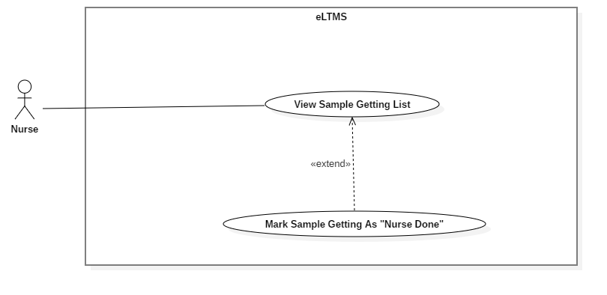

*Figure 28 - <Authorized User> Overview Use Case*

**<Nurse, Manager> Mark Sample Getting As “Nurse Done”**

**Use Case Diagram**

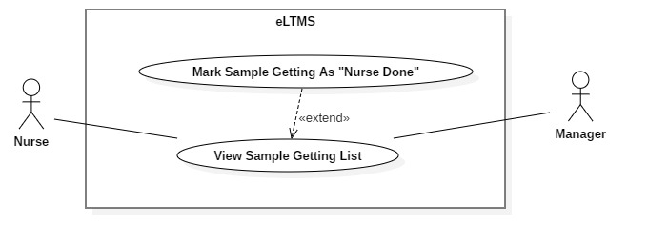

*Figure 29 - 2.3.5.1. <Nurse, Manager> Mark Sample Getting As “Nurse Done”*

**Use Case Specification**

|  |  |  |  |
| --- | --- | --- | --- |
| **USE CASE - UC_14** | | | |
| **Use Case No.** | 14 | **Use Case Version** | 1.0 |
| **Use Case Name** | Mark Sample Getting As “Nurse Done” | | |
| **Author** | YCM | | |
| **Date** | 1/10/2018 | **Priority** | Normal |
| **Actor:**   * Nurse. * Manager   **Summary:**   * Mark Sample Getting as “Nurse Done”   **Goal:**   * Sample Getting is marked as “Nurse Done”.   **Triggers:**   * User clicks on the switch on the “Đã lấy mẫu” column of the Sample Getting’s row.   **Preconditions:**   * User logged in as Nurse or Manager. * User is at View Sample Getting List page.   **Post Conditions:**   * **Success**: Show success message. Sample Getting status is changed into “*Nurse Done*”   **Main Success Scenario:**   |  |  |  | | --- | --- | --- | | Step | Actor Action | System Response | | 1 | Click on the switch on the “Đã lấy mẫu” column of the Sample Getting’s row. | Show a confirm pop up: “Bạn có chắc chắn đã lấy mẫu?” | | 2 | Click “Có” button. | Show success message. |   **Alternative Scenario:**   |  |  |  | | --- | --- | --- | | Step | Actor Action | System Response | | 1 | Click on the switch on the “Đã lấy mẫu” column of the Sample Getting’s row. | Show a confirm pop up: “Bạn có chắc chắn đã lấy mẫu?” | | 2 | Click “Không” button. | Come back to the Sample Getting List. |   **Exceptions:** N/A  **Relationships:** Extended from View Sample Getting List  **Business Rules:**   * Initially, all switches are set to OFF. | | | |

**Warehouse Keeper Overview Use Case**

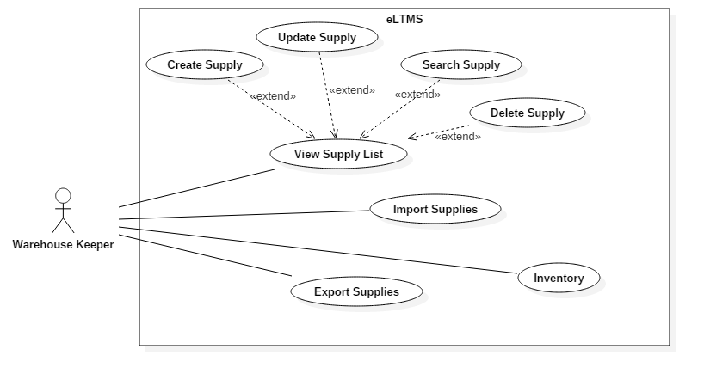

*Figure 28 - <Warehouse Keeper> Overview Use Case*

**<Warehouse Keeper, Manager> View Supply List**

**Use Case Diagram**

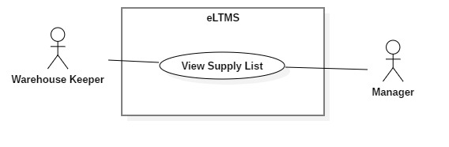

*Figure 29 - <Warehouse Keeper, Manager> View Supply List*

**Use Case Specification**

|  |  |  |  |
| --- | --- | --- | --- |
| **USE CASE - UC_14** | | | |
| **Use Case No.** | 14 | **Use Case Version** | 1.0 |
| **Use Case Name** | View Supply List | | |
| **Author** | YCM | | |
| **Date** | 1/10/2018 | **Priority** | Normal |
| **Actor:**   * Warehouse Keeper. * Manager   **Summary:**   * Display a list of supplies.   **Goal:**   * A table of supplies’ information, with search, filter and pagination controls.   **Triggers:**   * Display as default page of Warehouse Keeper. * Display after user clicks on “Quản lý vật tư” menu item.   **Preconditions:**   * User logged in as Warehouse Keeper or Manager.   **Post Conditions:**   * **Success**: A list of supplies is displayed.   **Main Success Scenario:**   |  |  |  | | --- | --- | --- | | Step | Actor Action | System Response | | 1 | Logged in successfully as Warehouse Keeper. | Display a list of supplies. |   **Alternative Scenario:**   |  |  |  | | --- | --- | --- | | Step | Actor Action | System Response | | 1 | Is at another page and clicks on “Quản lý vật tư” menu item. | Display a list of supplies. |   **Exceptions:**   |  |  |  | | --- | --- | --- | | No | Cause | System Response | | 1 | There are no data of supplies. | Show message: “Chưa có vật tư nào.” |   **Relationships:** N/A  **Business Rules:** N/A. | | | |

**<Warehouse Keeper, Manager> Search Supply**

**Use Case Diagram**

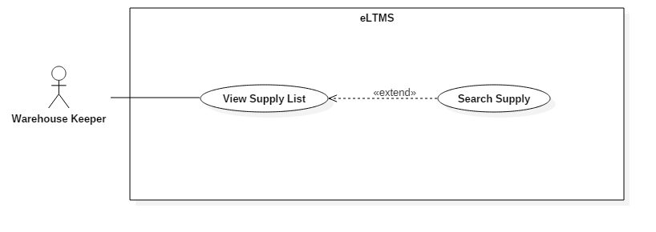

*Figure 29 - <Warehouse Keeper, Manager> Search Supply*

**Use Case Specification**

|  |  |  |  |
| --- | --- | --- | --- |
| **USE CASE - UC_14** | | | |
| **Use Case No.** | 14 | **Use Case Version** | 1.0 |
| **Use Case Name** | Search Supply | | |
| **Author** | DungTT | | |
| **Date** | 1/10/2018 | **Priority** | Normal |
| **Actor:**   * Warehouse Keeper.   **Summary:**   * Search for supplies.   **Goal:**   * Search for supplies.   **Triggers:**   * User enters a search string into search text field.   **Preconditions:**   * User logged in as Warehouse Keeper or Manager.   **Post Conditions:**   * **Success**: Show search results. * **Fail:** Show text “Không tìm thấy kết quả nào”.   **Main Success Scenario:**   |  |  |  | | --- | --- | --- | | Step | Actor Action | System Response | | 1 | Enter search string into search text field. Type Enter. | Display the search results in the table. |   **Alternative Scenario:**   |  |  |  | | --- | --- | --- | | Step | Actor Action | System Response | | 1 | Enter search string into search text field. Type Enter. | Display text messate: “Không tìm thấy kết quả.” |   **Relationships:** Extended from View Supply List use-case.  **Business Rules:**   * Search results are supplies that contains the search string in Supply Code or Supply Name. * Search case-insensitively. * User can search by unsigned Vietnamese. Ex: User searches “kim tiem”, system can return “kim tiêm” results. | | | |

**<Warehouse Keeper, Manager> Create Supply**

**Use Case Diagram**

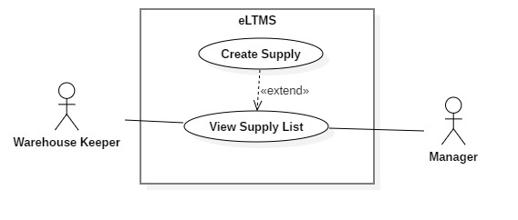

*Figure 29 - 2.3.6.2. <Warehouse Keeper, Manager> Create Supply*

**Use Case Specification**

|  |  |  |  |
| --- | --- | --- | --- |
| **USE CASE - UC_14** | | | |
| **Use Case No.** | 14 | **Use Case Version** | 1.0 |
| **Use Case Name** | Create Supply | | |
| **Author** | DungTT | | |
| **Date** | 1/10/2018 | **Priority** | Normal |
| **Actor:**   * Warehouse Keeper.   **Summary:**   * Create a new supply.   **Goal:**   * Create a new supply.   **Triggers:**   * User clicks “Thêm mới” Button. * User is at View Supply List page.   **Preconditions:**   * User logged in as Warehouse Keeper or Manager.   **Post Conditions:**   * **Success**: Show success message. * **Fail:** Show error message.   **Main Success Scenario:**   |  |  |  | | --- | --- | --- | | Step | Actor Action | System Response | | 1 | Click on “Thêm mới” button. | Require information:   * Mã vật tư: text input * Tên vật tư: text input * Loại vật tư: dropdown list * Đơn vị: dropdown list * Ghi chú: textarea | | 2 | Input information and click “Lưu” button | Process and show message. |   **Exceptions:**   |  |  |  | | --- | --- | --- | | No | Cause | System Response | | 1 | Mã vật tư is empty. | Show error message | | 2 | Tên vật tư is empty. | Show error message. | | 3 | Loại vật tư is not selected. | Show error message. | | 4 | Đơn vị is not selected. | Show error message. | | 5 | Ghi chú is empty | Show error message. |   **Relationships:** Extended from View Supply List use-case.  **Business Rules:**   * Mã vật tư is not empty, max length is 50. * Tên vật tư is not empty, max lenth is 50. * Ghi chú is not empty, max length is 50. | | | |

**<Warehouse Keeper, Manager> Update Supply**

**Use Case Diagram**

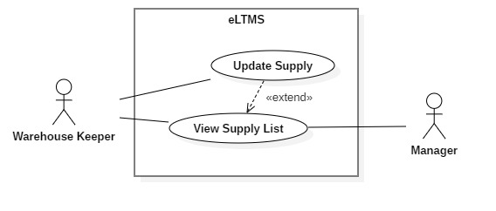

*Figure 29 - 2.3.6.3. <Warehouse Keeper, Manager> Update Supply*

**Use Case Specification**

|  |  |  |  |
| --- | --- | --- | --- |
| **USE CASE - UC_14** | | | |
| **Use Case No.** | 14 | **Use Case Version** | 1.0 |
| **Use Case Name** | Update Supply | | |
| **Author** | DungTT | | |
| **Date** | 1/10/2018 | **Priority** | Normal |
| **Actor:**   * Warehouse Keeper. * Manager   **Summary:**   * Update a supply’s information.   **Goal:**   * Update a supply’s information.   **Triggers:**   * User clicks on Edit button on the action column of the supply’s row.   **Preconditions:**   * User logged in as Warehouse Keeper or Manager.   **Post Conditions:**   * **Success**: Show success message. * **Fail:** Show error message.   **Main Success Scenario:**   |  |  |  | | --- | --- | --- | | Step | Actor Action | System Response | | 1 | Click on Edit button on the action column of the supply’s row. | Show a popup, containing fields are filled with old information. | | 2 | Enter new formation of the supply and click “Lưu” button. | Show success message. |   **Exceptions:**   |  |  |  | | --- | --- | --- | | No | Cause | System Response | | 1 | Mã vật tư is empty. | Show error message | | 2 | Tên vật tư is empty. | Show error message. | | 3 | Loại vật tư is not selected. | Show error message. | | 4 | Đơn vị is not selected. | Show error message. | | 5 | Ghi chú is empty | Show error message. |   **Relationships:** Extended from View Supply List  **Business Rules:**   * Mã vật tư cannot be changed in this use-case. * Tên vật tư is not empty, max lenth is 50. * Ghi chú is not empty, max length is 50. | | | |

**<Warehouse Keeper, Manager> Delete Supply**

**Use Case Diagram**

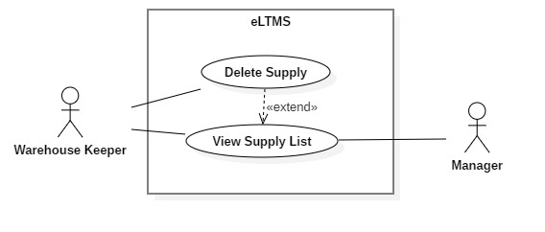

*Figure 29 - 2.3.6.4. <Warehouse Keeper, Manager> Delete Supply*

**Use Case Specification**

|  |  |  |  |
| --- | --- | --- | --- |
| **USE CASE - UC_14** | | | |
| **Use Case No.** | 14 | **Use Case Version** | 1.0 |
| **Use Case Name** | Delete Supply | | |
| **Author** | DungTT | | |
| **Date** | 1/10/2018 | **Priority** | Normal |
| **Actor:**   * Warehouse Keeper * Manager   **Summary:**   * Delete an existing supply.   **Goal:**   * Delete an existing supply.   **Triggers:**   * User clicks on Delete button on the action column of the supply’s row.   **Preconditions:**   * User logged in as Warehouse Keeper or Manager.   **Post Conditions:**   * **Success**: Show success message. * **Fail:** Show error message.   **Main Success Scenario:**   |  |  |  | | --- | --- | --- | | Step | Actor Action | System Response | | 1 | Click on Delete button on the action column of the supply’s row. | Show confirm popup: “Bạn có chắc chắn muốn xóa?” | | 2 | Click “Có”. | Show success message. |   **Alternative Scenario:**   |  |  |  | | --- | --- | --- | | Step | Actor Action | System Response | | 1 | Click on Delete button on the action column of the supply’s row. | Show confirm popup: “Bạn có chắc chắn muốn xóa?” | | 2 | Click “Không”. | Show error message. |   **Exceptions:**   |  |  |  | | --- | --- | --- | | No | Cause | System Response | | 1 | The supply is deleted at the same time by another person. | Show error message. |   **Relationships:** Extended from View Supply List use-case.  **Business Rules:** N/A. | | | |

**<Warehouse Keeper, Manager> Import Supply**

**Use Case Diagram**

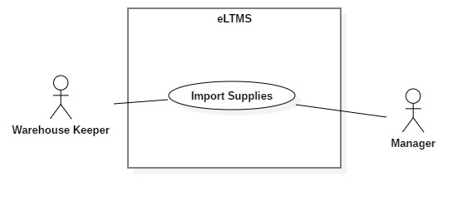

*Figure 29 - 2.3.6.5. <Warehouse Keeper, Manager> Import Supply*

**Use Case Specification**

|  |  |  |  |
| --- | --- | --- | --- |
| **USE CASE - UC_14** | | | |
| **Use Case No.** | 14 | **Use Case Version** | 1.0 |
| **Use Case Name** | Import Supply | | |
| **Author** | DungTT | | |
| **Date** | 1/10/2018 | **Priority** | Normal |
| **Actor:**   * Warehouse Keeper. * Manager   **Summary:**   * Display a list of supplies.   **Goal:**   * A table of supplies’ information, with search, filter and pagination controls.   **Triggers:**   * Display as default page of Warehouse Keeper. * Display after user clicks on “Quản lý vật tư” menu item.   **Preconditions:**   * User logged in as Warehouse Keeper or Manager.   **Post Conditions:**   * **Success**: A list of supplies is displayed.   **Main Success Scenario:**   |  |  |  | | --- | --- | --- | | Step | Actor Action | System Response | | 1 | Logged in successfully as Warehouse Keeper. | Display a list of supplies. |   **Alternative Scenario:**   |  |  |  | | --- | --- | --- | | Step | Actor Action | System Response | | 1 | Is at another page and clicks on “Quản lý vật tư” menu item. | Display a list of supplies. |   **Exceptions:**   |  |  |  | | --- | --- | --- | | No | Cause | System Response | | 1 | There are no data of supplies. | Show message: “Chưa có vật tư nào.” |   **Relationships:** N/A  **Business Rules:** N/A. | | | |

**<Warehouse Keeper, Manager> Export Supply**

**Use Case Diagram**

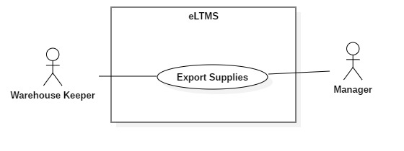

*Figure 29 - 2.3.6.6. <Warehouse Keeper, Manager> Export Supply*

**Use Case Specification**

|  |  |  |  |
| --- | --- | --- | --- |
| **USE CASE - UC_14** | | | |
| **Use Case No.** | 14 | **Use Case Version** | 1.0 |
| **Use Case Name** | Export Supply | | |
| **Author** | YCM | | |
| **Date** | 1/10/2018 | **Priority** | Normal |
| **Actor:**   * Warehouse Keeper. * Manager   **Summary:**   * Display a list of supplies.   **Goal:**   * A table of supplies’ information, with search, filter and pagination controls.   **Triggers:**   * Display as default page of Warehouse Keeper. * Display after user clicks on “Quản lý vật tư” menu item.   **Preconditions:**   * User logged in as Warehouse Keeper or Manager.   **Post Conditions:**   * **Success**: A list of supplies is displayed.   **Main Success Scenario:**   |  |  |  | | --- | --- | --- | | Step | Actor Action | System Response | | 1 | Logged in successfully as Warehouse Keeper. | Display a list of supplies. |   **Alternative Scenario:**   |  |  |  | | --- | --- | --- | | Step | Actor Action | System Response | | 1 | Is at another page and clicks on “Quản lý vật tư” menu item. | Display a list of supplies. |   **Exceptions:**   |  |  |  | | --- | --- | --- | | No | Cause | System Response | | 1 | There are no data of supplies. | Show message: “Chưa có vật tư nào.” |   **Relationships:** N/A  **Business Rules:** N/A. | | | |

**<Warehouse Keeper, Manager> Inventory**

**Use Case Diagram**

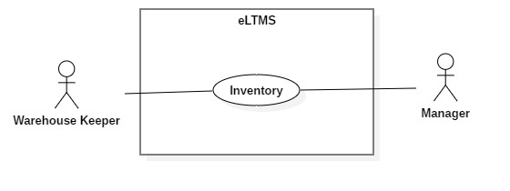

*Figure 29 - 2.3.6.7. <Warehouse Keeper, Manager> Inventory*

**Use Case Specification**

|  |  |  |  |
| --- | --- | --- | --- |
| **USE CASE - UC_14** | | | |
| **Use Case No.** | 14 | **Use Case Version** | 1.0 |
| **Use Case Name** | Inventory | | |
| **Author** | YCM | | |
| **Date** | 1/10/2018 | **Priority** | Normal |
| **Actor:**   * Warehouse Keeper. * Manager   **Summary:**   * Display a list of supplies.   **Goal:**   * A table of supplies’ information, with search, filter and pagination controls.   **Triggers:**   * Display as default page of Warehouse Keeper. * Display after user clicks on “Quản lý vật tư” menu item.   **Preconditions:**   * User logged in as Warehouse Keeper or Manager.   **Post Conditions:**   * **Success**: A list of supplies is displayed.   **Main Success Scenario:**   |  |  |  | | --- | --- | --- | | Step | Actor Action | System Response | | 1 | Logged in successfully as Warehouse Keeper. | Display a list of supplies. |   **Alternative Scenario:**   |  |  |  | | --- | --- | --- | | Step | Actor Action | System Response | | 1 | Is at another page and clicks on “Quản lý vật tư” menu item. | Display a list of supplies. |   **Exceptions:**   |  |  |  | | --- | --- | --- | | No | Cause | System Response | | 1 | There are no data of supplies. | Show message: “Chưa có vật tư nào.” |   **Relationships:** N/A  **Business Rules:** N/A. | | | |

**Manager Overview Use Case**

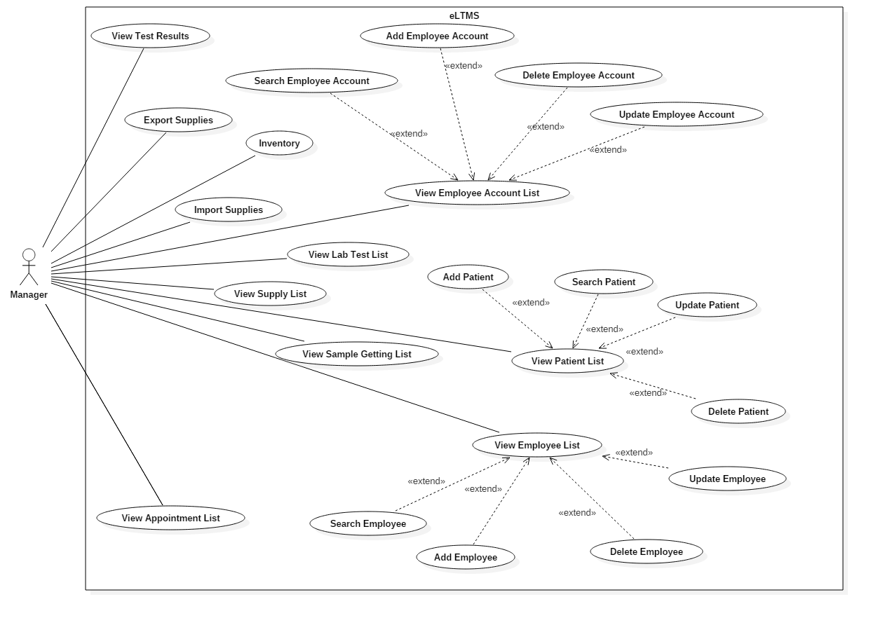

*Figure 28 - <Authorized User> Overview Use Case*

**<Manager, Lab Technician> View Sample Group List**

**Use Case Diagram**

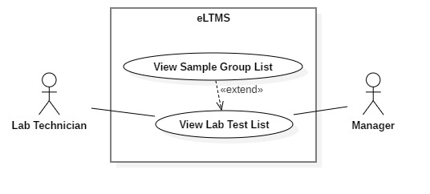

*Figure 29 - 2.3.6.1. <Manager, Lab Technician> View Sample Group List*

**Use Case Specification**

|  |  |  |  |
| --- | --- | --- | --- |
| USE CASE - UC_14 | | | |
| Use Case No. | 14 | **Use Case Version** | 1.0 |
| Use Case Name | View Sample Group List | | |
| Author | DungTT | | |
| Date | 1/10/2018 | **Priority** | Normal |
| Actor:   * **Lab Technician.** * **Manager**   Summary:   * **Display a list of Sample Groups.**   Goal:   * **A table of Sample Groups’ information, with search, filter and pagination controls.**   Triggers:   * **Display after user clicks on “Quản lý nhóm xét nghiệm” menu item.**   Preconditions:   * **User logged in as Manager, Lab Technician.**   Post Conditions:   * Success**: A list of Sample Groups is displayed.**   Main Success Scenario:   |  |  |  | | --- | --- | --- | | **Step** | **Actor Action** | **System Response** | | **1** | Logged in successfully as Manager, Lab Technician. | Display a list of Sample Groups. |   Alternative Scenario:   |  |  |  | | --- | --- | --- | | **Step** | **Actor Action** | **System Response** | | **1** | Is at another page and clicks on “Quản lý nhóm xét nghiệm” menu item. | Display a list of Sample Groups. |   Exceptions:   |  |  |  | | --- | --- | --- | | **No** | **Cause** | **System Response** | | **1** | There are no data of Sample Groups. | Show message: “Chưa có nhóm xét nghiệm nào.” |   Relationships: **N/A**  Business Rules: **N/A.** | | | |

**<Manager, Lab Technician> Create Sample Group**

**Use Case Diagram**

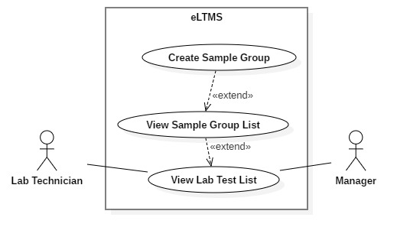

*Figure 29 - 2.3.6.2. <Manager, Lab Technician> Create Sample Group*

**Use Case Specification**

|  |  |  |  |
| --- | --- | --- | --- |
| USE CASE - UC_14 | | | |
| Use Case No. | 14 | **Use Case Version** | 1.0 |
| Use Case Name | Create Sample Group | | |
| Author | DungTT | | |
| Date | 1/10/2018 | **Priority** | Normal |
| Actor:   * **Manager, Lab Technician.**   Summary:   * **Create a new Sample Group.**   Goal:   * **Create a new Sample Group.**   Triggers:   * **User clicks “Thêm mới” Button.** * **User is at View Sample Group List page.**   Preconditions:   * **User logged in as Manager, Lab Technician.**   Post Conditions:   * Success**: Show success message.** * Fail: **Show error message.**   Main Success Scenario:   |  |  |  | | --- | --- | --- | | **Step** | **Actor Action** | **System Response** | | **1** | Click on “Thêm mới” button. | Require information:   * Sample Group Name: text input * Description: text input | | **2** | Input information and click “Lưu” button | Process and show message. |   Exceptions:   |  |  |  | | --- | --- | --- | | **No** | **Cause** | **System Response** | | **1** | Sample Group Nameis empty. | Show error message | | **2** | Descriptionis empty. | Show error message. |   Relationships: **Extended from View Sample Group List use-case.**  Business Rules:   * **Sample Group Name is not empty, max length is 50.** * **Description is not empty, max length is 500.** | | | |

**<Manager, Lab Technician> Update Sample Group**

**Use Case Diagram**

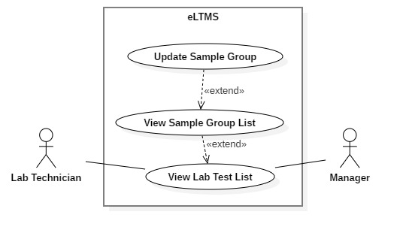

*Figure 29 - 2.3.6.3. <Manager, Lab Technician> Update Sample Group*

**Use Case Specification**

|  |  |  |  |
| --- | --- | --- | --- |
| USE CASE - UC_14 | | | |
| Use Case No. | 14 | **Use Case Version** | 1.0 |
| Use Case Name | Update Sample Group | | |
| Author | DungTT | | |
| Date | 1/10/2018 | **Priority** | Normal |
| Actor:   * **Manager, Lab Technician.**   Summary:   * **Update a Sample Group’s information.**   Goal:   * **Update a Sample Group’s information.**   Triggers:   * **User clicks on Edit button on the action column of the Sample Group’s row.**   Preconditions:   * **User logged in as Manager, Lab Technician.**   Post Conditions:   * Success**: Show success message.** * Fail: **Show error message.**   Main Success Scenario:   |  |  |  | | --- | --- | --- | | **Step** | **Actor Action** | **System Response** | | **1** | Click on Edit button on the action column of the Sample Group’s row. | Show a popup, containing fields are filled with old information. | | **2** | Enter new formation of the Sample Group and click “Lưu” button. | Show success message. |   Exceptions:   |  |  |  | | --- | --- | --- | | **No** | **Cause** | **System Response** | | **1** | Sample Group Nameis empty. | Show error message | | **2** | Descriptionis empty. | Show error message. |   Relationships: **Extended from View Sample Group List**  Business Rules:   * **Sample Group Name is not empty, max length is 50.** * **Description is not empty, max length is 500.** | | | |

**<Manager, Lab Technician> Delete Sample Group**

**Use Case Diagram**

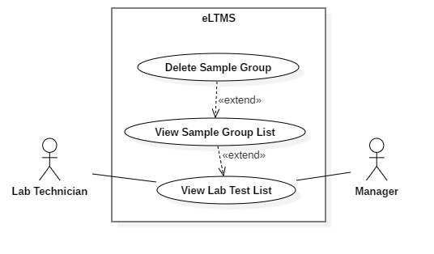

*Figure 29 - 2.3.6.4. <Manager, Lab Technician> Delete Sample Group*

**Use Case Specification**

|  |  |  |  |
| --- | --- | --- | --- |
| USE CASE - UC_14 | | | |
| Use Case No. | 14 | **Use Case Version** | 1.0 |
| Use Case Name | Delete Sample Group | | |
| Author | DungTT | | |
| Date | 1/10/2018 | **Priority** | Normal |
| Actor:   * **Manager, Lab Technician**   Summary:   * **Delete an existing Sample Group.**   Goal:   * **Delete an existing Sample Group.**   Triggers:   * **User clicks on Delete button on the action column of the Sample Group’s row.**   Preconditions:   * **User logged in as Manager, Lab Technician.**   Post Conditions:   * Success**: Show success message.** * Fail: **Show error message.**   Main Success Scenario:   |  |  |  | | --- | --- | --- | | **Step** | **Actor Action** | **System Response** | | **1** | Click on Delete button on the action column of the Sample Group’s row. | Show confirm popup: “Bạn có chắc chắn muốn xóa?” | | **2** | Click “Có”. | Show success message. |   Alternative Scenario:   |  |  |  | | --- | --- | --- | | **Step** | **Actor Action** | **System Response** | | **1** | Click on Delete button on the action column of the Sample Group’s row. | Show confirm popup: “Bạn có chắc chắn muốn xóa?” | | **2** | Click “Không”. | Show error message. |   Exceptions:   |  |  |  | | --- | --- | --- | | **No** | **Cause** | **System Response** | | **1** | The Sample Group is deleted at the same time by another person. | Show error message. |   Relationships: **Extended from View Sample Group List use-case.**  Business Rules: **N/A.** | | | |

**<Manager, Lab Technician> View Sample List**

**Use Case Diagram**

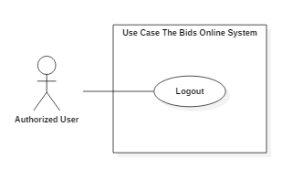

*Figure 29 - 2.3.6.1. <Manager, Lab Technician> View Sample List*

**Use Case Specification**

|  |  |  |  |
| --- | --- | --- | --- |
| USE CASE - UC_14 | | | |
| Use Case No. | 14 | **Use Case Version** | 1.0 |
| Use Case Name | View Sample List | | |
| Author | DungTT | | |
| Date | 1/10/2018 | **Priority** | Normal |
| Actor:   * **Manager, Lab Technician.**   Summary:   * **Display a list of Samples.**   Goal:   * **A table of Samples’ information, with search, filter and pagination controls.**   Triggers:   * **Display after user clicks on “Quản lý loại xét nghiệm” menu item.**   Preconditions:   * **User logged in as Manager, Lab Technician.**   Post Conditions:   * Success**: A list of Samples is displayed.**   Main Success Scenario:   |  |  |  | | --- | --- | --- | | **Step** | **Actor Action** | **System Response** | | **1** | Logged in successfully as Manager, Lab Technician. | Display a list of Samples. |   Alternative Scenario:   |  |  |  | | --- | --- | --- | | **Step** | **Actor Action** | **System Response** | | **1** | Is at another page and clicks on “Quản lý loại xét nghiệm” menu item. | Display a list of Samples. |   Exceptions:   |  |  |  | | --- | --- | --- | | **No** | **Cause** | **System Response** | | **1** | There are no data of Samples. | Show message: “Chưa có loại xét nghiệm nào.” |   Relationships: **N/A**  Business Rules: **N/A.** | | | |

**<Manager, Lab Technician> Create Sample**

**Use Case Diagram**

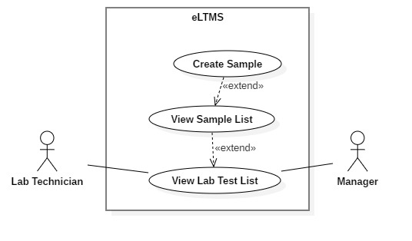

*Figure 29 - 2.3.6.2. <Manager, Lab Technician> Create Sample*

**Use Case Specification**

|  |  |  |  |
| --- | --- | --- | --- |
| USE CASE - UC_14 | | | |
| Use Case No. | 14 | **Use Case Version** | 1.0 |
| Use Case Name | Create Sample | | |
| Author | DungTT | | |
| Date | 1/10/2018 | **Priority** | Normal |
| Actor:   * **Manager, Lab Technician.**   Summary:   * **Create a new Sample.**   Goal:   * **Create a new Sample.**   Triggers:   * **User clicks “Thêm mới” Button.** * **User is at View Sample List page.**   Preconditions:   * **User logged in as Manager, Lab Technician.**   Post Conditions:   * Success**: Show success message.** * Fail: **Show error message.**   Main Success Scenario:   |  |  |  | | --- | --- | --- | | **Step** | **Actor Action** | **System Response** | | **1** | Click on “Thêm mới” button. | Require information:   * Sample Name: text input * Description: text area | | **2** | Input information and click “Lưu” button | Process and show message. |   Exceptions:   |  |  |  | | --- | --- | --- | | **No** | **Cause** | **System Response** | | **1** | Sample Name is empty. | Show error message | | **2** | Description is empty. | Show error message. |   Relationships: **Extended from View Sample List use-case.**  Business Rules:   * **Sample Name is not empty, max length is 50.** * **Description is not empty, max length is 500.** | | | |

**<Manager, Lab Technician> Update Sample**

**Use Case Diagram**

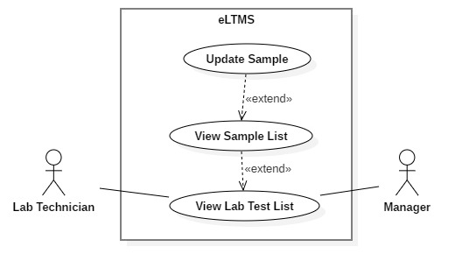

*Figure 29 - 2.3.6.3. <Manager, Lab Technician> Update Sample*

**Use Case Specification**

|  |  |  |  |
| --- | --- | --- | --- |
| USE CASE - UC_14 | | | |
| Use Case No. | 14 | **Use Case Version** | 1.0 |
| Use Case Name | Update Sample | | |
| Author | DungTT | | |
| Date | 1/10/2018 | **Priority** | Normal |
| Actor:   * **Manager, Lab Technician.**   Summary:   * **Update a Sample’s information.**   Goal:   * **Update a Sample’s information.**   Triggers:   * **User clicks on Edit button on the action column of the Sample’s row.**   Preconditions:   * **User logged in as Manager, Lab Technician.**   Post Conditions:   * Success**: Show success message.** * Fail: **Show error message.**   Main Success Scenario:   |  |  |  | | --- | --- | --- | | **Step** | **Actor Action** | **System Response** | | **1** | Click on Edit button on the action column of the Sample’s row. | Show a popup, containing fields are filled with old information. | | **2** | Enter new formation of the Sample and click “Lưu” button. | Show success message. |   Exceptions:   |  |  |  | | --- | --- | --- | | **No** | **Cause** | **System Response** | | **1** | Sample Name is empty. | Show error message | | **2** | Description is empty. | Show error message. |   Relationships: **Extended from View Sample List**  Business Rules:   * **Sample Name is not empty, max length is 50.** * **Description is not empty, max length is 500.** | | | |

**<Manager, Lab Technician> Delete Sample**

**Use Case Diagram**

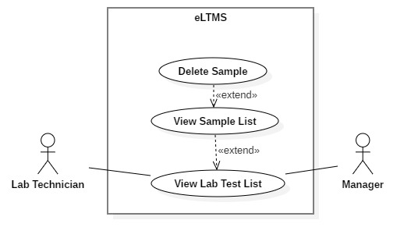

*Figure 29 - 2.3.6.4. <Manager, Lab Technician> Delete Sample*

**Use Case Specification**

|  |  |  |  |
| --- | --- | --- | --- |
| USE CASE - UC_14 | | | |
| Use Case No. | 14 | **Use Case Version** | 1.0 |
| Use Case Name | Delete Sample | | |
| Author | DungTT | | |
| Date | 1/10/2018 | **Priority** | Normal |
| Actor:   * **Manager, Lab Technician**   Summary:   * **Delete an existing Sample.**   Goal:   * **Delete an existing Sample.**   Triggers:   * **User clicks on Delete button on the action column of the Sample’s row.**   Preconditions:   * **User logged in as Manager, Lab Technician.**   Post Conditions:   * Success**: Show success message.** * Fail: **Show error message.**   Main Success Scenario:   |  |  |  | | --- | --- | --- | | **Step** | **Actor Action** | **System Response** | | **1** | Click on Delete button on the action column of the Sample’s row. | Show confirm popup: “Bạn có chắc chắn muốn xóa?” | | **2** | Click “Có”. | Show success message. |   Alternative Scenario:   |  |  |  | | --- | --- | --- | | **Step** | **Actor Action** | **System Response** | | **1** | Click on Delete button on the action column of the Sample’s row. | Show confirm popup: “Bạn có chắc chắn muốn xóa?” | | **2** | Click “Không”. | Show error message. |   Exceptions:   |  |  |  | | --- | --- | --- | | **No** | **Cause** | **System Response** | | **1** | The Sample is deleted at the same time by another person. | Show error message. |   Relationships: **Extended from View Sample List use-case.**  Business Rules: **N/A.** | | | |

**<Manager, Lab Technician> View LabTest List**

**Use Case Diagram**

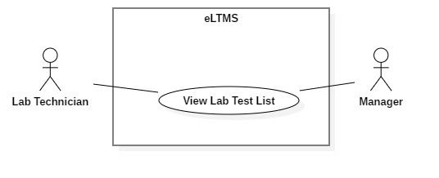

*Figure 29 - 2.3.6.1. <Manager, Lab Technician> View LabTest List*

**Use Case Specification**

|  |  |  |  |
| --- | --- | --- | --- |
| USE CASE - UC_14 | | | |
| Use Case No. | 14 | **Use Case Version** | 1.0 |
| Use Case Name | View LabTest List | | |
| Author | DungTT | | |
| Date | 1/10/2018 | **Priority** | Normal |
| Actor:   * **Manager, Lab Technician.**   Summary:   * **Display a list of LabTests.**   Goal:   * **A table of LabTests’ information, with search, filter and pagination controls.**   Triggers:   * **Display after user clicks on “Quản lý dịch vụ xét nghiệm” menu item.**   Preconditions:   * **User logged in as Manager, Lab Technician.**   Post Conditions:   * Success**: A list of LabTests is displayed.**   Main Success Scenario:   |  |  |  | | --- | --- | --- | | **Step** | **Actor Action** | **System Response** | | **1** | Logged in successfully as Manager, Lab Technician. | Display a list of LabTests. |   Alternative Scenario:   |  |  |  | | --- | --- | --- | | **Step** | **Actor Action** | **System Response** | | **1** | Is at another page and clicks on “Quản lý dịch vụ xét nghiệm” menu item. | Display a list of LabTests. |   Exceptions:   |  |  |  | | --- | --- | --- | | **No** | **Cause** | **System Response** | | **1** | There are no data of LabTests. | Show message: “Chưa có dịch vụ xét nghiệm nào nào.” |   Relationships: **N/A**  Business Rules: **N/A.** | | | |

**<Manager, Lab Technician> Search LabTest**

**Use Case Diagram**

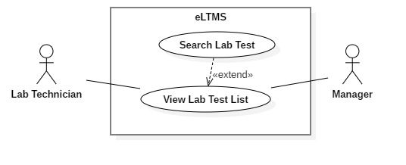

*Figure 29 - 2.3.6.2. <Manager, Lab Technician> Search LabTest*

**Use Case Specification**

|  |  |  |  |
| --- | --- | --- | --- |
| USE CASE - UC_14 | | | |
| Use Case No. | 14 | **Use Case Version** | 1.0 |
| Use Case Name | Search LabTest | | |
| Author | DungTT | | |
| Date | 1/10/2018 | **Priority** | Normal |
| Actor:   * **Manager, Lab Technician.**   Summary:   * **Search for LabTests.**   Goal:   * **Search for LabTests.**   Triggers:   * **User enters a search string into search text field.**   Preconditions:   * **User logged in as Manager, Lab Technician.**   Post Conditions:   * Success**: Show search results.** * Fail: **Show text “Không tìm thấy kết quả nào”.**   Main Success Scenario:   |  |  |  | | --- | --- | --- | | **Step** | **Actor Action** | **System Response** | | **1** | Enter search string into search text field. Type Enter. | Display the search results in the table. |   Alternative Scenario:   |  |  |  | | --- | --- | --- | | **Step** | **Actor Action** | **System Response** | | **1** | Enter search string into search text field. Type Enter. | Display text messate: “Không tìm thấy kết quả.” |   Relationships: **Extended from View LabTest List use-case.**  Business Rules:   * **Search results are LabTests that contains the search string in LabTest Code or LabTest Name.** * **Search case-insensitively.** * **User can search by unsigned Vietnamese. Ex: User searches “kim tiem”, system can return “kim tiêm” results.** | | | |

**<Manager, Lab Technician> Create LabTest**

**Use Case Diagram**

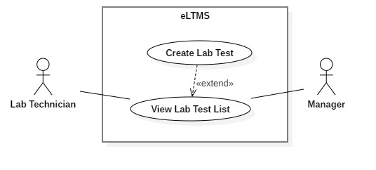

*Figure 29 - 2.3.6.2. <Manager, Lab Technician> Create LabTest*

**Use Case Specification**

|  |  |  |  |
| --- | --- | --- | --- |
| USE CASE - UC_14 | | | |
| Use Case No. | 14 | **Use Case Version** | 1.0 |
| Use Case Name | Create LabTest | | |
| Author | DungTT | | |
| Date | 1/10/2018 | **Priority** | Normal |
| Actor:   * **Manager, Lab Technician.**   Summary:   * **Create a new LabTest.**   Goal:   * **Create a new LabTest.**   Triggers:   * **User clicks “Thêm mới” Button.** * **User is at View LabTest List page.**   Preconditions:   * **User logged in as Manager, Lab Technician.**   Post Conditions:   * Success**: Show success message.** * Fail: **Show error message.**   Main Success Scenario:   |  |  |  | | --- | --- | --- | | **Step** | **Actor Action** | **System Response** | | **1** | Click on “Thêm mới” button. | Require information:   * Lab Test Code: text input * Lab Test Name: text input * Description: text area | | **2** | Input information and click “Lưu” button | Process and show message. |   Exceptions:   |  |  |  | | --- | --- | --- | | **No** | **Cause** | **System Response** | | **1** | Lab Test Code is empty. | Show error message | | **2** | Lab Test Name is empty. | Show error message. | | **3** | Description is not selected. | Show error message. |   Relationships: **Extended from View LabTest List use-case.**  Business Rules:   * **Lab Test Code is not empty, max length is 50.** * **Lab Test Name is not empty, max lenth is 50.** * **Description is not empty, max length is 500.** | | | |

**<Manager, Lab Technician> Update LabTest**

**Use Case Diagram**

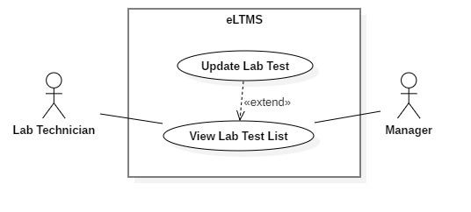

*Figure 29 - 2.3.6.3. <Manager, Lab Technician> Update LabTest*

**Use Case Specification**

|  |  |  |  |
| --- | --- | --- | --- |
| USE CASE - UC_14 | | | |
| Use Case No. | 14 | **Use Case Version** | 1.0 |
| Use Case Name | Update LabTest | | |
| Author | DungTT | | |
| Date | 1/10/2018 | **Priority** | Normal |
| Actor:   * **Manager, Lab Technician.**   Summary:   * **Update a LabTest’s information.**   Goal:   * **Update a LabTest’s information.**   Triggers:   * **User clicks on Edit button on the action column of the LabTest’s row.**   Preconditions:   * **User logged in as Manager, Lab Technician.**   Post Conditions:   * Success**: Show success message.** * Fail: **Show error message.**   Main Success Scenario:   |  |  |  | | --- | --- | --- | | **Step** | **Actor Action** | **System Response** | | **1** | Click on Edit button on the action column of the LabTest’s row. | Show a popup, containing fields are filled with old information. | | **2** | Enter new formation of the LabTest and click “Lưu” button. | Show success message. |   Exceptions:   |  |  |  | | --- | --- | --- | | **No** | **Cause** | **System Response** | | **1** | Lab Test Code is empty. | Show error message | | **2** | Lab Test Name is empty. | Show error message. | | **3** | Description is not selected. | Show error message. |   Relationships: **Extended from View LabTest List**  Business Rules:   * **Lab Test Code is not empty, max length is 50.** * **Lab Test Name is not empty, max length is 50.** * **Description is not empty, max length is 500.** | | | |

**<Manager, Lab Technician> Delete LabTest**

**Use Case Diagram**

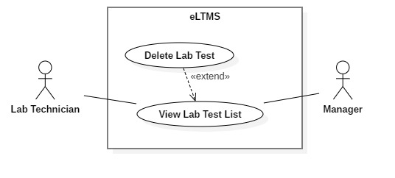

*Figure 29 - 2.3.6.4. <Manager, Lab Technician> Delete LabTest*

**Use Case Specification**

|  |  |  |  |
| --- | --- | --- | --- |
| USE CASE - UC_14 | | | |
| Use Case No. | 14 | **Use Case Version** | 1.0 |
| Use Case Name | Delete LabTest | | |
| Author | DungTT | | |
| Date | 1/10/2018 | **Priority** | Normal |
| Actor:   * **Manager, Lab Technician**   Summary:   * **Delete an existing LabTest.**   Goal:   * **Delete an existing LabTest.**   Triggers:   * **User clicks on Delete button on the action column of the LabTest’s row.**   Preconditions:   * **User logged in as Manager, Lab Technician.**   Post Conditions:   * Success**: Show success message.** * Fail: **Show error message.**   Main Success Scenario:   |  |  |  | | --- | --- | --- | | **Step** | **Actor Action** | **System Response** | | **1** | Click on Delete button on the action column of the LabTest’s row. | Show confirm popup: “Bạn có chắc chắn muốn xóa?” | | **2** | Click “Có”. | Show success message. |   Alternative Scenario:   |  |  |  | | --- | --- | --- | | **Step** | **Actor Action** | **System Response** | | **1** | Click on Delete button on the action column of the LabTest’s row. | Show confirm popup: “Bạn có chắc chắn muốn xóa?” | | **2** | Click “Không”. | Show error message. |   Exceptions:   |  |  |  | | --- | --- | --- | | **No** | **Cause** | **System Response** | | **1** | The LabTest is deleted at the same time by another person. | Show error message. |   Relationships: **Extended from View LabTest List use-case.**  Business Rules: **N/A.** | | | |

**<Manager> View Employee Account List**

**Use Case Diagram**



*Figure 29 - 2.3.6.1. <Manager> View Employee Account List*

**Use Case Specification**

|  |  |  |  |
| --- | --- | --- | --- |
| USE CASE - UC_14 | | | |
| Use Case No. | 14 | **Use Case Version** | 1.0 |
| Use Case Name | View Employee Account List | | |
| Author | LamNH | | |
| Date | 1/10/2018 | **Priority** | Normal |
| Actor:   * **Manager.**   Summary:   * **Display a list of Employee Accounts.**   Goal:   * **A table of Employee Accounts’ information, with search, filter and pagination controls.**   Triggers:   * **Display after user clicks on “Quản lý tài khoản nhân viên” menu item.**   Preconditions:   * **User logged in as Manager.**   Post Conditions:   * Success**: A list of Employee Accounts is displayed.**   Main Success Scenario:   |  |  |  | | --- | --- | --- | | **Step** | **Actor Action** | **System Response** | | **1** | Logged in successfully as Manager. | Display a list of Employee Accounts. |   Alternative Scenario:   |  |  |  | | --- | --- | --- | | **Step** | **Actor Action** | **System Response** | | **1** | Is at another page and clicks on “Quản lý tài khoản nhân viên” menu item. | Display a list of Employee Accounts. |   Exceptions:   |  |  |  | | --- | --- | --- | | **No** | **Cause** | **System Response** | | **1** | There are no data of Employee Accounts. | Show message: “Chưa có tài khoản nhân viên nào.” |   Relationships: **N/A**  Business Rules: **N/A.** | | | |

**<Manager> Search Employee Account**

**Use Case Diagram**



*Figure 29 - 2.3.6.2. <Manager> Search Employee Account*

**Use Case Specification**

|  |  |  |  |
| --- | --- | --- | --- |
| USE CASE - UC_14 | | | |
| Use Case No. | 14 | **Use Case Version** | 1.0 |
| Use Case Name | Search Employee Account | | |
| Author | DungTT | | |
| Date | 1/10/2018 | **Priority** | Normal |
| Actor:   * **Manager.**   Summary:   * **Search for Employee Accounts.**   Goal:   * **Search for Employee Accounts.**   Triggers:   * **User enters a search string into search text field.**   Preconditions:   * **User logged in as Manager.**   Post Conditions:   * Success**: Show search results.** * Fail: **Show text “Không tìm thấy kết quả nào”.**   Main Success Scenario:   |  |  |  | | --- | --- | --- | | **Step** | **Actor Action** | **System Response** | | **1** | Enter search string into search text field. Type Enter. | Display the search results in the table. |   Alternative Scenario:   |  |  |  | | --- | --- | --- | | **Step** | **Actor Action** | **System Response** | | **1** | Enter search string into search text field. Type Enter. | Display text messate: “Không tìm thấy kết quả.” |   Relationships: **Extended from View Employee Account List use-case.**  Business Rules:   * **Search results are Employee Accounts that contains the search string in Employee Account Code or Employee Account Name.** * **Search case-insensitively.** * **User can search by unsigned Vietnamese. Ex: User searches “kim tiem”, system can return “kim tiêm” results.** | | | |

**<Manager> Create Employee Account**

**Use Case Diagram**



*Figure 29 - 2.3.6.2. <Manager> Create Employee Account*

**Use Case Specification**

|  |  |  |  |
| --- | --- | --- | --- |
| USE CASE - UC_14 | | | |
| Use Case No. | 14 | **Use Case Version** | 1.0 |
| Use Case Name | Create Employee Account | | |
| Author | DungTT | | |
| Date | 1/10/2018 | **Priority** | Normal |
| Actor:   * **Manager.**   Summary:   * **Create a new Employee Account.**   Goal:   * **Create a new Employee Account.**   Triggers:   * **User clicks “Thêm mới” Button.** * **User is at View Employee Account List page.**   Preconditions:   * **User logged in as Manager.**   Post Conditions:   * Success**: Show success message.** * Fail: **Show error message.**   Main Success Scenario:   |  |  |  | | --- | --- | --- | | **Step** | **Actor Action** | **System Response** | | **1** | Click on “Thêm mới” button. | Require information:   * Mã vật tư: text input * Tên vật tư: text input * Loại vật tư: dropdown list * Đơn vị: dropdown list * Ghi chú: textarea | | **2** | Input information and click “Lưu” button | Process and show message. |   Relationships: **Extended from View Employee Account List use-case.**  Business Rules: **N/A** | | | |

**<Manager> Update Employee Account**

**Use Case Diagram**



*Figure 29 - 2.3.6.3. <Manager> Update Employee Account*

**Use Case Specification**

|  |  |  |  |
| --- | --- | --- | --- |
| USE CASE - UC_14 | | | |
| Use Case No. | 14 | **Use Case Version** | 1.0 |
| Use Case Name | Update Employee Account | | |
| Author | DungTT | | |
| Date | 1/10/2018 | **Priority** | Normal |
| Actor:   * **Manager.**   Summary:   * **Update a Employee Account’s information.**   Goal:   * **Update a Employee Account’s information.**   Triggers:   * **User clicks on Edit button on the action column of the Employee Account’s row.**   Preconditions:   * **User logged in as Manager.**   Post Conditions:   * Success**: Show success message.** * Fail: **Show error message.**   Main Success Scenario:   |  |  |  | | --- | --- | --- | | **Step** | **Actor Action** | **System Response** | | **1** | Click on Edit button on the action column of the Employee Account’s row. | Show a popup, containing fields are filled with old information. | | **2** | Enter new formation of the Employee Account and click “Lưu” button. | Show success message. |   Relationships: **Extended from View Employee Account List**  Business Rules: **N/A** | | | |

**<Manager> Delete Employee Account**

**Use Case Diagram**



*Figure 29 - 2.3.6.4. <Manager> Delete Employee Account*

**Use Case Specification**

|  |  |  |  |
| --- | --- | --- | --- |
| USE CASE - UC_14 | | | |
| Use Case No. | 14 | **Use Case Version** | 1.0 |
| Use Case Name | Delete Employee Account | | |
| Author | DungTT | | |
| Date | 1/10/2018 | **Priority** | Normal |
| Actor:   * **Manager**   Summary:   * **Delete an existing Employee Account.**   Goal:   * **Delete an existing Employee Account.**   Triggers:   * **User clicks on Delete button on the action column of the Employee Account’s row.**   Preconditions:   * **User logged in as Manager.**   Post Conditions:   * Success**: Show success message.** * Fail: **Show error message.**   Main Success Scenario:   |  |  |  | | --- | --- | --- | | **Step** | **Actor Action** | **System Response** | | **1** | Click on Delete button on the action column of the Employee Account’s row. | Show confirm popup: “Bạn có chắc chắn muốn xóa?” | | **2** | Click “Có”. | Show success message. |   Alternative Scenario:   |  |  |  | | --- | --- | --- | | **Step** | **Actor Action** | **System Response** | | **1** | Click on Delete button on the action column of the Employee Account’s row. | Show confirm popup: “Bạn có chắc chắn muốn xóa?” | | **2** | Click “Không”. | Show error message. |   Exceptions:   |  |  |  | | --- | --- | --- | | **No** | **Cause** | **System Response** | | **1** | The Employee Account is deleted at the same time by another person. | Show error message. |   Relationships: **Extended from View Employee Account List use-case.**  Business Rules: **N/A.** | | | |

**<Manager> View Patient List**

**Use Case Diagram**



*Figure 29 - 2.3.6.1. <Manager> View Patient List*

**Use Case Specification**

|  |  |  |  |
| --- | --- | --- | --- |
| USE CASE - UC_14 | | | |
| Use Case No. | 14 | **Use Case Version** | 1.0 |
| Use Case Name | View Patient List | | |
| Author | LamNH | | |
| Date | 1/10/2018 | **Priority** | Normal |
| Actor:   * **Manager.**   Summary:   * **Display a list of Patients.**   Goal:   * **A table of Patients’ information, with search, filter and pagination controls.**   Triggers:   * **Display after user clicks on “Quản lý bệnh nhân” menu item.**   Preconditions:   * **User logged in as Manager.**   Post Conditions:   * Success**: A list of Patients is displayed.**   Main Success Scenario:   |  |  |  | | --- | --- | --- | | **Step** | **Actor Action** | **System Response** | | **1** | Logged in successfully as Manager. | Display a list of Patients. |   Alternative Scenario:   |  |  |  | | --- | --- | --- | | **Step** | **Actor Action** | **System Response** | | **1** | Is at another page and clicks on “Quản lý bệnh nhân” menu item. | Display a list of Patients. |   Exceptions:   |  |  |  | | --- | --- | --- | | **No** | **Cause** | **System Response** | | **1** | There are no data of Patients. | Show message: “Chưa có nhân viên nào.” |   Relationships: **N/A**  Business Rules: **N/A.** | | | |

**<Manager> Search Patient**

**Use Case Diagram**



*Figure 29 - 2.3.6.2. <Manager> Search Patient*

**Use Case Specification**

|  |  |  |  |
| --- | --- | --- | --- |
| USE CASE - UC_14 | | | |
| Use Case No. | 14 | **Use Case Version** | 1.0 |
| Use Case Name | Search Patient | | |
| Author | DungTT | | |
| Date | 1/10/2018 | **Priority** | Normal |
| Actor:   * **Manager.**   Summary:   * **Search for Patients.**   Goal:   * **Search for Patients.**   Triggers:   * **User enters a search string into search text field.**   Preconditions:   * **User logged in as Manager.**   Post Conditions:   * Success**: Show search results.** * Fail: **Show text “Không tìm thấy kết quả nào”.**   Main Success Scenario:   |  |  |  | | --- | --- | --- | | **Step** | **Actor Action** | **System Response** | | **1** | Enter search string into search text field. Type Enter. | Display the search results in the table. |   Alternative Scenario:   |  |  |  | | --- | --- | --- | | **Step** | **Actor Action** | **System Response** | | **1** | Enter search string into search text field. Type Enter. | Display text messate: “Không tìm thấy kết quả.” |   Relationships: **Extended from View Patient List use-case.**  Business Rules:   * **Search results are Patients that contains the search string in Patient Code or Patient Name.** * **Search case-insensitively.** * **User can search by unsigned Vietnamese. Ex: User searches “Nguyen Van”, system can return “Nguyễn Văn” results.** | | | |

**<Manager> Create Patient**

**Use Case Diagram**

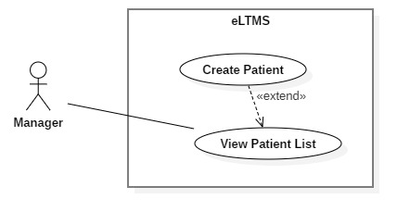

*Figure 29 - 2.3.6.2. <Manager> Create Patient*

**Use Case Specification**

|  |  |  |  |
| --- | --- | --- | --- |
| USE CASE - UC_14 | | | |
| Use Case No. | 14 | **Use Case Version** | 1.0 |
| Use Case Name | Create Patient | | |
| Author | DungTT | | |
| Date | 1/10/2018 | **Priority** | Normal |
| Actor:   * **Manager.**   Summary:   * **Create a new Patient.**   Goal:   * **Create a new Patient.**   Triggers:   * **User clicks “Thêm mới” Button.** * **User is at View Patient List page.**   Preconditions:   * **User logged in as Manager.**   Post Conditions:   * Success**: Show success message.** * Fail: **Show error message.**   Main Success Scenario:   |  |  |  | | --- | --- | --- | | **Step** | **Actor Action** | **System Response** | | **1** | Click on “Thêm mới” button. | Require information:   * Full name: text input * Gender: radio buttons * Phone number: text input * Email: text input * Date of birth: date input * Home Address: text input * Company Address: text input * Identity Card Number: text input | | **2** | Input information and click “Lưu” button | Process and show message. |   Exceptions:   |  |  |  | | --- | --- | --- | | **No** | **Cause** | **System Response** | | **1** | Full name is empty. | Show error message | | **2** | Phone number is empty. | Show error message. | | **3** | Date of birth is empty. | Show error message. | | **4** | Identity Card Number is empty. | Show error message. |   Relationships: **Extended from View Patient List use-case.**  Business Rules:   * **Full name: is not empty, max length is 200.** * **Phone number: is not empty, max length is 20.** * **Email: max length is 255.** * **Date of birth: is not empty.** * **Home Address: max length is 200.** * **Company Address: max length is 200.** * **Identity Card Number: is not empty, max length is 20.** | | | |

**<Manager> Update Patient**

**Use Case Diagram**

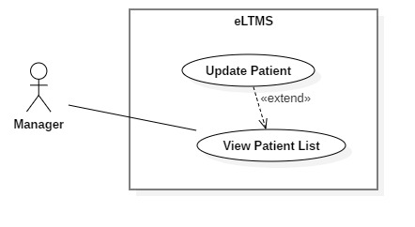

*Figure 29 - 2.3.6.3. <Manager> Update Patient*

**Use Case Specification**

|  |  |  |  |
| --- | --- | --- | --- |
| USE CASE - UC_14 | | | |
| Use Case No. | 14 | **Use Case Version** | 1.0 |
| Use Case Name | Update Patient | | |
| Author | DungTT | | |
| Date | 1/10/2018 | **Priority** | Normal |
| Actor:   * **Manager.**   Summary:   * **Update a Patient’s information.**   Goal:   * **Update a Patient’s information.**   Triggers:   * **User clicks on Edit button on the action column of the Patient’s row.**   Preconditions:   * **User logged in as Manager.**   Post Conditions:   * Success**: Show success message.** * Fail: **Show error message.**   Main Success Scenario:   |  |  |  | | --- | --- | --- | | **Step** | **Actor Action** | **System Response** | | **1** | Click on Edit button on the action column of the Patient’s row. | Show a popup, containing fields are filled with old information. | | **2** | Enter new formation of the Patient and click “Lưu” button. | Show success message. |   Exceptions:   |  |  |  | | --- | --- | --- | | **No** | **Cause** | **System Response** | | **1** | Full name is empty. | Show error message | | **2** | Phone number is empty. | Show error message. | | **3** | Date of birth is empty. | Show error message. | | **4** | Identity Card Number is empty. | Show error message. | | **5** | Full name is empty. | Show error message |   Relationships: **Extended from View Patient List**  Business Rules:   * **Full name: is not empty, max length is 200.** * **Phone number: is not empty, max length is 20.** * **Email: max length is 255.** * **Date of birth: is not empty.** * **Home Address: max length is 200.** * **Company Address: max length is 200.** * **Identity Card Number: is not empty, max length is 20.** | | | |

**<Manager> Delete Patient**

**Use Case Diagram**

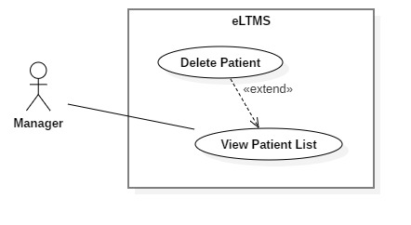

*Figure 29 - 2.3.6.4. <Manager> Delete Patient*

**Use Case Specification**

|  |  |  |  |
| --- | --- | --- | --- |
| USE CASE - UC_14 | | | |
| Use Case No. | 14 | **Use Case Version** | 1.0 |
| Use Case Name | Delete Patient | | |
| Author | DungTT | | |
| Date | 1/10/2018 | **Priority** | Normal |
| Actor:   * **Manager**   Summary:   * **Delete an existing Patient.**   Goal:   * **Delete an existing Patient.**   Triggers:   * **User clicks on Delete button on the action column of the Patient’s row.**   Preconditions:   * **User logged in as Manager.**   Post Conditions:   * Success**: Show success message.** * Fail: **Show error message.**   Main Success Scenario:   |  |  |  | | --- | --- | --- | | **Step** | **Actor Action** | **System Response** | | **1** | Click on Delete button on the action column of the Patient’s row. | Show confirm popup: “Bạn có chắc chắn muốn xóa?” | | **2** | Click “Có”. | Show success message. |   Alternative Scenario:   |  |  |  | | --- | --- | --- | | **Step** | **Actor Action** | **System Response** | | **1** | Click on Delete button on the action column of the Patient’s row. | Show confirm popup: “Bạn có chắc chắn muốn xóa?” | | **2** | Click “Không”. | Show error message. |   Exceptions:   |  |  |  | | --- | --- | --- | | **No** | **Cause** | **System Response** | | **1** | The Patient is deleted at the same time by another person. | Show error message. |   Relationships: **Extended from View Patient List use-case.**  Business Rules: **N/A.** | | | |

**<Manager> View Employee List**

**Use Case Diagram**

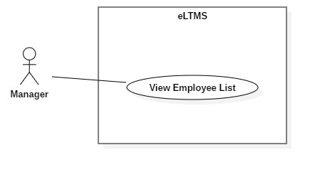

*Figure 29 - 2.3.6.1. <Manager> View Employee List*

**Use Case Specification**

|  |  |  |  |
| --- | --- | --- | --- |
| USE CASE - UC_14 | | | |
| Use Case No. | 14 | **Use Case Version** | 1.0 |
| Use Case Name | View Employee List | | |
| Author | DungTT | | |
| Date | 1/10/2018 | **Priority** | Normal |
| Actor:   * **Manager.**   Summary:   * **Display a list of Employees.**   Goal:   * **A table of Employees’ information, with search, filter and pagination controls.**   Triggers:   * **Display after user clicks on “Quản lý nhân viên” menu item.**   Preconditions:   * **User logged in as Manager.**   Post Conditions:   * Success**: A list of Employees is displayed.**   Main Success Scenario:   |  |  |  | | --- | --- | --- | | **Step** | **Actor Action** | **System Response** | | **1** | Logged in successfully as Manager. | Display a list of Employees. |   Alternative Scenario:   |  |  |  | | --- | --- | --- | | **Step** | **Actor Action** | **System Response** | | **1** | Is at another page and clicks on “Quản lý nhân viên” menu item. | Display a list of Employees. |   Exceptions:   |  |  |  | | --- | --- | --- | | **No** | **Cause** | **System Response** | | **1** | There are no data of Employees. | Show message: “Chưa có nhân viên nào.” |   Relationships: **N/A**  Business Rules: **N/A.** | | | |

**<Manager> Search Employee**

**Use Case Diagram**

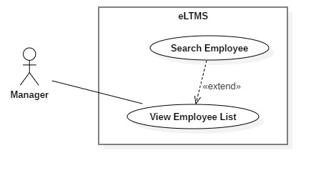

*Figure 29 - 2.3.6.2. <Manager> Search Employee*

**Use Case Specification**

|  |  |  |  |
| --- | --- | --- | --- |
| USE CASE - UC_14 | | | |
| Use Case No. | 14 | **Use Case Version** | 1.0 |
| Use Case Name | Search Employee | | |
| Author | DungTT | | |
| Date | 1/10/2018 | **Priority** | Normal |
| Actor:   * **Manager.**   Summary:   * **Search for Employees.**   Goal:   * **Search for Employees.**   Triggers:   * **User enters a search string into search text field.**   Preconditions:   * **User logged in as Manager.**   Post Conditions:   * Success**: Show search results.** * Fail: **Show text “Không tìm thấy kết quả nào”.**   Main Success Scenario:   |  |  |  | | --- | --- | --- | | **Step** | **Actor Action** | **System Response** | | **1** | Enter search string into search text field. Type Enter. | Display the search results in the table. |   Alternative Scenario:   |  |  |  | | --- | --- | --- | | **Step** | **Actor Action** | **System Response** | | **1** | Enter search string into search text field. Type Enter. | Display text messate: “Không tìm thấy kết quả.” |   Relationships: **Extended from View Employee List use-case.**  Business Rules:   * **Search results are Employees that contains the search string in Employee Code or Employee Name.** * **Search case-insensitively.** * **User can search by unsigned Vietnamese. Ex: User searches “Nguyen Van”, system can return “Nguyễn Văn” results.** | | | |

**<Manager> Create Employee**

**Use Case Diagram**

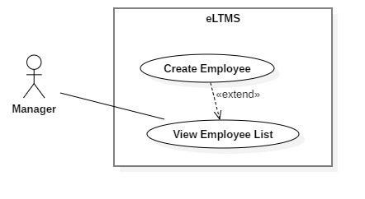

*Figure 29 - 2.3.6.2. <Manager> Create Employee*

**Use Case Specification**

|  |  |  |  |
| --- | --- | --- | --- |
| USE CASE - UC_14 | | | |
| Use Case No. | 14 | **Use Case Version** | 1.0 |
| Use Case Name | Create Employee | | |
| Author | DungTT | | |
| Date | 1/10/2018 | **Priority** | Normal |
| Actor:   * **Manager.**   Summary:   * **Create a new Employee.**   Goal:   * **Create a new Employee.**   Triggers:   * **User clicks “Thêm mới” Button.** * **User is at View Employee List page.**   Preconditions:   * **User logged in as Manager.**   Post Conditions:   * Success**: Show success message.** * Fail: **Show error message.**   Main Success Scenario:   |  |  |  | | --- | --- | --- | | **Step** | **Actor Action** | **System Response** | | **1** | Click on “Thêm mới” button. | Require information:   * Full name: text input * Gender: radio buttons * Phone number: text input * Email: text input * Date of birth: date input * Home Address: text input | | **2** | Input information and click “Lưu” button | Process and show message. |   Exceptions:   |  |  |  | | --- | --- | --- | | **No** | **Cause** | **System Response** | | **1** | Full name is empty. | Show error message | | **2** | Date of birth is in the future | Show error message |   Relationships: **Extended from View Employee List use-case.**  Business Rules:   * Full name: is not empty, max length is 200 * Phone number: max length is 20 * Email: max length is 255 * Date of birth: is not in the future * Home Address: max length is 500 | | | |

**<Manager> Update Employee**

**Use Case Diagram**

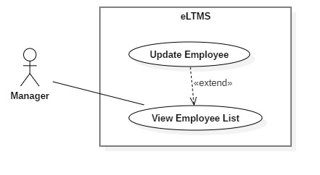

*Figure 29 - 2.3.6.3. <Manager> Update Employee*

**Use Case Specification**

|  |  |  |  |
| --- | --- | --- | --- |
| USE CASE - UC_14 | | | |
| Use Case No. | 14 | **Use Case Version** | 1.0 |
| Use Case Name | Update Employee | | |
| Author | DungTT | | |
| Date | 1/10/2018 | **Priority** | Normal |
| Actor:   * **Manager.**   Summary:   * **Update a Employee’s information.**   Goal:   * **Update a Employee’s information.**   Triggers:   * **User clicks on Edit button on the action column of the Employee’s row.**   Preconditions:   * **User logged in as Manager.**   Post Conditions:   * Success**: Show success message.** * Fail: **Show error message.**   Main Success Scenario:   |  |  |  | | --- | --- | --- | | **Step** | **Actor Action** | **System Response** | | **1** | Click on Edit button on the action column of the Employee’s row. | Show a popup, containing fields are filled with old information. | | **2** | Enter new formation of the Employee and click “Lưu” button. | Show success message. |   Exceptions:   |  |  |  | | --- | --- | --- | | **No** | **Cause** | **System Response** | | **1** | Full name is empty. | Show error message | | **2** | Date of birth is in the future | Show error message |   Relationships: **Extended from View Employee List**  Business Rules:   * Full name: is not empty, max length is 200 * Phone number: max length is 20 * Email: max length is 255 * Date of birth: is not in the future * Home Address: max length is 500 | | | |

**<Manager> Delete Employee**

**Use Case Diagram**

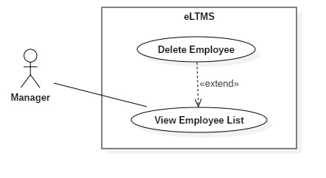

*Figure 29 - 2.3.6.4. <Manager> Delete Employee*

**Use Case Specification**

|  |  |  |  |
| --- | --- | --- | --- |
| USE CASE - UC_14 | | | |
| Use Case No. | 14 | **Use Case Version** | 1.0 |
| Use Case Name | Delete Employee | | |
| Author | DungTT | | |
| Date | 1/10/2018 | **Priority** | Normal |
| Actor:   * **Manager**   Summary:   * **Delete an existing Employee.**   Goal:   * **Delete an existing Employee.**   Triggers:   * **User clicks on Delete button on the action column of the Employee’s row.**   Preconditions:   * **User logged in as Manager.**   Post Conditions:   * Success**: Show success message.** * Fail: **Show error message.**   Main Success Scenario:   |  |  |  | | --- | --- | --- | | **Step** | **Actor Action** | **System Response** | | **1** | Click on Delete button on the action column of the Employee’s row. | Show confirm popup: “Bạn có chắc chắn muốn xóa?” | | **2** | Click “Có”. | Show success message. |   Alternative Scenario:   |  |  |  | | --- | --- | --- | | **Step** | **Actor Action** | **System Response** | | **1** | Click on Delete button on the action column of the Employee’s row. | Show confirm popup: “Bạn có chắc chắn muốn xóa?” | | **2** | Click “Không”. | Show error message. |   Exceptions:   |  |  |  | | --- | --- | --- | | **No** | **Cause** | **System Response** | | **1** | The Employee is deleted at the same time by another person. | Show error message. |   Relationships: **Extended from View Employee List use-case.**  Business Rules: **N/A.** | | | |

**Lab Technician Overview Use Case**

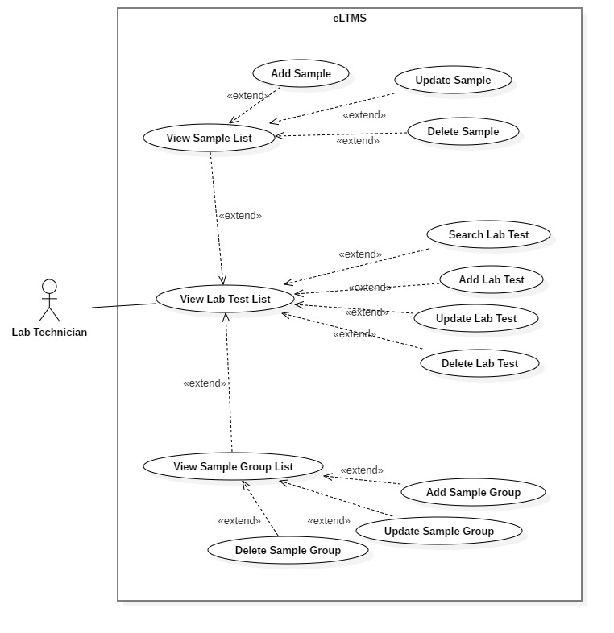

*Figure 28 - Lab Technician Overview Use Case*

**Software System Attribute**

* 1. **Usability**
* User website and mobile app: User can make appointment at the first time of using.
* Admin website: 90% employees can work with the system rightly after less than 8 hours of training.
  1. **Reliability**
* The rate of failure occurrence shall be 1/1500 (1 occurrence in 1500 days – nearly 3 years).
* The number of sending notification failure is 1 time per 1000 notifications.
* The data should be backed up every day.
  1. **Availability**
* System is divided into modules, if a module is down, it will not affect others.
* The system can be adapted for a large number of request (maximum 100 users at the same time).
  1. **Security**
* Privacy: Each role of user has a specific permission to interact with system.
* System always checks authorization and authentication before doing anything.
* Only admin can grant permission to other roles.
  1. **Maintainability**
* The system is divided into separate modules.
* The source code is easy to maintain and upgrade.
  1. **Portability**
* The web application is running on desktop, tablet and mobile.

**Conceptual Diagram**

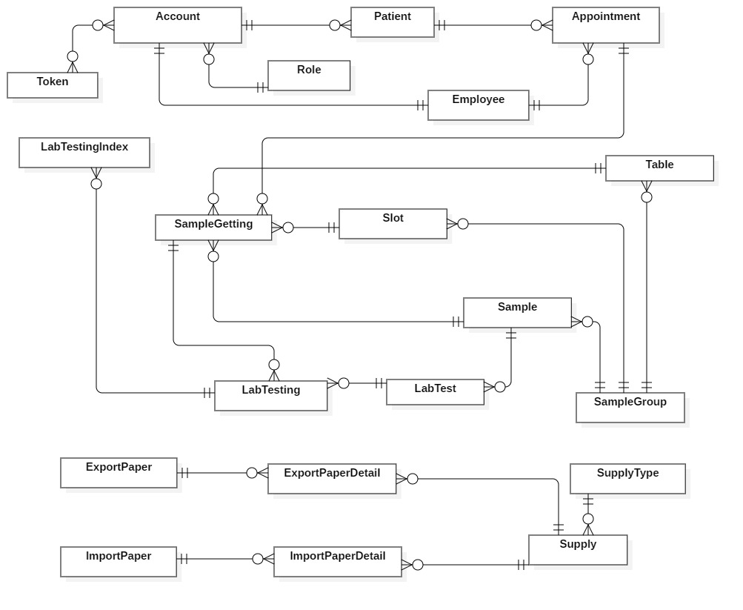

*Figure 31 - Conceptual Diagram*

**Data Dictionary**

|  |  |
| --- | --- |
| Entity Data dictionary: describe all content of all entities | |
| **Entity Name** | **Description** |
| Account | Contain account information |
| Appointment | Contain Appointment information |
| Employee | Contain staff’s information |
| ExportPaper | Contain Export Paper information |
| ExportPaperDetail | Contain Export Paper Detail information |
| ImportPaper | Contain information about Import Paper |
| ImportPaperDetail | Contain Import Paper Detail information |
| LabTest | Contain Lab Test information |
| LabTesting | Contain information about Lab Testing |
| LabTestingIndex | Contain transaction information of Lab Testing Index |
| Patient | Contain Patient information |
| Role | Contain Role information |
| Sample | Contain Sample information |
| SampleGetting | Contain Sample Getting information |
| SampleGroup | Contain Sample Group information |
| Slot | Contain Slot information |
| Supply | Contain Supply information |
| SupplyType | Contain Supply Type information |
| Table | Contain Table information |
| Token | Contain Token information |

*Table 1 - Data dictionary*

# **Software Design Description**

## **Design Overview**

This document describes the technical and user interface design of Building the laboratory tests management system (eLTMS).

Document overview:

Section 2: gives an overall description of the system architecture design.

Section 3: gives component diagrams that describe the connection and integration of the system.

Section 4: gives the details design description which includes class diagram, class explanation, and sequence diagram to details the application functions.

Section 5: describes screens design.

Section 6: describes a fully attributed ERD.

Section 7: describes algorithms.

## **System Architectural Design**

Our system has been developed under the 3-layer architecture. The 3-layer architecture is different from the 3-tier architecture, because 3 components are separated logically (can be deployed on the same server), not physically (on different servers).

We choose this architecture for our system because of following advantages:

* **Speed of development:** a specific layer can be upgraded with minimal impact on the other layers.
* **Scalability**: By separating out the different layers we can scale each independently depending on the need at any given time.
* **Performance:** This allows you to load balance each layer independently, improving overall performance with minimal resources.

The 3-layer architecture consists of:

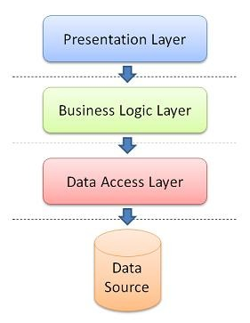

Figure 1 - System Architecture Design

* **Presentation Layer:** consists of the user interface. This user interface is often a graphical one accessible through a web browser or web-based application and which displays content and information useful to an end user.
* **Business Logic Layer:** contains the functional business logic which drives an application’s core capabilities.
* **Data Access Layer:** provides simplified access to data source.

## **Component Diagram**

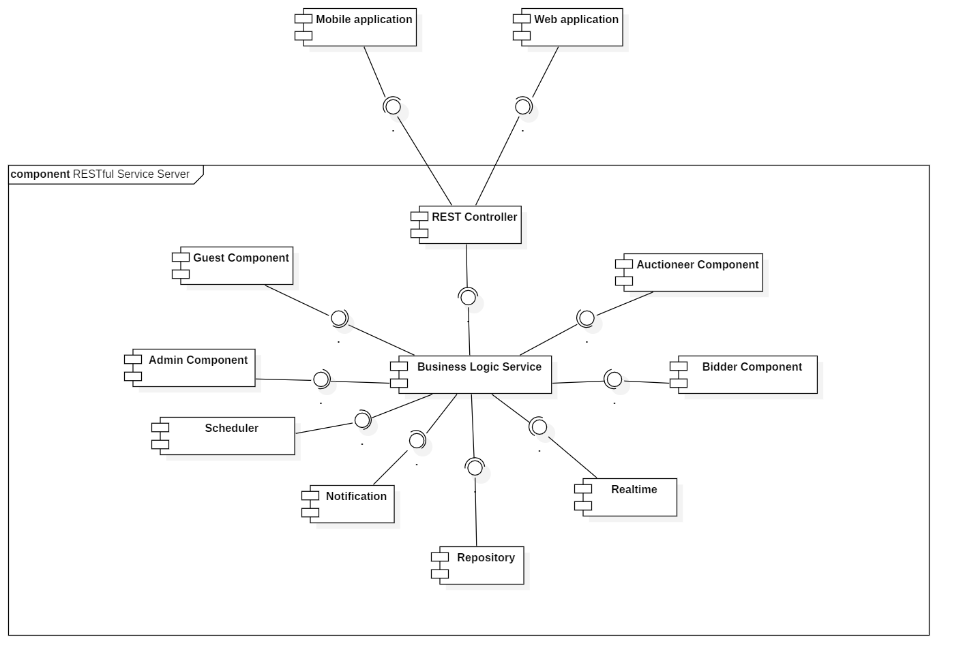

Figure 2 - Component Diagram

|  |  |
| --- | --- |
| COMPONENT DICTIONARY: DESCRIBES COMPONENTS | |
| Mobile Application | Component to contain system’s functions for end user on mobile device |
| Web Application | Component to contain system’s functions for end user on web |
| REST Controller | Component to receive requests, call services to process information, get data back from services and respond result to clients |
| Business Logic Service | Component to handle system’s business operations |
| Guest Component | Component to handle guest’s activities in the system |
| Admin Component | Component to handle admin’s activities in the system |
| Bidder Component | Component to handle bidder’s activities in the system |
| Auctioneer Component | Component to handle auctioneer’s activities in the system |
| Scheduler | Component to handle scheduling future tasks |
| Realtime | Component to handle realtime operations |
| Notification | Component to handle sending notifications |
| Repository Component | Component to handle data reading/writing operations from/to database |

Table 1 - Component Dictionary

## **Details Description**

### Class Diagram

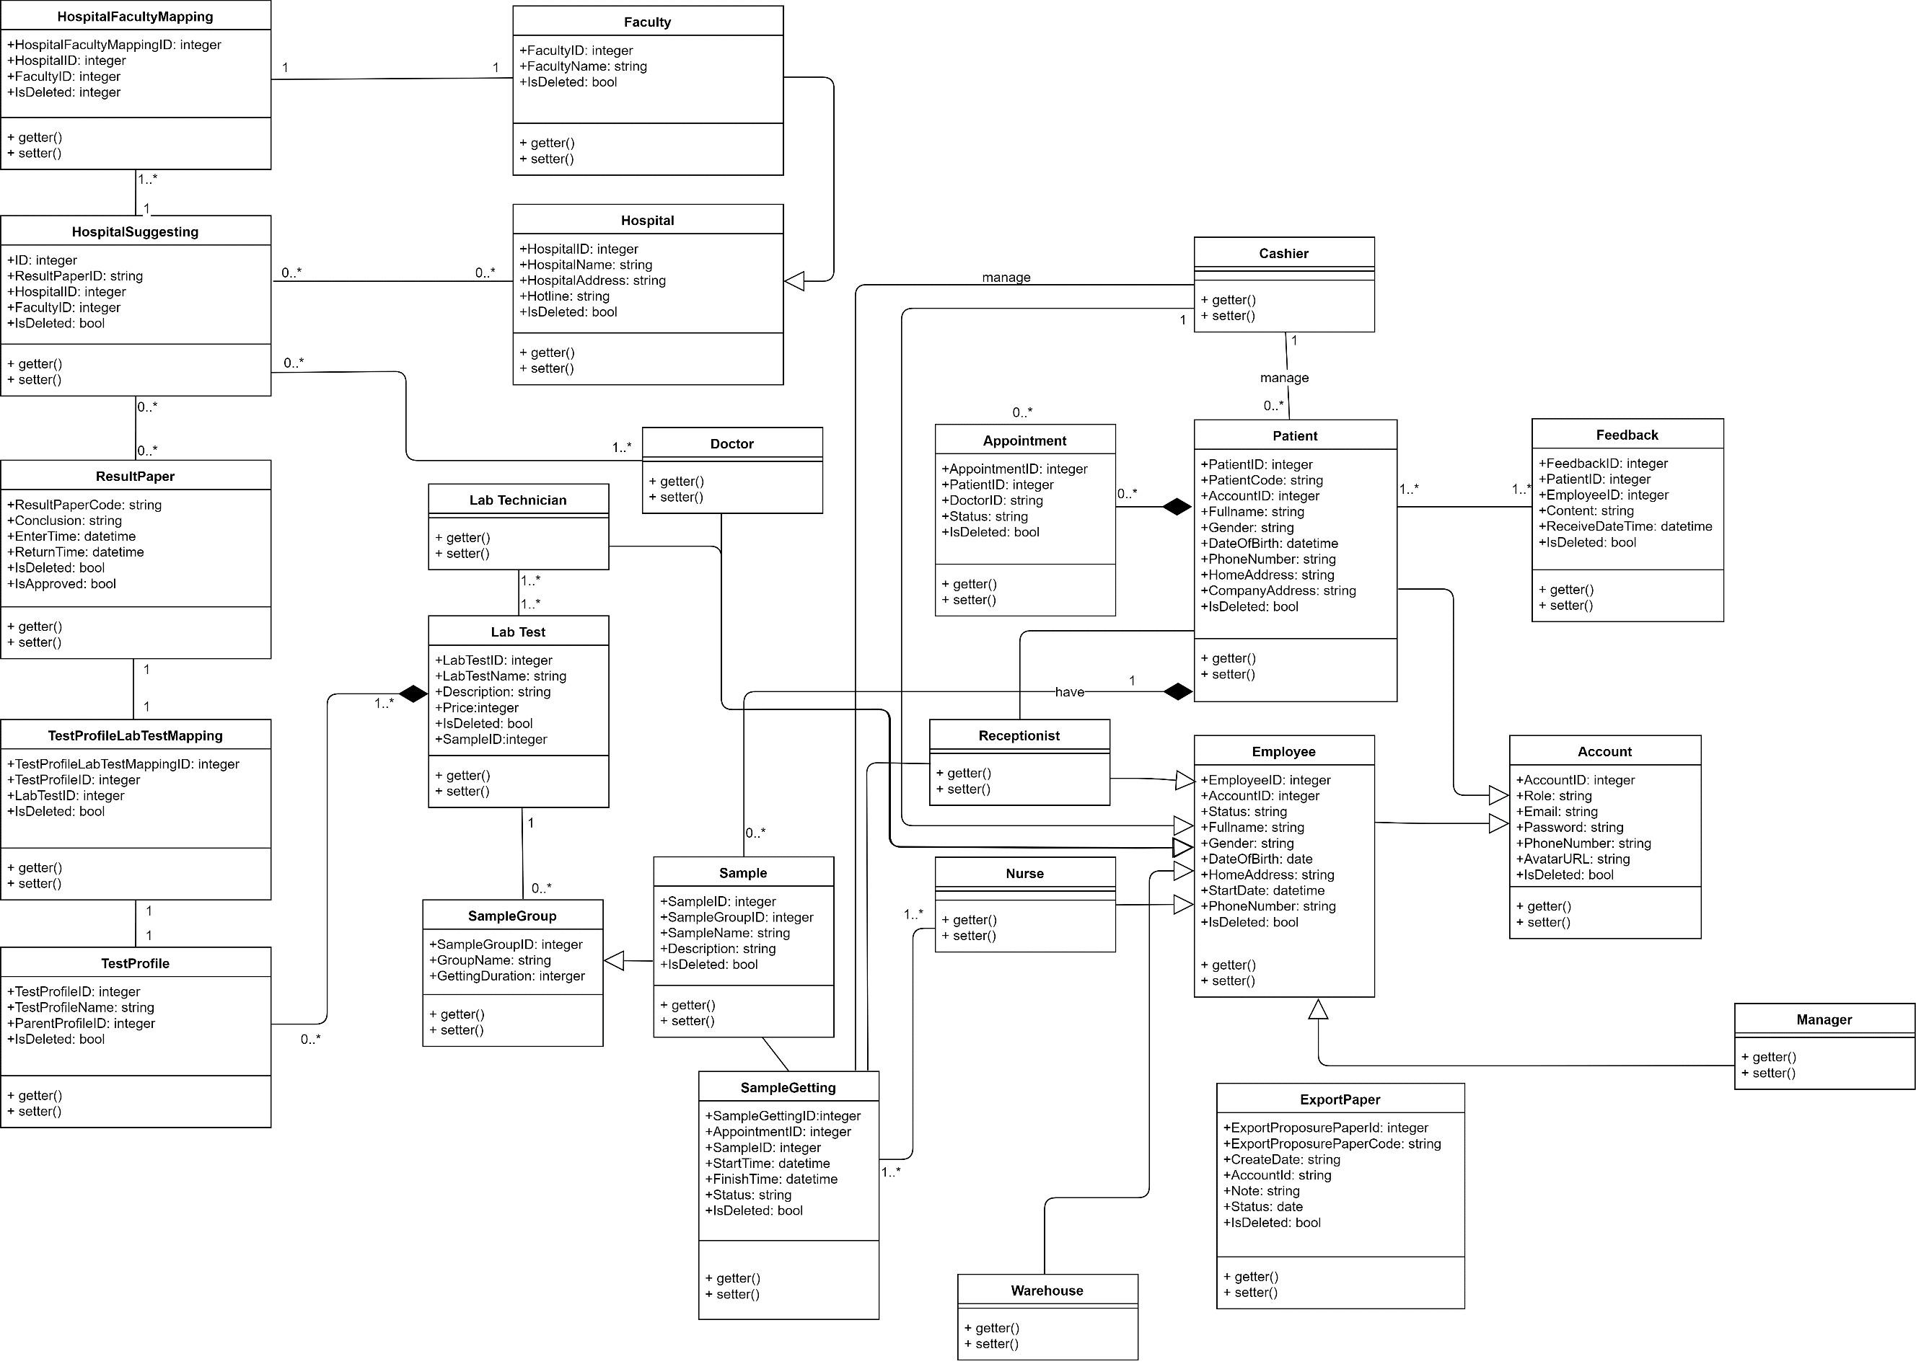

Figure 3 - Class Diagram

|  |  |
| --- | --- |
| CLASS DICTIONARY: DESCRIBE CLASS | |
| Class Name | **Description** |
| Patient | Patient |
| Employee | Employee |
| Feedback | Feedback |
| Account | Account |
| Manager | Manager |
| Receptionist | Receptionist |
| Appointment | Appointment |
| ExportPaperDetail | ExportPaperDetail |
| ExportPaper | ExportPaper |
| Supply | Supply |
| SupplyType | SupplyType |
| ImportPaperDetail | ImportPaperDetail |

Table 2 - Class Dictionary

### Class Diagram Explanation

#### Account

**Attribute**

|  |  |  |  |
| --- | --- | --- | --- |
| Attribute | Type | Visibility | Description |
| AccountID | integer | public | Unique identifier of an account |
| Role | string | public | Account’s Role |
| Email | string | public | Account’s Email |
| Password | string | public | Account’s Password |
| PhoneNumber | string | public | Account’s Phone number |
| AvatarURL | string | public | Account’s AvatarURL |
| IsDeleted | bool | public | Account’s IsDeleted |

Table 64 Account attribute explanation

**Method**

|  |  |  |  |
| --- | --- | --- | --- |
| Method | Return type | Visibility | Description |
| getter() | string | public | get attribute value |
| setter() | void | public | return value of attribute |
| checkLogin() | Boolean | public | check Account’s phone and password |
| register() | Boolean | public | register new user account |

Table 65 Account method explanation

#### Feedback (removed)

**Attribute**

|  |  |  |  |
| --- | --- | --- | --- |
| Attribute | Type | Visibility | Description |
| FeedbackID | integer | public | Unique identifier of a feedback |
| PatientID | integer | public | Feedback’s Patient |
| EmployeeID | integer | public | Feedback’s Employee |
| Content | string | public | Feedback’s Content |
| ReceiveDateTime | datetime | public | Feedback’s Date Receive |
| IsDeleted | bool | public | Feedback’s IsDeleted |

Table 66 Feedback attribute explanation

**Method**

|  |  |  |  |
| --- | --- | --- | --- |
| Method | Return type | Visibility | Description |
| getter() | string | public | get attribute value |
| setter() | void | public | return value of attribute |

Table 67 Feedback method explanation

#### Manager (removed)

**Attribute**

|  |  |  |  |
| --- | --- | --- | --- |
| Attribute | Type | Visibility | Description |
|  |  |  |  |

Table 68 Manager attribute explanation

**Method**

|  |  |  |  |
| --- | --- | --- | --- |
| Method | Return type | Visibility | Description |
| getter() | string | public | get attribute value |
| setter() | void | public | return value of attribute |

Table 69 Manager method explanation

#### ExportPaper

**Attribute**

|  |  |  |  |
| --- | --- | --- | --- |
| Attribute | Type | Visibility | Description |
| ExportProposurePaperId | integer | public | Unique identifier of an Export Paper |
| ExportProposurePaperCode | string | public | ExportPaper’s Code |
| CreateDate | datetime | public | ExportPaper’s CreateDate |
| AccountId | integer | public | ExportPaper’s Account |
| Note | string | public | ExportPaper’s Note |
| Status | string | public | ExportPaper’s Status |
| IsDeleted | bool | public | ExportPaper’s IsDeleted |

Table 70 Export Paper attribute explanation

**Method**

|  |  |  |  |
| --- | --- | --- | --- |
| Method | Return type | Visibility | Description |
| getter() | string | public | get attribute value |
| setter() | void | public | return value of attribute |

Table 71 Export Paper method explanation

#### SupplyType

**Attribute**

|  |  |  |  |
| --- | --- | --- | --- |
| Attribute | Type | Visibility | Description |
| SupplyTypeID | integer | public | Unique identifier of a Supply Type |
| SupplyTypeName | integer | public | SupplyType’s Name |
| IsDeleted | bool | public | SupplyType’s IsDeleted |

Table 72 Supply Type attribute explanation

**Method**

|  |  |  |  |
| --- | --- | --- | --- |
| Method | Return type | Visibility | Description |
| getter() | string | public | get attribute value |
| setter() | void | public | return value of attribute |

Table 73 Supply Type method explanation

#### Patient (removed)

**Attribute**

|  |  |  |  |
| --- | --- | --- | --- |
| Attribute | Type | Visibility | Description |
| PatientID | integer | public | Unique identifier of a Patient |
| PatientCode | string | public | Patient’s Code |
| AccountID | integer | public | Patient’s Account |
| Fullname | string | public | Patient’s Name |
| Gender | string | public | Patient’s Gender |
| DateOfBirth | datetime | public | Patient’s BirthDay |
| PhoneNumber | string | public | Patient’s Phone |
| HomeAddress | string | public | Patient’s Home Address |
| CompanyAddress | string | public | Patient’s Company Address |
| IsDeleted | bool | public | Patient’s IsDeleted |

Table 74 Patient attribute explanation

**Method**

|  |  |  |  |
| --- | --- | --- | --- |
| Method | Return type | Visibility | Description |
| getter() | string | public | get attribute value |
| setter() | void | public | return value of attribute |

Table 75 Patient method explanation

#### Employee (removed)

**Attribute**

|  |  |  |  |
| --- | --- | --- | --- |
| Attribute | Type | Visibility | Description |
| EmployeeID | integer | public | Unique identifier of an Employee |
| AccountID | integer | public | Employee’s Account |
| Status | string | public | Employee’s Status |
| Fullname | string | public | Employee’s Name |
| Gender | string | public | Employee’s Gender |
| DateOfBirth | datetime | public | Employee’s BirthDay |
| PhoneNumber | string | public | Employee’s Phone |
| HomeAddress | string | public | Employee’s Home Address |
| StartDay | datetime | public | Employee’s Start Day |
| IsDeleted | bool | public | Employee’s IsDeleted |

Table 76 Employee attribute explanation

**Method**

|  |  |  |  |
| --- | --- | --- | --- |
| Method | Return type | Visibility | Description |
| getter() | string | public | get attribute value |
| setter() | void | public | return value of attribute |

Table 77 Employee method explanation

#### ExportPaperDetail

**Attribute**

|  |  |  |  |
| --- | --- | --- | --- |
| Attribute | Type | Visibility | Description |
| ExportProposurePaperDetailId | integer | public | Unique identifier of an Export Paper Detail |
| ExportProposurePaperId | integer | public | ExportPaperDetail’s Export Proposer Paper |
| SuppliesId | integer | public | ExportPaperDetail’s Supply |
| Unit | string | public | ExportPaperDetail’s Unit |
| Quantity | integer | public | ExportPaperDetail’s Quantity |
| Note | string | public | ExportPaperDetail’s Note |
| IsDeleted | bool | public | ExportPaperDetail’s IsDeleted |

Table 78 Export Paper Detail attribute explanation

**Method**

|  |  |  |  |
| --- | --- | --- | --- |
| Method | Return type | Visibility | Description |
| getter() | string | public | get attribute value |
| setter() | void | public | return value of attribute |

Table 79 Export Paper Detail method explanation

#### Supply

**Attribute**

|  |  |  |  |
| --- | --- | --- | --- |
| Attribute | Type | Visibility | Description |
| SuppliesId | integer | public | Unique identifier of a Supply |
| SuppliesCode | string | public | Supply’s Code |
| SuppliesName | string | public | Supply’s Name |
| Unit | string | public | Supply’s Unit |
| Quantity | integer | public | Supply’s Quantity |
| Note | string | public | Supply’s Note |
| IsDeleted | bool | public | Supply’s IsDeleted |

Table 80 Supply attribute explanation

**Method**

|  |  |  |  |
| --- | --- | --- | --- |
| Method | Return type | Visibility | Description |
| getter() | string | public | get attribute value |
| setter() | void | public | return value of attribute |

Table 81 Supply method explanation

#### Appointment

**Attribute**

|  |  |  |  |
| --- | --- | --- | --- |
| Attribute | Type | Visibility | Description |
| AppointmentID | integer | public | Unique identifier of a Appointment |
| PatientID | integer | public | Appointment’s Patient |
| DoctorID | string | public | Appointment’s Doctor |
| Status | string | public | Appointment’s Status |
| IsDeleted | bool | public | Appointment’s IsDeleted |

Table 82 Appointment attribute explanation

**Method**

|  |  |  |  |
| --- | --- | --- | --- |
| Method | Return type | Visibility | Description |
| getter() | string | public | get attribute value |
| setter() | void | public | return value of attribute |

Table 83 Appointment method explanation

#### R**ecepti**onist (removed)

**Attribute**

|  |  |  |  |
| --- | --- | --- | --- |
| Attribute | Type | Visibility | Description |
|  |  |  |  |

Table 84 Receptionist attribute explanation

**Method**

|  |  |  |  |
| --- | --- | --- | --- |
| Method | Return type | Visibility | Description |
| getter() | string | public | get attribute value |
| setter() | void | public | return value of attribute |

Table 85 Receptionist method explanation

#### Nurse (removed)

**Attribute**

|  |  |  |  |
| --- | --- | --- | --- |
| Attribute | Type | Visibility | Description |
|  |  |  |  |

Table 86 Nurse attribute explanation

**Method**

|  |  |  |  |
| --- | --- | --- | --- |
| Method | Return type | Visibility | Description |
| getter() | string | public | get attribute value |
| setter() | void | public | return value of attribute |

Table 87 Nurse method explanation

#### Warehouse Keepper (removed)

**Attribute**

|  |  |  |  |
| --- | --- | --- | --- |
| Attribute | Type | Visibility | Description |
|  |  |  |  |

Table 88 Warehouse Keepper attribute explanation

**Method**

|  |  |  |  |
| --- | --- | --- | --- |
| Method | Return type | Visibility | Description |
| getter() | string | public | get attribute value |
| setter() | void | public | return value of attribute |

Table 89 Warehouse Keepper method explanation

#### ImportPaperDetail

**Attribute**

|  |  |  |  |
| --- | --- | --- | --- |
| Attribute | Type | Visibility | Description |
| ImportPaperDetailId | integer | public | Unique identifier of an Import Paper Detail |
| ImportPaperId | integer | public | ImportPaperDetail’s Import Paper |
| SuppliesId | integer | public | ImportPaperDetail’s Supply |
| Unit | string | public | ImportPaperDetail’s Unit |
| Quantity | integer | public | ImportPaperDetail’s Quantity |
| Note | string | public | ImportPaperDetail’s Note |
| IsDeleted | bool | public | ImportPaperDetail’s IsDeleted |

Table 90 Import Paper Detail attribute explanation

**Method**

|  |  |  |  |
| --- | --- | --- | --- |
| Method | Return type | Visibility | Description |
| getter() | string | public | get attribute value |
| setter() | void | public | return value of attribute |

Table 91 Import Paper Detail method explanation

#### Department (removed)

**Attribute**

|  |  |  |  |
| --- | --- | --- | --- |
| Attribute | Type | Visibility | Description |
| DepartmentID | integer | public | Unique identifier of an Department |
| DepartmentName | string | public | Department’s Name |
| IsDeleted | bool | public | Department’s IsDeleted |

Table 92 Department attribute explanation

**Method**

|  |  |  |  |
| --- | --- | --- | --- |
| Method | Return type | Visibility | Description |
| getter() | string | public | get attribute value |
| setter() | void | public | return value of attribute |

Table 93 Department method explanation

#### Hospital (removed)

**Attribute**

|  |  |  |  |
| --- | --- | --- | --- |
| Attribute | Type | Visibility | Description |
| HospitalID | integer | public | Unique identifier of a Hospital |
| HospitalName | string | public | Hospital’s Name |
| HospitalAddress | bool | public | Hospital’s Address |
| Hotline | string | public | Hospital’s Hotline |
| IsDeleted | bool | public | Hospital’s IsDeleted |

Table 94 Hospital attribute explanation

**Method**

|  |  |  |  |
| --- | --- | --- | --- |
| Method | Return type | Visibility | Description |
| getter() | string | public | get attribute value |
| setter() | void | public | return value of attribute |

Table 95 Hospital method explanation

#### Doctor (removed)

**Attribute**

|  |  |  |  |
| --- | --- | --- | --- |
| Attribute | Type | Visibility | Description |
|  |  |  |  |

Table 96 Doctor attribute explanation

**Method**

|  |  |  |  |
| --- | --- | --- | --- |
| Method | Return type | Visibility | Description |
| getter() | string | public | get attribute value |
| setter() | void | public | return value of attribute |

Table 97 Doctor method explanation

#### Sample

**Attribute**

|  |  |  |  |
| --- | --- | --- | --- |
| Attribute | Type | Visibility | Description |
| SampleID | integer | public | Unique identifier of a Sample |
| SampleGroupID | integer | public | Sample’s Group |
| SampleName | string | public | Sample’s Name |
| Description | string | public | Sample’s Description |
| IsDeleted | bool | public | Hospital’s IsDeleted |

Table 98 Sample attribute explanation

**Method**

|  |  |  |  |
| --- | --- | --- | --- |
| Method | Return type | Visibility | Description |
| getter() | string | public | get attribute value |
| setter() | void | public | return value of attribute |

Table 99 Sample method explanation

#### SampleGetting

**Attribute**

|  |  |  |  |
| --- | --- | --- | --- |
| Attribute | Type | Visibility | Description |
| SampleGettingID | integer | public | Unique identifier of a SampleGetting |
| SampleGroupID | integer | public | Sample’s Group |
| SampleName | string | public | Sample’s Name |
| Description | string | public | Sample’s Description |
| IsDeleted | bool | public | Hospital’s IsDeleted |

Table 100 SampleGetting attribute explanation

**Method**

|  |  |  |  |
| --- | --- | --- | --- |
| Method | Return type | Visibility | Description |
| getter() | string | public | get attribute value |
| setter() | void | public | return value of attribute |

Table 101 SampleGetting method explanation

#### ImportPaper

**Attribute**

|  |  |  |  |
| --- | --- | --- | --- |
| Attribute | Type | Visibility | Description |
| ImportPaperId | integer | public | Unique identifier of an Import Paper |
| ImportPaperCode | string | public | ImportPaper’s Code |
| CreateDate | datetime | public | ImportPaper’s CreateDate |
| AccountId | integer | public | ImportPaper’s Account |
| Note | string | public | ImportPaper’s Note |
| Status | string | public | ImportPaper’s Status |
| IsDeleted | bool | public | ImportPaper’s IsDeleted |

Table 102 Import Paper attribute explanation

**Method**

|  |  |  |  |
| --- | --- | --- | --- |
| Method | Return type | Visibility | Description |
| getter() | string | public | get attribute value |
| setter() | void | public | return value of attribute |

Table 103 Import Paper method explanation

#### Lab Technician (removed)

**Attribute**

|  |  |  |  |
| --- | --- | --- | --- |
| Attribute | Type | Visibility | Description |
|  |  |  |  |

Table 104 Lab Technician attribute explanation

**Method**

|  |  |  |  |
| --- | --- | --- | --- |
| Method | Return type | Visibility | Description |
| getter() | string | public | get attribute value |
| setter() | void | public | return value of attribute |

Table 105 Lab Technician method explanation

#### Lab Test

**Attribute**

|  |  |  |  |
| --- | --- | --- | --- |
| Attribute | Type | Visibility | Description |
| LabTestID | integer | public | Unique identifier of a Lab Test |
| LabTestName | string | public | Labtest’s Name |
| Description | string | public | Labtest’s Description |
| Price | integer | public | Labtest’s Price |
| SampleID | integer | public | Labtest’s Sample |
| IsDeleted | bool | public | Labtest’s IsDeleted |

Table 106 Lab Test attribute explanation

**Method**

|  |  |  |  |
| --- | --- | --- | --- |
| Method | Return type | Visibility | Description |
| getter() | string | public | get attribute value |
| setter() | void | public | return value of attribute |

Table 107 Lab Test method explanation

#### SampleGroup

**Attribute**

|  |  |  |  |
| --- | --- | --- | --- |
| Attribute | Type | Visibility | Description |
| SampleGroupID | integer | public | Unique identifier of a Sample Group |
| GroupName | string | public | Sample Group’s Name |
| GettingDuration | integer | public | Sample Group’s Duration |

Table 108 Sample Group attribute explanation

**Method**

|  |  |  |  |
| --- | --- | --- | --- |
| Method | Return type | Visibility | Description |
| getter() | string | public | get attribute value |
| setter() | void | public | return value of attribute |

Table 109 Sample Group method explanation

#### Hospita**lDepartment**Mapping (removed)

**Attribute**

|  |  |  |  |
| --- | --- | --- | --- |
| Attribute | Type | Visibility | Description |
| HospitalDepartmentMappingID | integer | public | Unique identifier of a Hospital Department Mapping |
| HospitalID | integer | public | HospitalDepartment’s ID |
| DepartmentID | integer | public | HospitalDepartment’s Department |
| IsDeleted | bool | public | HospitalDepartment’s IsDeleted |

Table 110 Hospital Department attribute explanation

**Method**

|  |  |  |  |
| --- | --- | --- | --- |
| Method | Return type | Visibility | Description |
| getter() | string | public | get attribute value |
| setter() | void | public | return value of attribute |

Table 111 Hospital Department method explanation

#### Hospital**Suggesti**ng (removed)

**Attribute**

|  |  |  |  |
| --- | --- | --- | --- |
| Attribute | Type | Visibility | Description |
| ID | integer | public | Unique identifier of a Hospital Suggest |
| ResultPaperID | string | public | HospitalSuggest’s Result Paper |
| HospitalID | integer | public | HospitalSuggest’s Hospital |
| DepartmentID | integer |  | HospitalSuggest’s Department |
| IsDeleted | bool | public | HospitalDepartment’s IsDeleted |

Table 112 Hospital Suggestion attribute explanation

**Method**

|  |  |  |  |
| --- | --- | --- | --- |
| Method | Return type | Visibility | Description |
| getter() | string | public | get attribute value |
| setter() | void | public | return value of attribute |

Table 113 Hospital Suggestion method explanation

#### **ResultPa**per (removed)

**Attribute**

|  |  |  |  |
| --- | --- | --- | --- |
| Attribute | Type | Visibility | Description |
| ResultPaperCode | integer | public | Unique identifier of a Result Paper |
| Conclusion | string | public | ResultPaper’s Conclusion |
| EnterTime | integer | public | ResultPaper’s EnterTime |
| ReturnTime | integer | public | ResultPaper’s ReturnTime |
| IsApproved | bool | public | ResultPaper’s IsApproved |
| IsDeleted | bool | public | ResultPaper’s IsDeleted |

Table 114 Result Paper attribute explanation

**Method**

|  |  |  |  |
| --- | --- | --- | --- |
| Method | Return type | Visibility | Description |
| getter() | string | public | get attribute value |
| setter() | void | public | return value of attribute |

Table 115 Result Paper method explanation

#### TestProfileLabTestMapping (removed)

|  |  |  |  |
| --- | --- | --- | --- |
| Attribute | Type | Visibility | Description |
| TestProfileLabTestMappingID | integer | public | Unique identifier of a Test Profile Lab Test |
| TestProfileID | integer | public | TestProfileLabTestMapping’s Test Profile |
| LabTestID | integer | public | TestProfileLabTestMapping’s Lab |
| IsDeleted | bool | public | TestProfileLabTestMapping’s IsDeleted |

Table 116 Test Profile Lab Test Mapping attribute explanation

**Method**

|  |  |  |  |
| --- | --- | --- | --- |
| Method | Return type | Visibility | Description |
| getter() | string | public | get attribute value |
| setter() | void | public | return value of attribute |

Table 117 Test Profile Lab Test Mapping method explanation

#### Tes**tPr**ofile

**Attribute**

|  |  |  |  |
| --- | --- | --- | --- |
| Attribute | Type | Visibility | Description |
| TestProfileID | integer | public | Unique identifier of a Test Profile |
| TestProfileName | string | public | TestProfile’s Name |
| ParentProfileID | integer | public | TestProfile’s Profile |
| IsDeleted | bool | public | TestProfile’s IsDeleted |

Table 118 Test Profile attribute explanation

**Method**

|  |  |  |  |
| --- | --- | --- | --- |
| Method | Return type | Visibility | Description |
| getter() | string | public | get attribute value |
| setter() | void | public | return value of attribute |

Table 119 Test Profile method explanation

### Interactive Diagram

#### Guest

##### Login

Summary: this diagram shows process for login.

x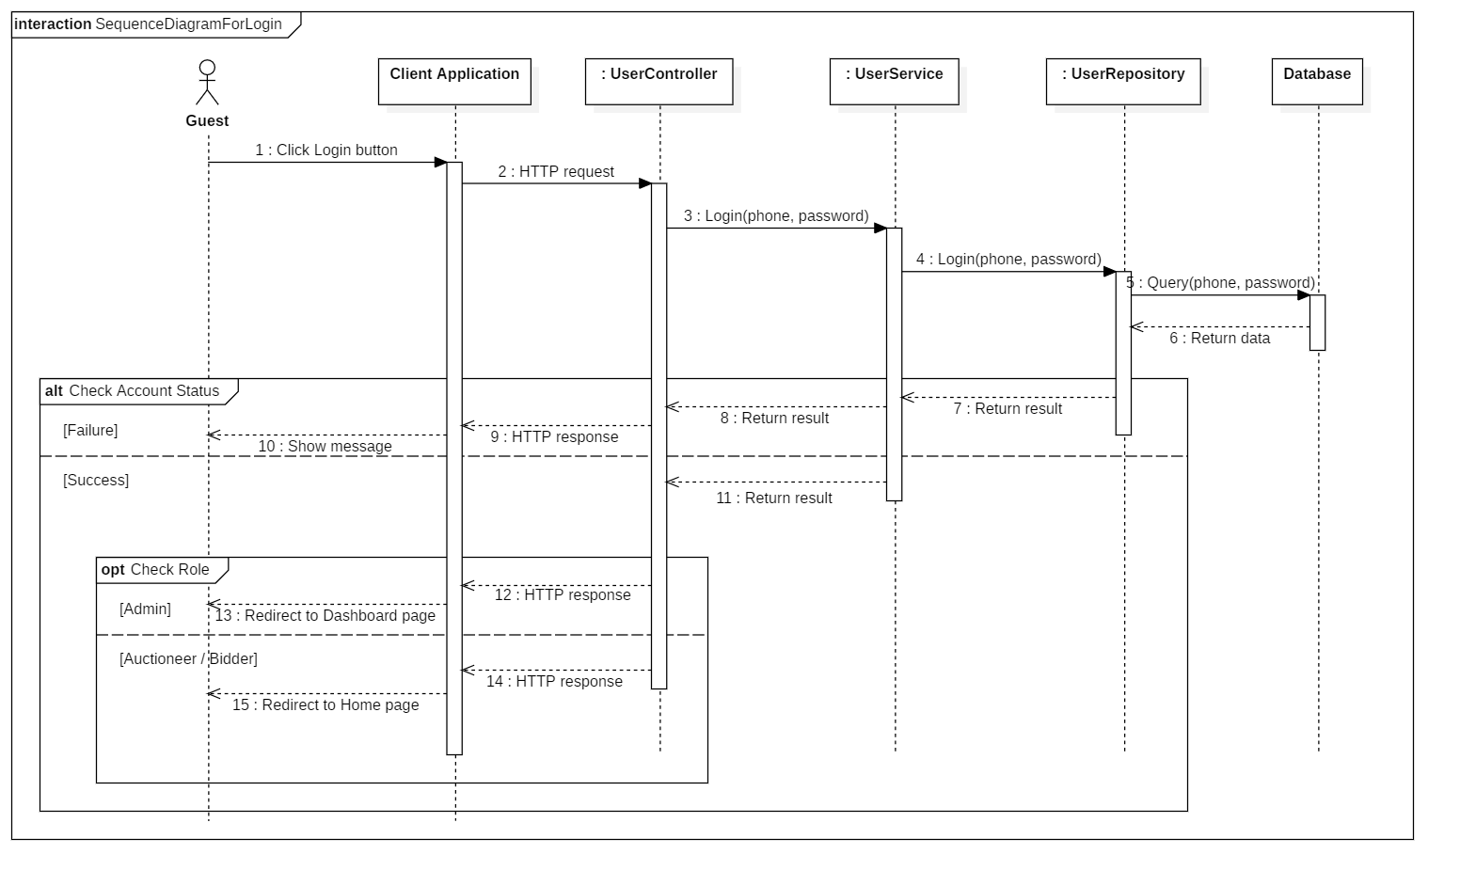

Figure 4 - Sequence Diagram for Login < Guest >

##### Register account

Summary: this diagram shows process for register account.

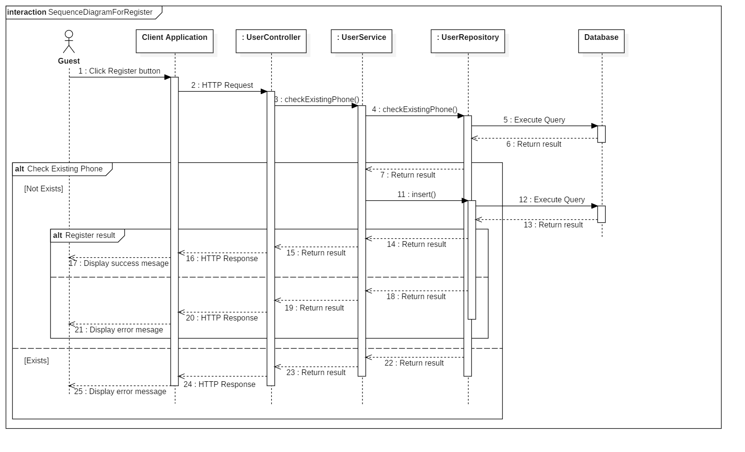

Figure 5 - Sequence Diagram for Register Account < Guest >

##### Search Auctions

Summary: this diagram shows process for search auctions (by keyword/ category).

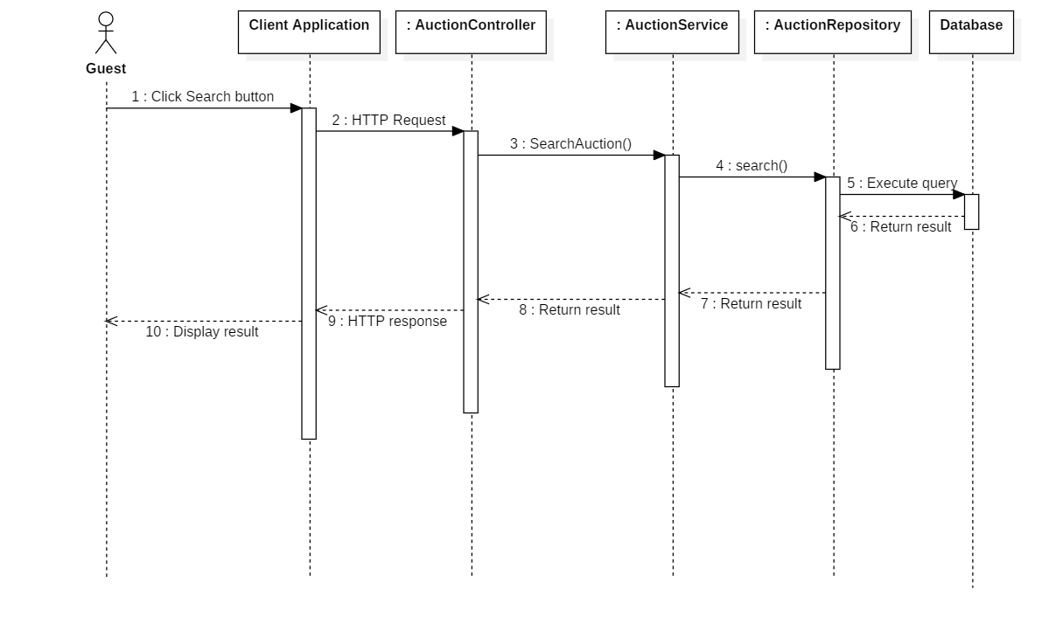

Figure 6 - Sequence Diagram for Search Auctions < Guest >

##### View Auction Details

Summary: this diagram shows process for view auction details.

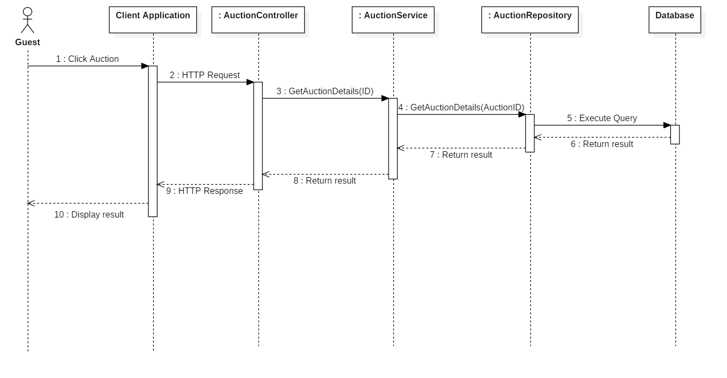

Figure 7 - Sequence Diagram for View Auction Details < Guest >

##### View Suggested Auctions

Summary: this diagram shows process for view suggested auctions

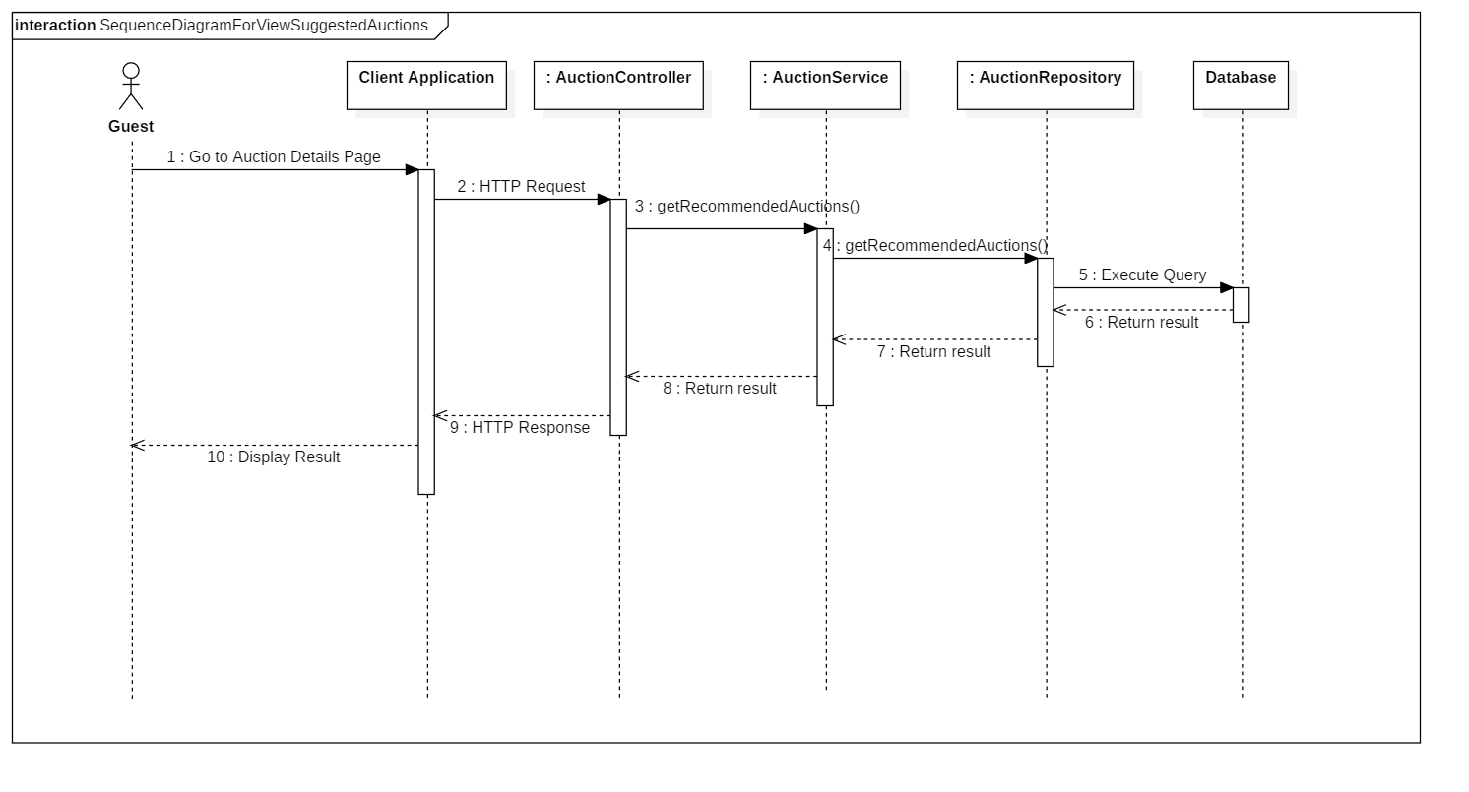

Figure 8 - Sequence Diagram for View Suggested Auctions < Guest >

#### Administrator

##### Accept Auction

Summary: this diagram shows process for accept auction.

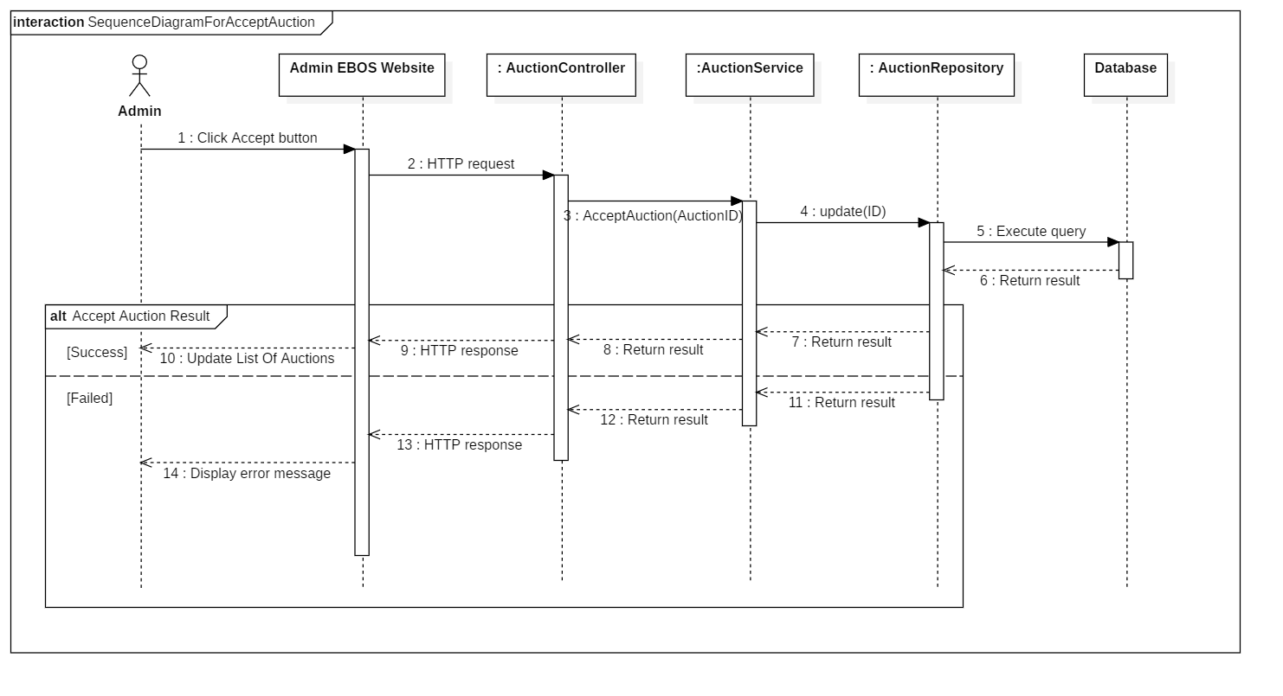

Figure 9 - Sequence Diagram for Accept Auction < Administrator >

##### Reject Auction

Summary: this diagram shows process for reject auction.

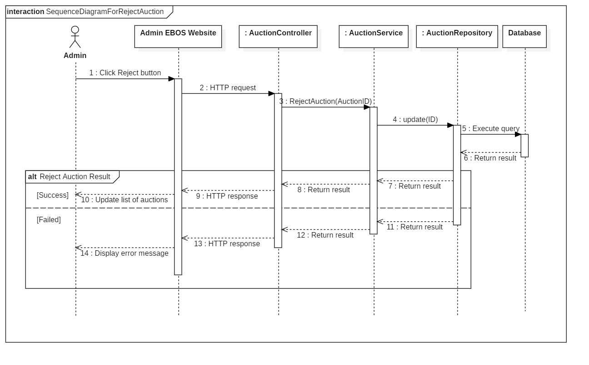

Figure 10 - Sequence Diagram for Reject Auction < Administrator >

##### Search Users

Summary: this diagram shows process for search users.

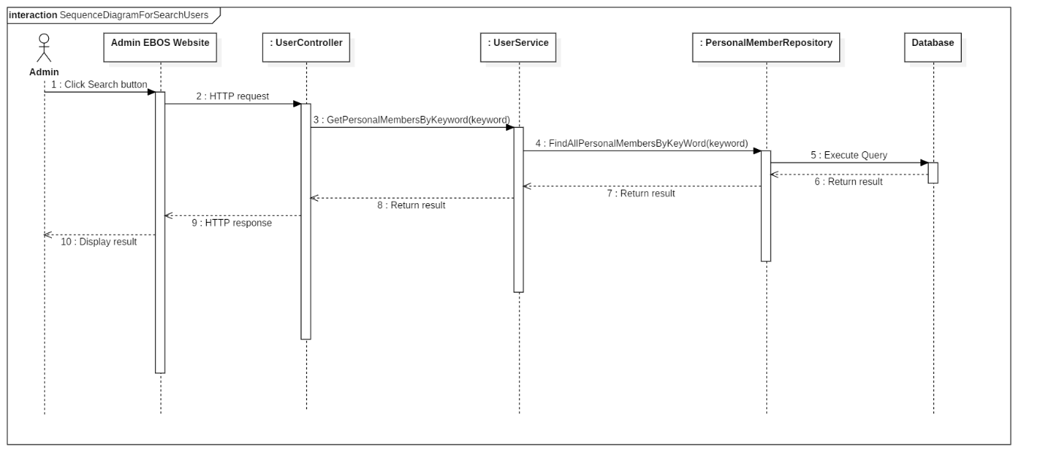

Figure 11 - Sequence Diagram for Search Users < Administrator >

##### Activate User

Summary: this diagram shows process for activate user.

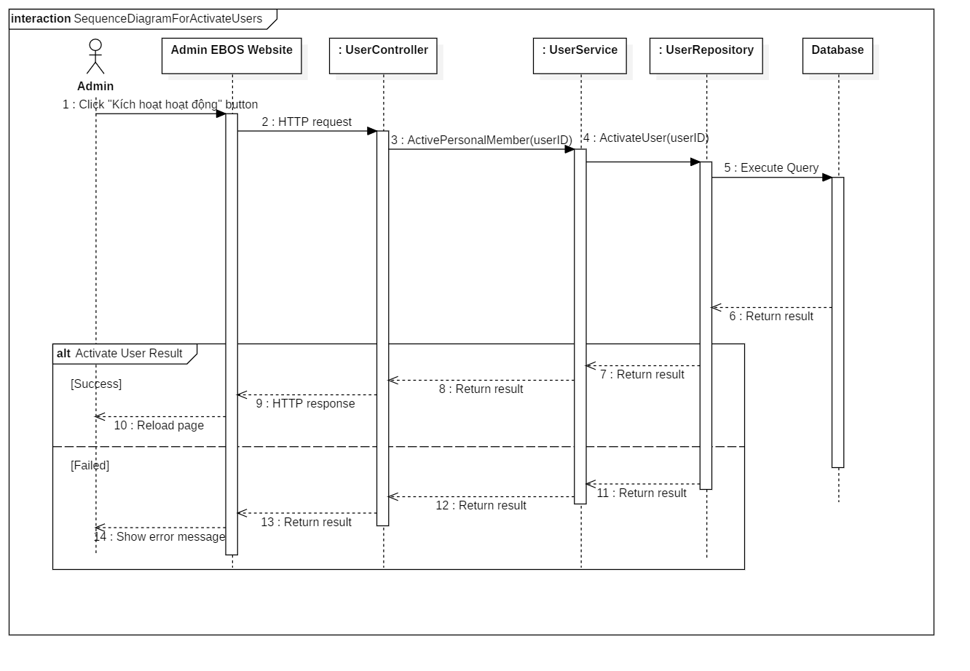

Figure 12 - Sequence Diagram for Activate User < Administrator >

##### Restrict User

Summary: this diagram shows process for restrict user.

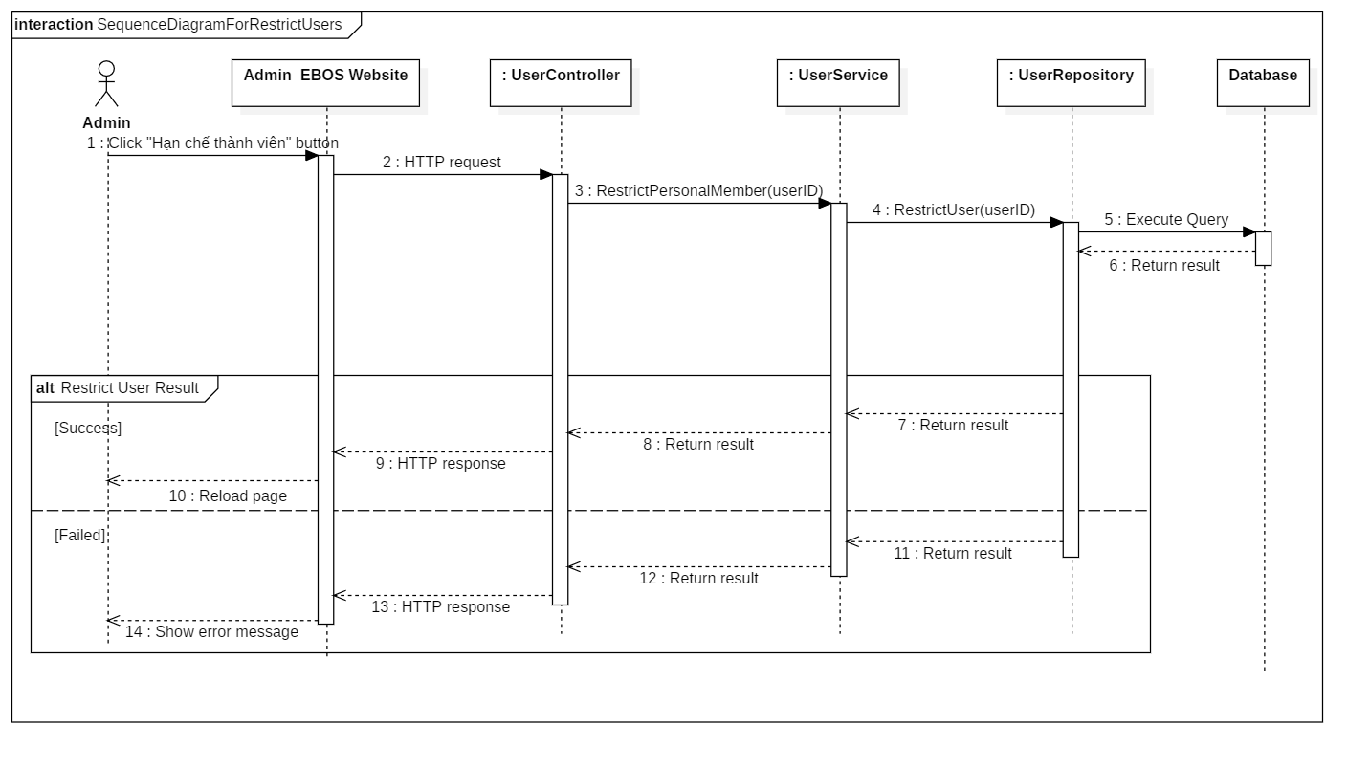

Figure 13 - Sequence Diagram for Restrict User < Administrator >

#### Auctioneer

##### Submit Auction

Summary: this diagram shows process for submit auction.

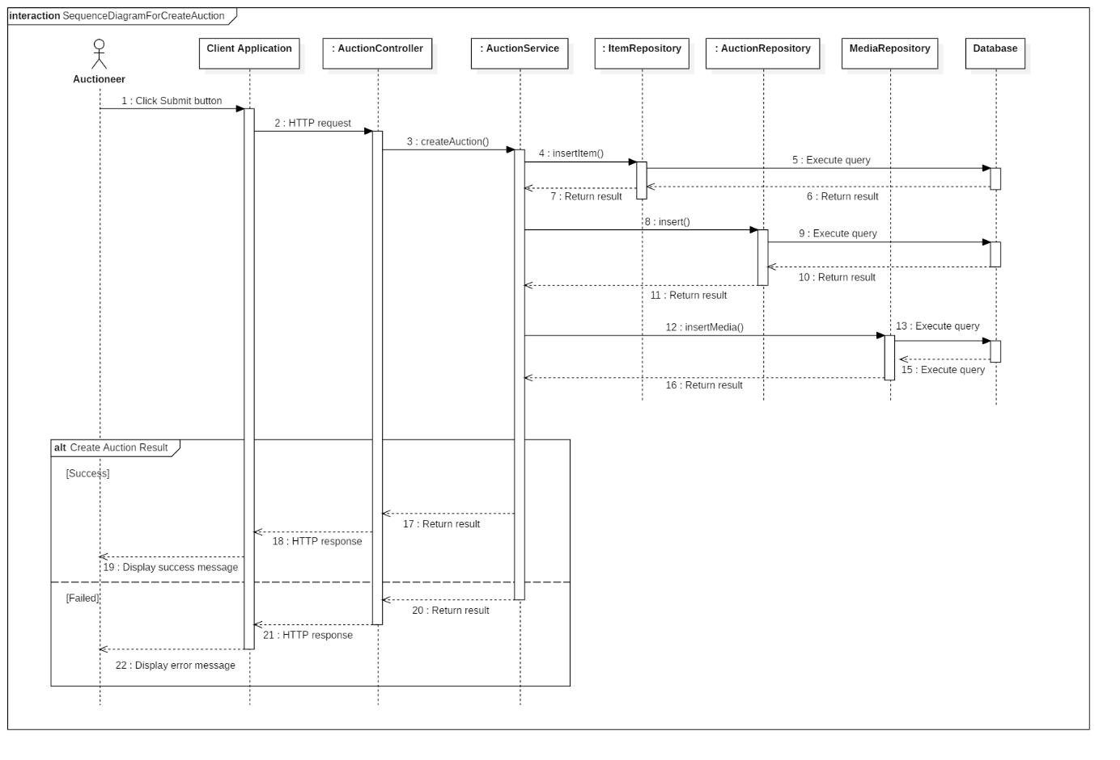

Figure 14 - Sequence Diagram for Submit Auction < Auctioneer >

#### Bidder

##### Place Bid

Summary: this diagram shows process for place bid.

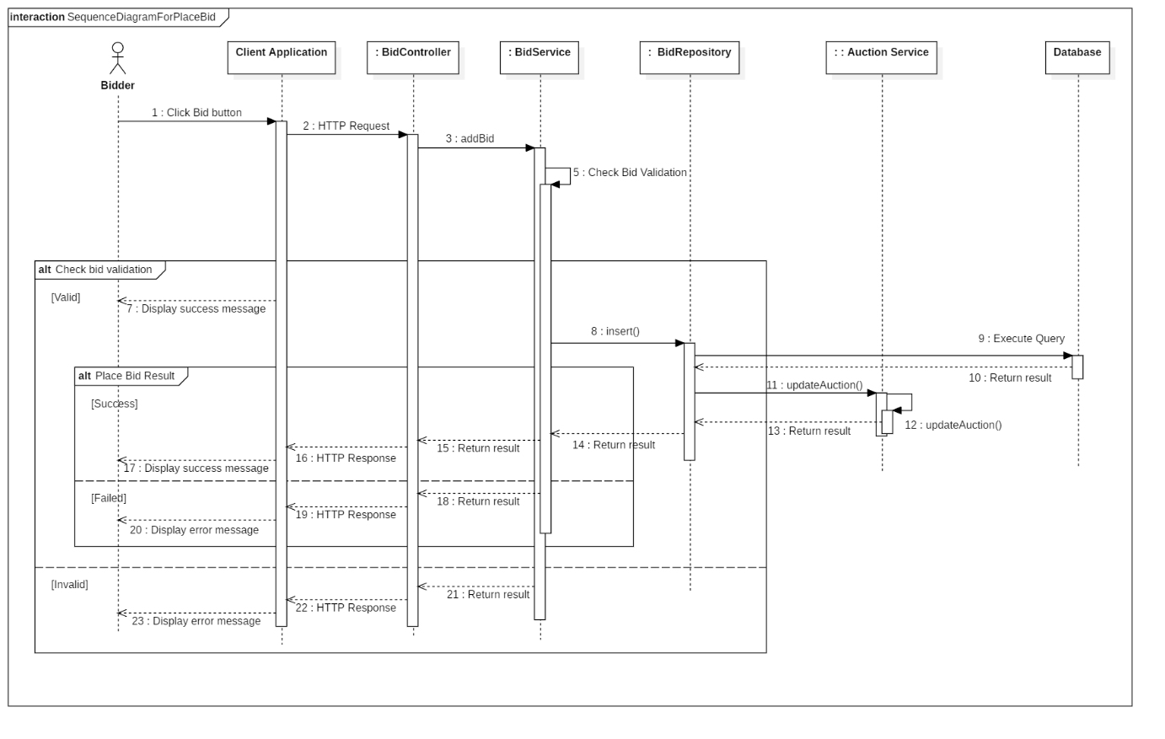

Figure 15 - Sequence Diagram for Place Bid < Bidder >

#### Auctioneer & Bidder

##### View Auction History

Summary: this diagram shows process for view auction history.

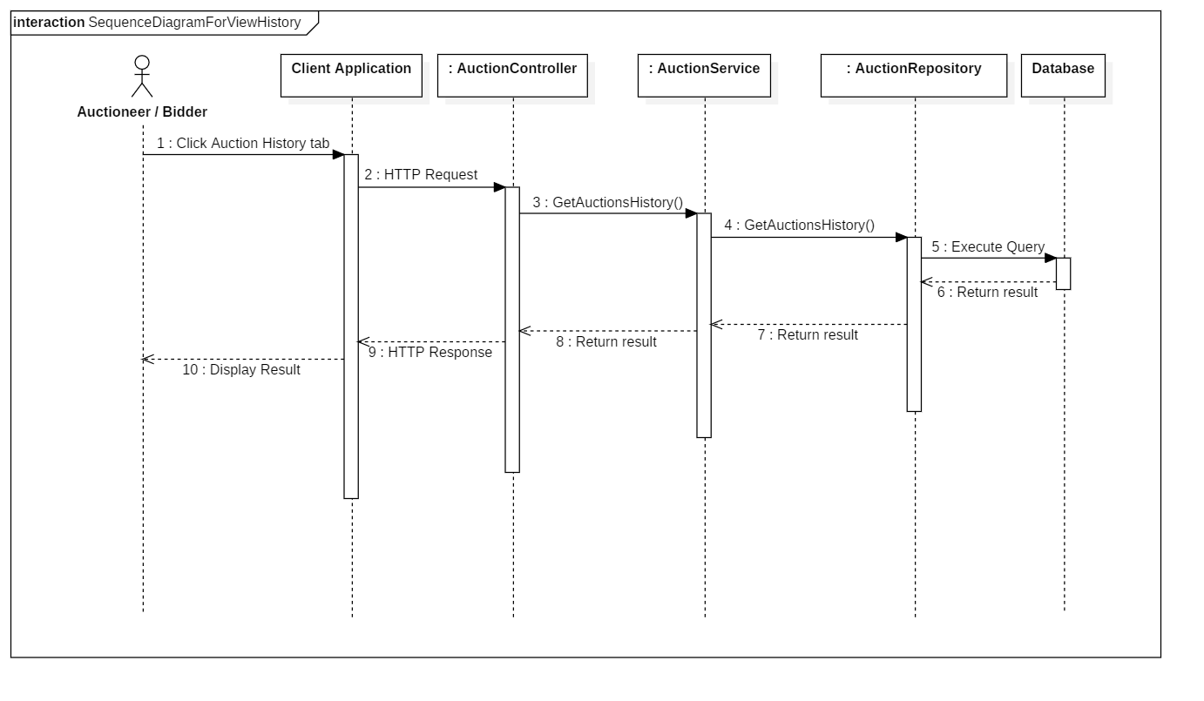

Figure 16 - Sequence Diagram for View Auction History < Auctioneer/Bidder >

##### Register address

Summary: this diagram shows process for register address.

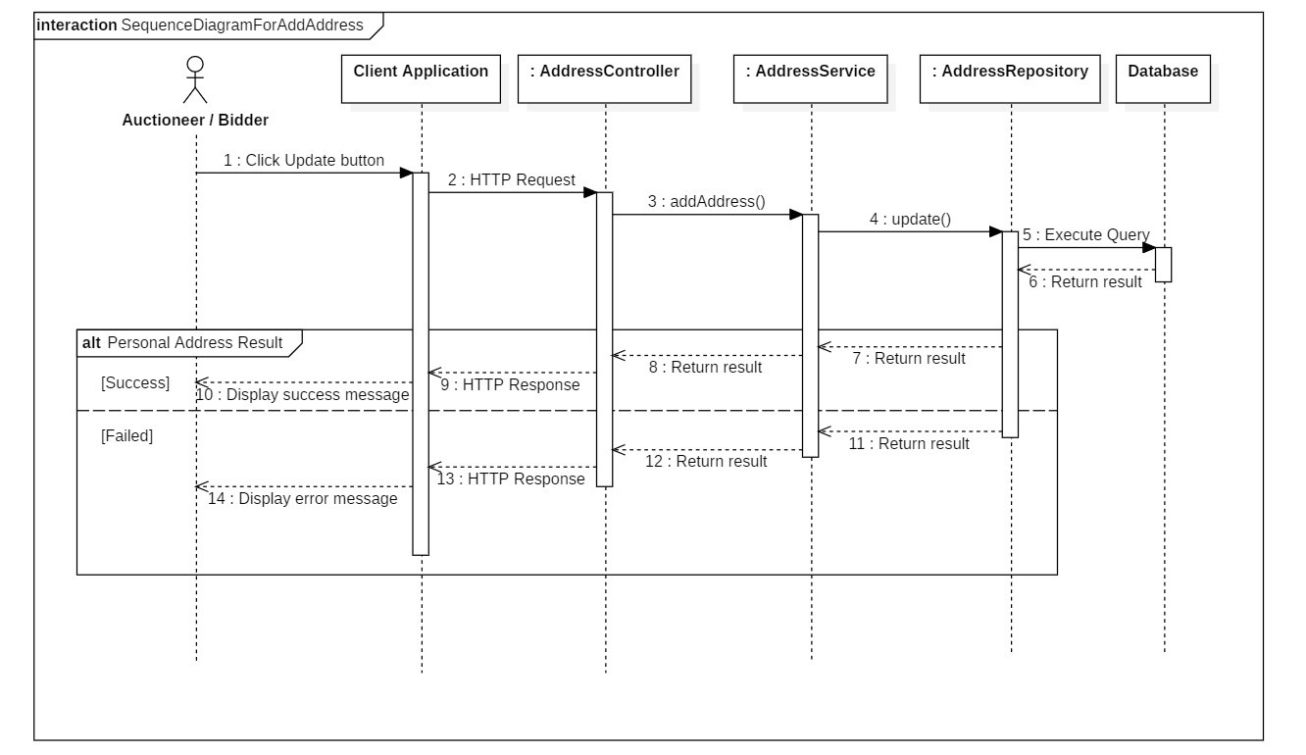

Figure 17 - Sequence Diagram for Register Address < Auctioneer/Bidder >

##### View Contact Information

Summary: this diagram shows process for view contact information of:

* winner of auction for seller
* seller of won auction for bidder

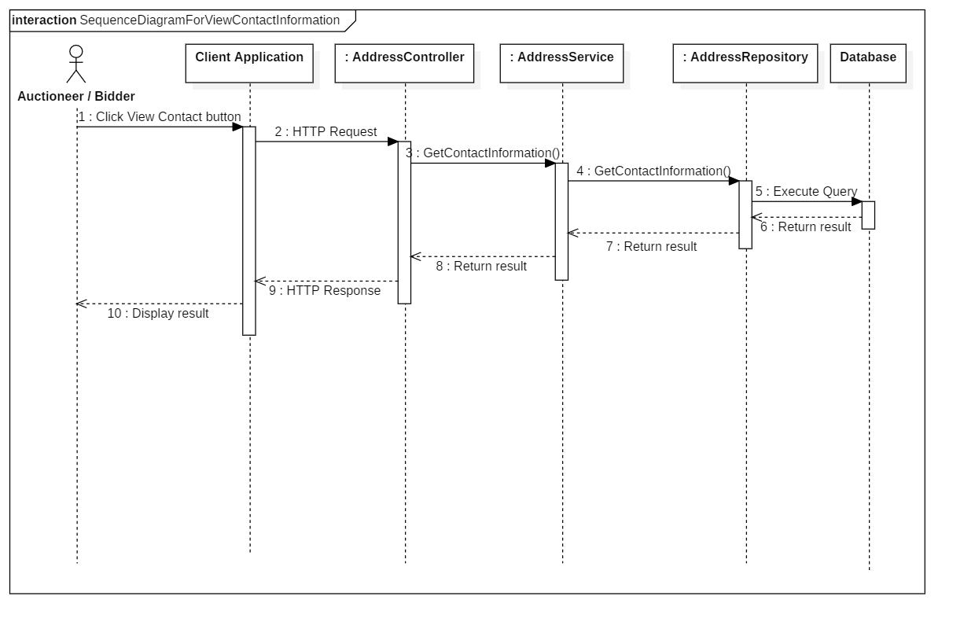

Figure 18 - Sequence Diagram for View Contact Information` < Auctioneer/Bidder >

### State Machine Diagram

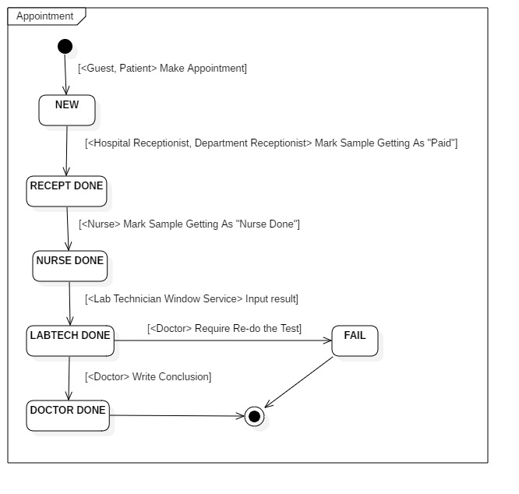

Figure 19 - State Machine Diagram of Appointment

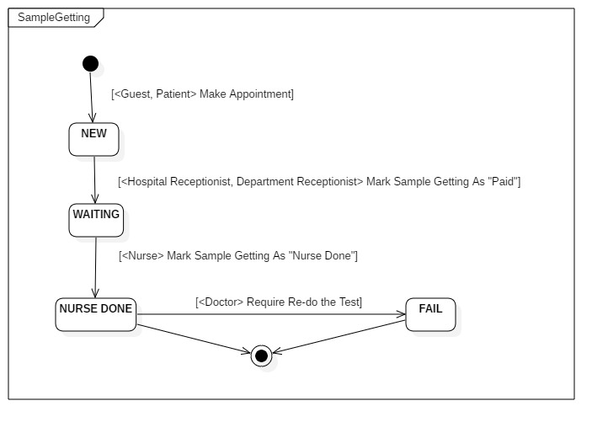

Figure 19 - State Machine Diagram of Sample Gettin

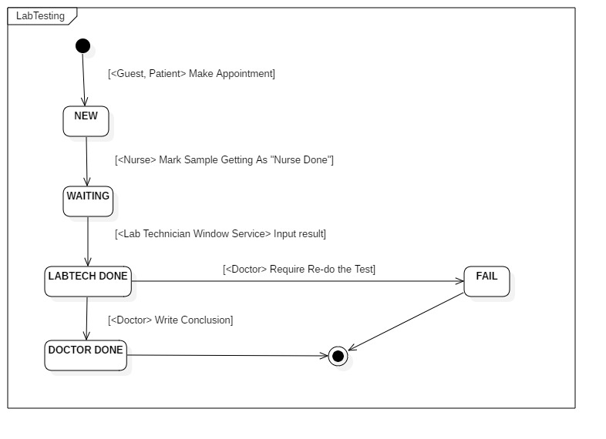

Figure 19 - State Machine Diagram of Lab Testing

## **User Interface Design**

### Web admin application user interface

#### Login Page

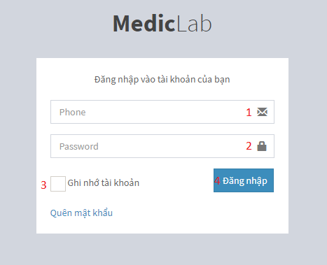

Figure 20 - Web Interface <Login>

**Field**

|  |  |  |  |  |  |  |  |
| --- | --- | --- | --- | --- | --- | --- | --- |
| **No** | **Field Name** | **Description** | **Read only** | **Mandatory** | **Control Type** | **Data Type** | **Length** |
| 1 | Phone | Phone to login | No | Yes | Textbox | String |  |
| 2 | Password | Password to login | No | Yes | Textbox | String |  |
| 3 | Remember me | Auto log in | No | No | Checkbox | Boolean |  |

**Buttons/Hyperlinks:**

|  |  |  |  |  |
| --- | --- | --- | --- | --- |
| **No** | **Function** | **Description** | **Validation** | **Outcome** |
| 4 | Sign In | Login into system | Validate all required fields | Navigate to Admin page |

#### Hospital Receptionist Page

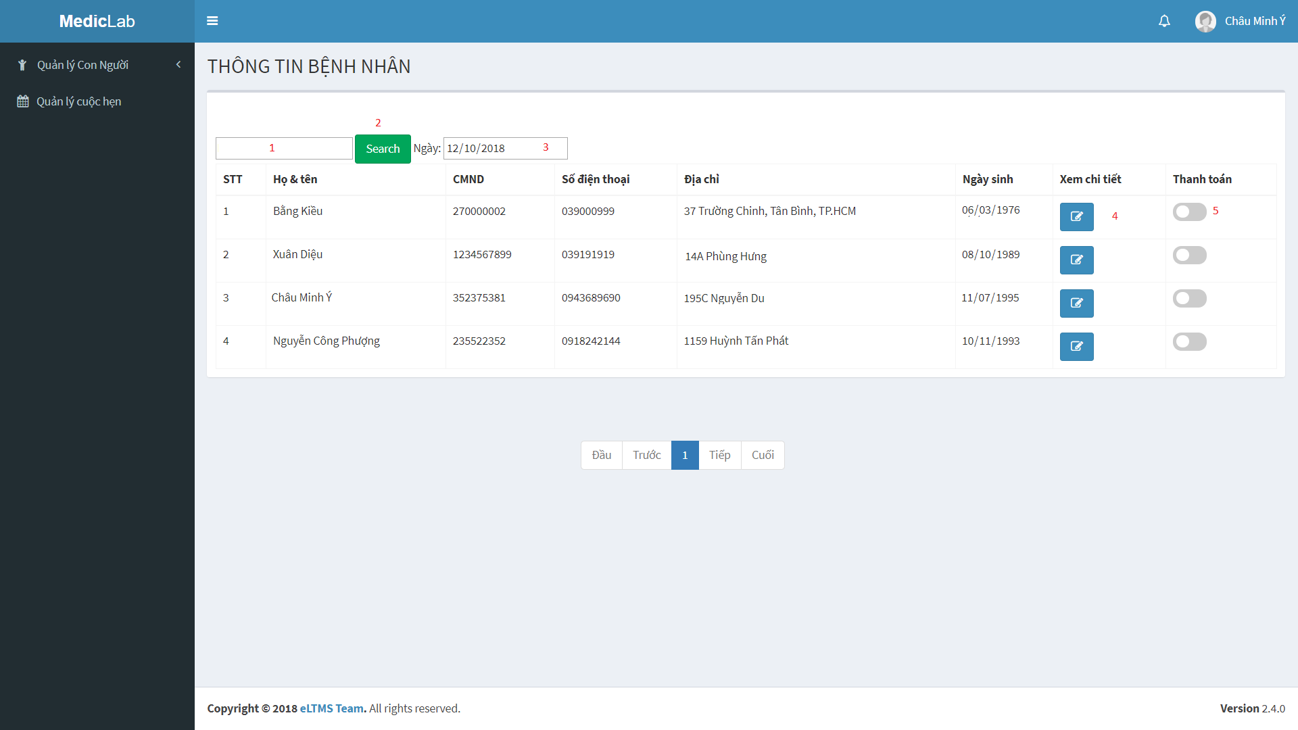

Figure 21 - Admin Web Interface <Hospital Receptionist>

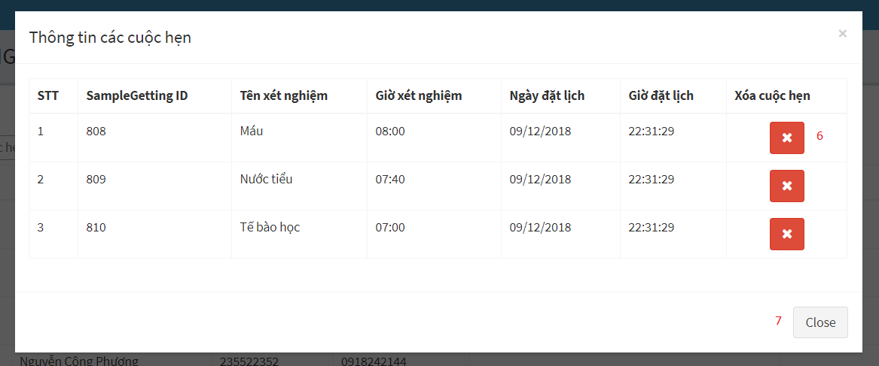

Figure 22 - Admin Web Interface <Hospital Receptionist>

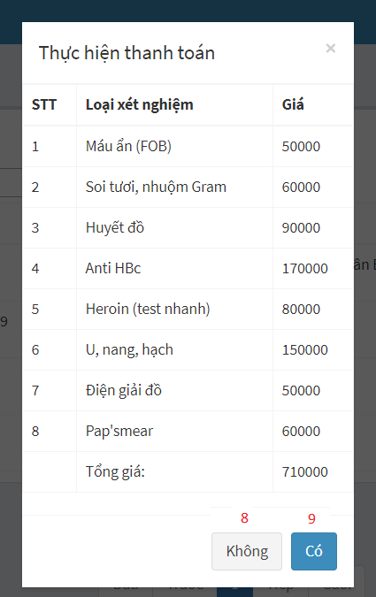

Figure 23 - Admin Web Interface <Hospital Receptionist>

**Field**

|  |  |  |  |  |  |  |  |
| --- | --- | --- | --- | --- | --- | --- | --- |
| **No** | **Field Name** | **Description** | **Read only** | **Mandatory** | **Control Type** | **Data Type** | **Length** |
| 1 | Keyword | Fill keyword to search | No | Yes | Text | String |  |
| 3 | Select Date | Select Date to show Patient | No | Yes | Date | Date |  |

**Buttons/Hyperlinks**

|  |  |  |  |  |
| --- | --- | --- | --- | --- |
| **No** | **Function** | **Description** | **Validation** | **Outcome** |
| 2 | Search | Search after getting keywork | N/A | Show list of patients by keywork |
| 4 | Show details appointment | Show list of appointments | N/A | Show list of appointments |
| 5 | Change status | Show popup for admin to check hospital fee for patient and pay it | N/A | Show list of price and confirm Y/N to change status |
| 6 | Delete sampleGetting | Delete sampleGetting after getting request | N/A | SampleGetting is deleted |
| 7 | Close popup | Close popup details appointment | N/A | Popup is closed |
| 8 | Cancel paying | Confirm payment | N/A | Status is not changed |
| 9 | Accept paying | Confirm payment | N/A | Status is changed |

#### View Department Receptionist Page

# 

Figure 24 - Admin Web Interface <View Department Receptionist>

# 

Figure 25 - Admin Web Interface <View Department Receptionist>

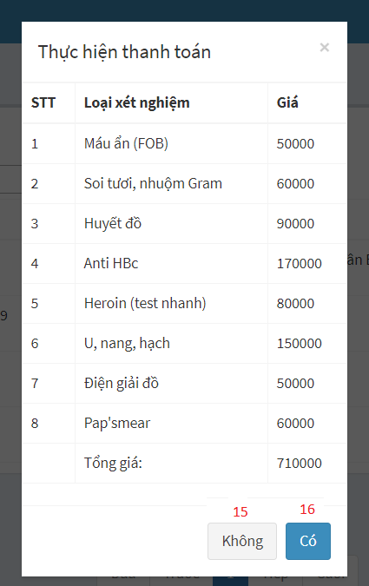

Figure 26 - Admin Web Interface <View Department Receptionist>

**Field**

|  |  |  |  |  |  |  |  |
| --- | --- | --- | --- | --- | --- | --- | --- |
| **No** | **Field Name** | **Description** | **Read only** | **Mandatory** | **Control Type** | **Data Type** | **Length** |
| 2 | Keyword | Fill keyword to search | No | Yes | Text | String |  |
| 4 | Select sample | Select sample to show appointment | No | Yes | Dropdown list | String |  |
| 5 | Select Date | Select date to show appointment | No | Yes | Date | Date |  |
| 7 | Họ và Tên | Patient’s information | No | Yes | Textbox | String |  |
| 8 | CMND | Patient’s information | No | Yes | Textbox | String |  |
| 9 | Ngày sinh | Patient’s information | No | Yes | Date | Date |  |
| 10 | Số điện thoại | Patient’s information | No | Yes | Textbox | String |  |
| 11 | Địa chỉ | Patient’s information | No | Yes | Textbox | String |  |
| 12 | Loại xét nghiệm | Choose labtest | No | Yes | Checkbox | Boolean |  |

**Buttons/Hyperlinks:**

|  |  |  |  |  |
| --- | --- | --- | --- | --- |
| **No** | **Function** | **Description** | **Validation** | **Outcome** |
| 1 | Create appointment | Create appointment for patient | N/A | Show popup appointment’s information |
| 3 | Search | Search after getting keywork | N/A | Show list of appointments by keywork |
| 6 | Change status | Show popup for admin to check hospital fee for patient and pay it | N/A | Show list of price and confirm Y/N to change status |
| 13 | Add a new appointment | Add a new appointment | N/A | A new appointment is created |
| 14 | Close popup | Close popup details appointment | N/A | Popup is closed |
| 15 | Cancel paying | Confirm payment | N/A | Status is not changed |
| 16 | Accept paying | Confirm payment | N/A | Status is changed |

#### View Nurse Page

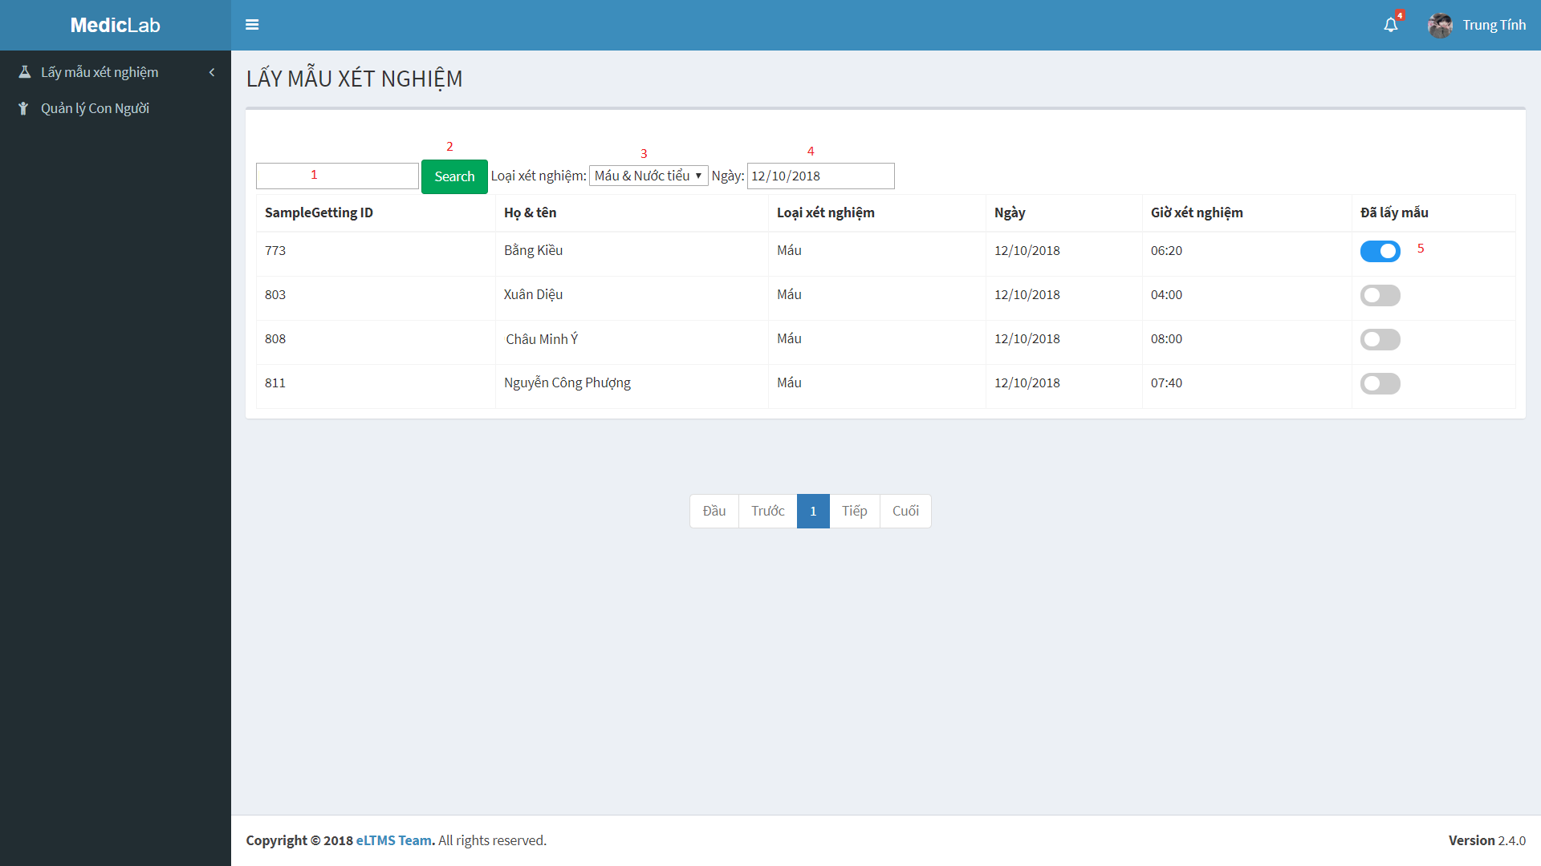

Figure 27 - Admin Web Interface <View Nurse>

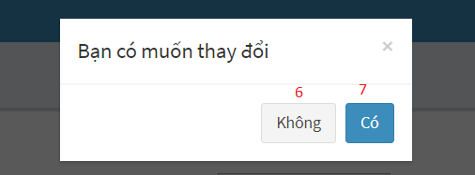

Figure 28 - Admin Web Interface <View Nurse>

**Field**

|  |  |  |  |  |  |  |  |
| --- | --- | --- | --- | --- | --- | --- | --- |
| **No** | **Field Name** | **Description** | **Read only** | **Mandatory** | **Control Type** | **Data Type** | **Length** |
| 1 | Keyword | Fill Keyword to seach | No | Yes | Text | String |  |
| 3 | Select sample | Select sample to show appointment | No | Yes | Dropdown list | String |  |
| 4 | Select Date | Select date to show appointment | No | Yes | Date | Date |  |

**Buttons/Hyperlinks**

|  |  |  |  |  |
| --- | --- | --- | --- | --- |
| **No** | **Function** | **Description** | **Validation** | **Outcome** |
| 2 | Search | Search after getting keywork | N/A | Show list of appointment by keywork |
| 5 | Change status | Show popup for admin to confirm and change status | N/A | Show options to choose Y/N |
| 6 | Cancel action | Choose No | N/A | Status is not changed |
| 7 | Accept action | Choose Yes | N/A | Status is changed |

#### View Laboratory Technician Page

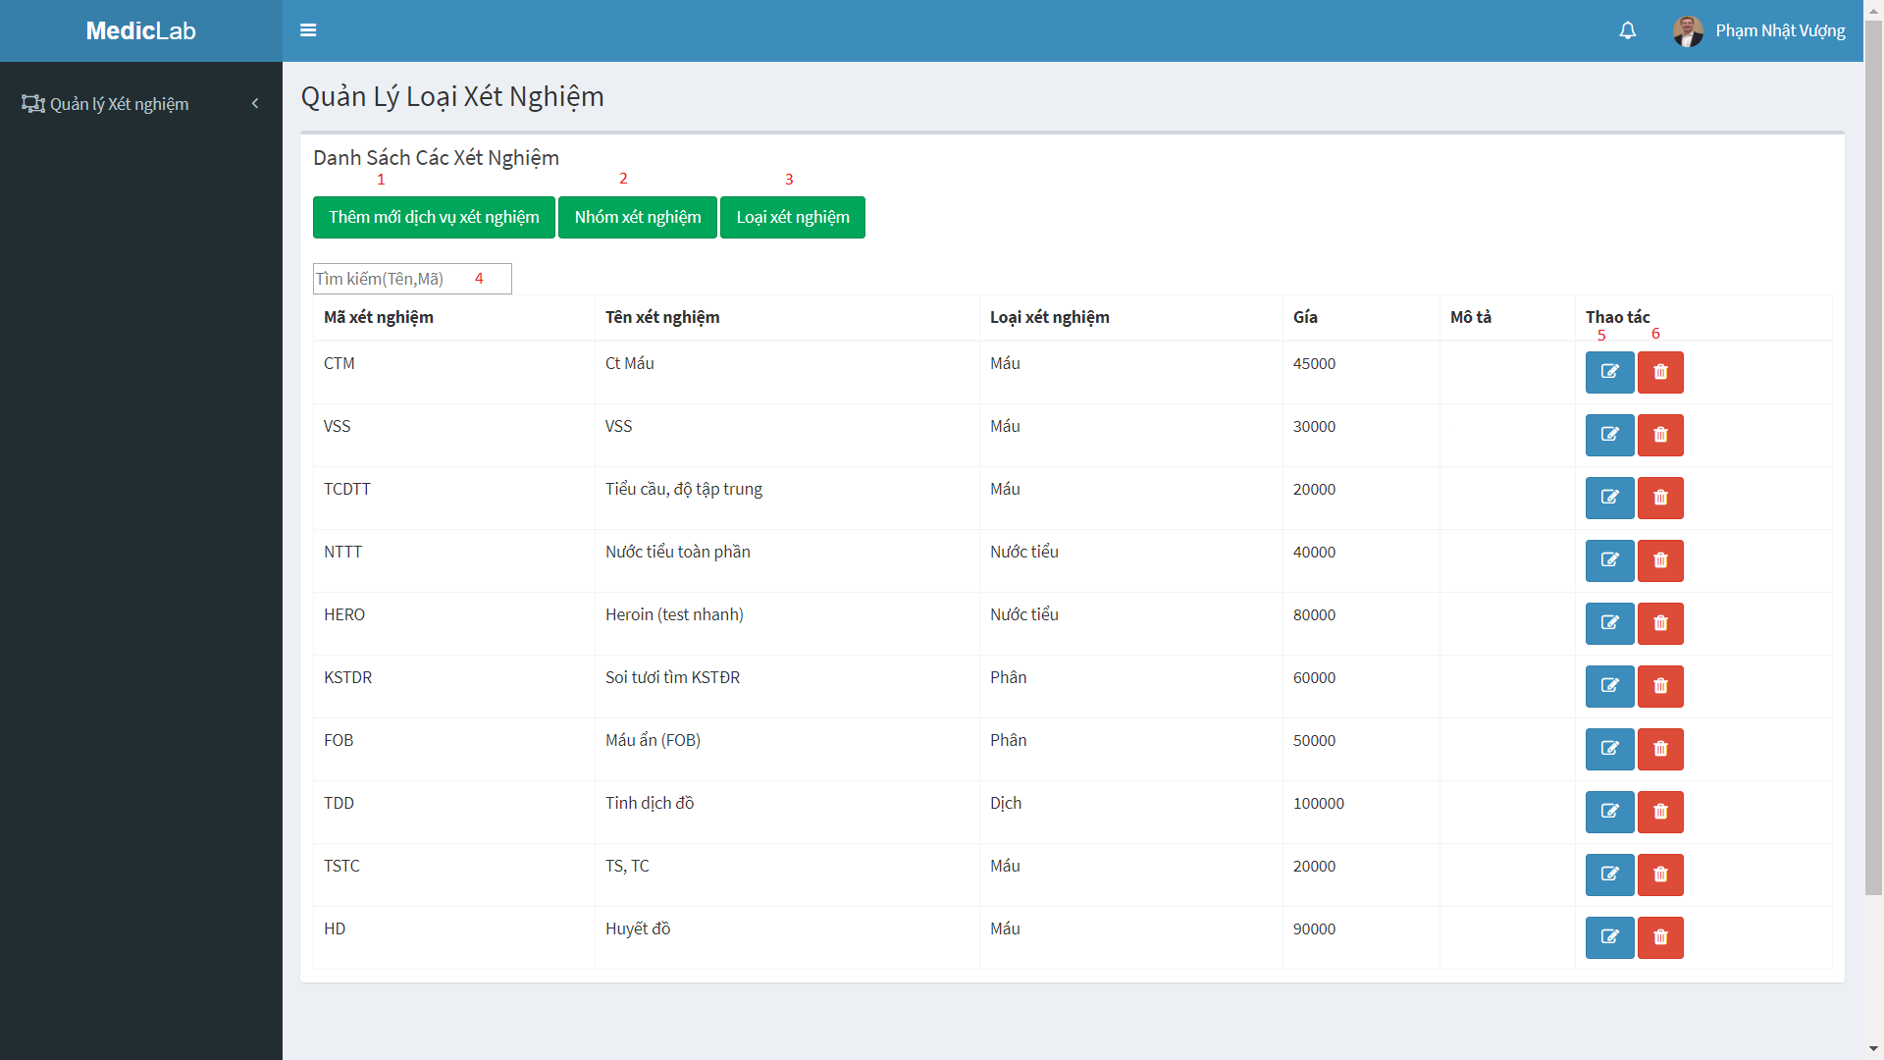

Figure 29 - Admin Web Interface <View Laboratory Technician>

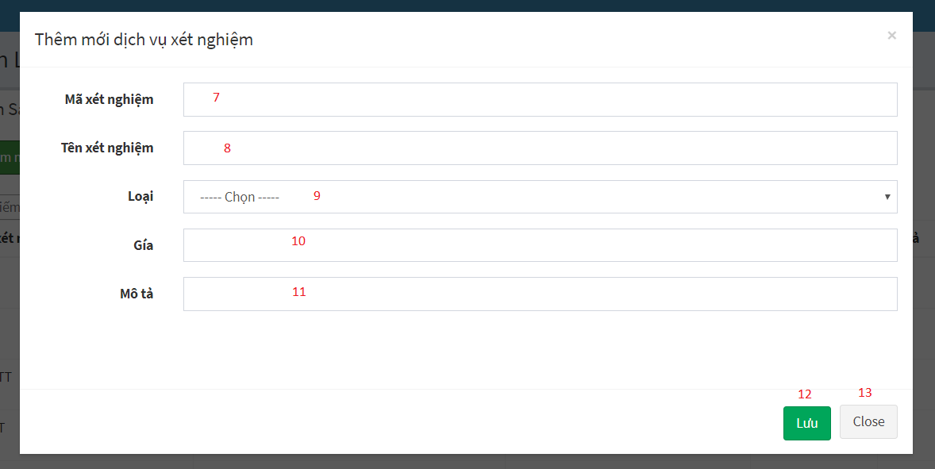

Figure 30 - Admin Web Interface <View Laboratory Technician-Add Labtest>

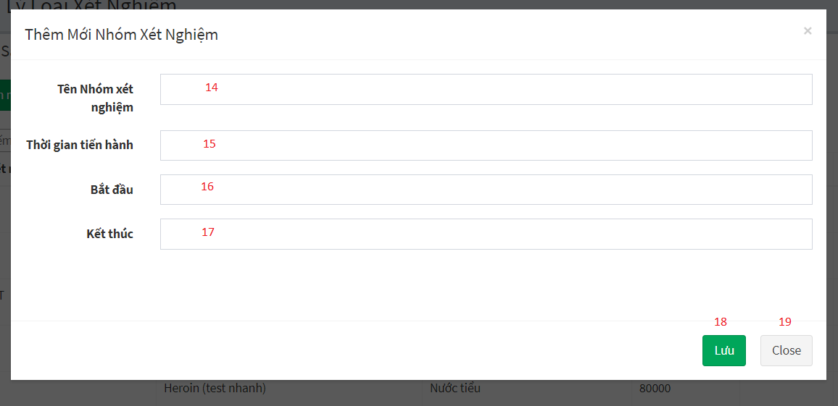

Figure 31 - Admin Web Interface <View Laboratory Technician-Add Sample group>

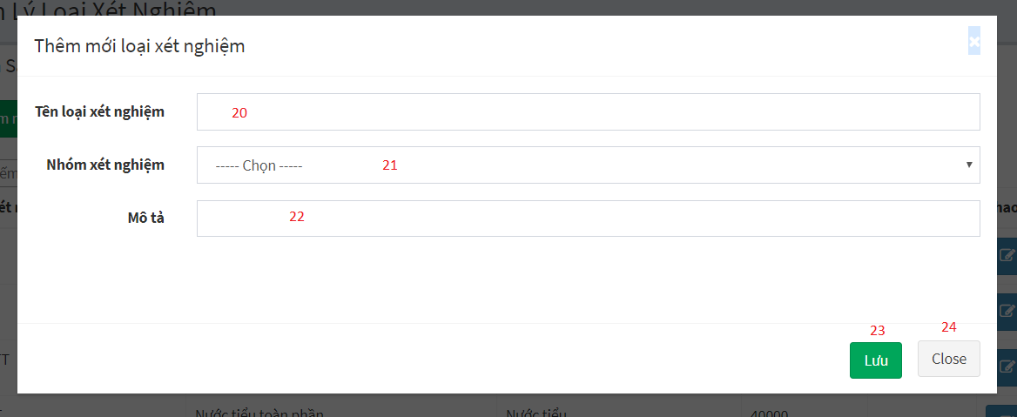

Figure 32 - Admin Web Interface <View Laboratory Technician-Add Sample>

**Field**

|  |  |  |  |  |  |  |  |
| --- | --- | --- | --- | --- | --- | --- | --- |
| **No** | **Field Name** | **Description** | **Read only** | **Mandatory** | **Control Type** | **Data Type** | **Length** |
| 4 | Keyword | Fill keyword to seach | No | Yes | Text | String |  |
| 7 | Mã xét nghiệm | Labtest’s information | No | Yes | Textbox | String |  |
| 8 | Tên xét nghiệm | Labtest’s information | No | Yes | Textbox | String |  |
| 9 | Loại | Labtest’s information | No | Yes | Dropdown list | String |  |
| 10 | Giá | Labtest’s information | No | Yes | Textbox | String |  |
| 11 | Mô tả | Labtest’s information | No | Yes | Textbox | String |  |
| 14 | Tên nhóm xét nghiệm | Sample group’s information | No | Yes | Textbox | String |  |
| 15 | Thời gian tiến hành | Sample group’s information | No | Yes | Textbox | String |  |
| 16 | Bắt đầu | Sample group’s information | No | Yes | Textbox | String |  |
| 17 | Kết thúc | Sample group’s information | No | Yes | Textbox | String |  |
| 20 | Tên loại xét nghiệm | Sample’s information | No | Yes | Textbox | String |  |
| 21 | Nhóm xét nghiệm | Sample’s information | No | Yes | Dropdown list | String |  |
| 22 | Mô tả | Sample’s information | No | Yes | Textbox | String |  |

**Buttons/Hyperlinks**

|  |  |  |  |  |
| --- | --- | --- | --- | --- |
| **No** | **Function** | **Description** | **Validation** | **Outcome** |
| 1 | Add new labtest | Add new labtest | N/A | Show popup to fill information of labtest |
| 2 | Add new sample group | Add new sample group | N/A | Show popup to fill information of sample group |
| 3 | Add new sample | Add new sample | N/A | Show popup to fill information of sample |
| 5 | Edit labtest | Edit information of labtest | N/A | Edit information of labtest |
| 6 | Delete labtest | Delete labtest after getting request | N/A | Labtest is deleted |
| 12 | Add a new labtest | Add a new labtest | N/A | A new labtest is created |
| 13 | Close popup | Close popup | N/A | Popup is closed |
| 18 | Add a new sample group | Add a new sample group | N/A | A new sample group is created |
| 19 | Close popup | Close popup | N/A | Popup is closed |
| 23 | Add a new sample | Add a new sample | N/A | A new sample is created |
| 24 | Close popup | Close popup | N/A | Popup is closed |

#### View Doctor Page

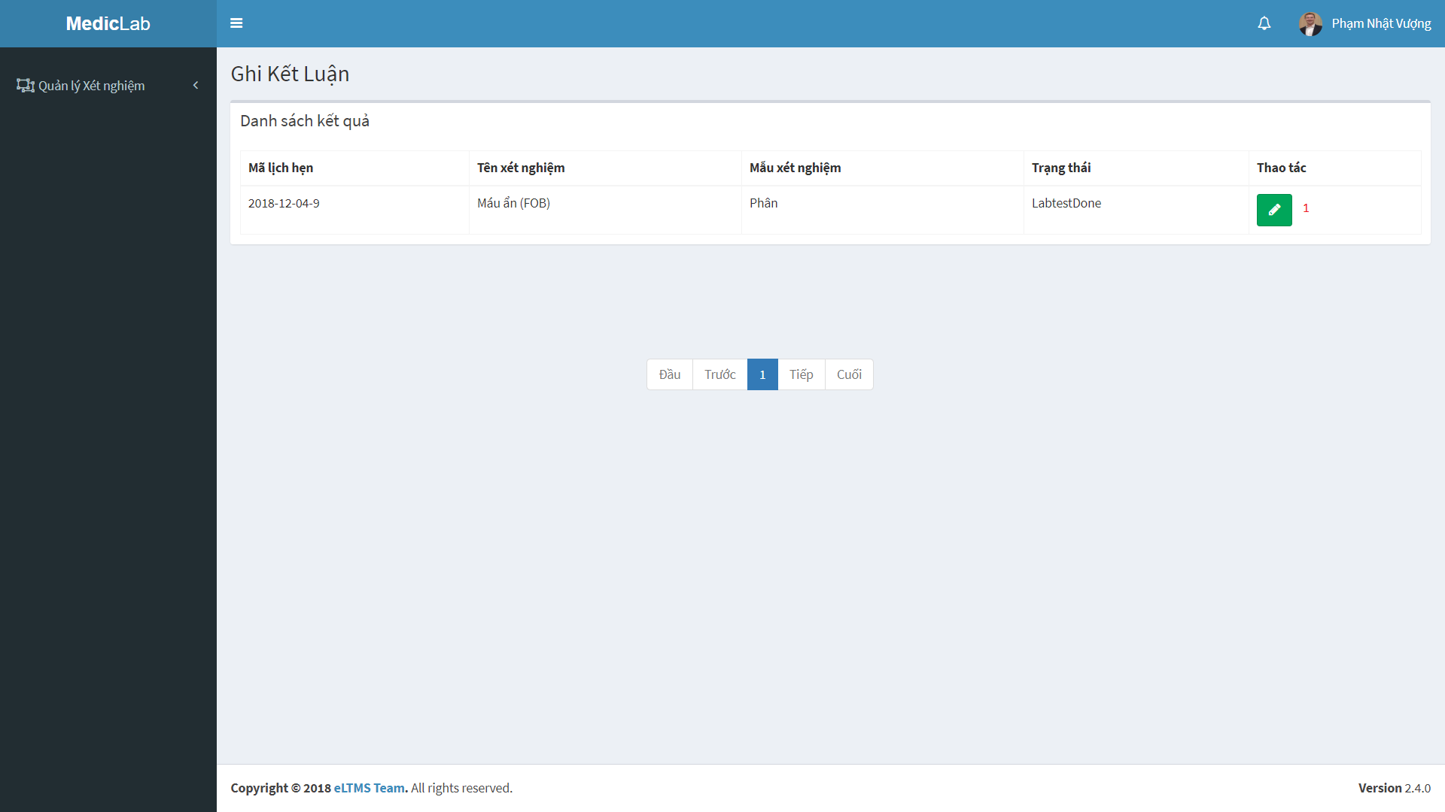

Figure 33 - Admin Web Interface <View Doctor>

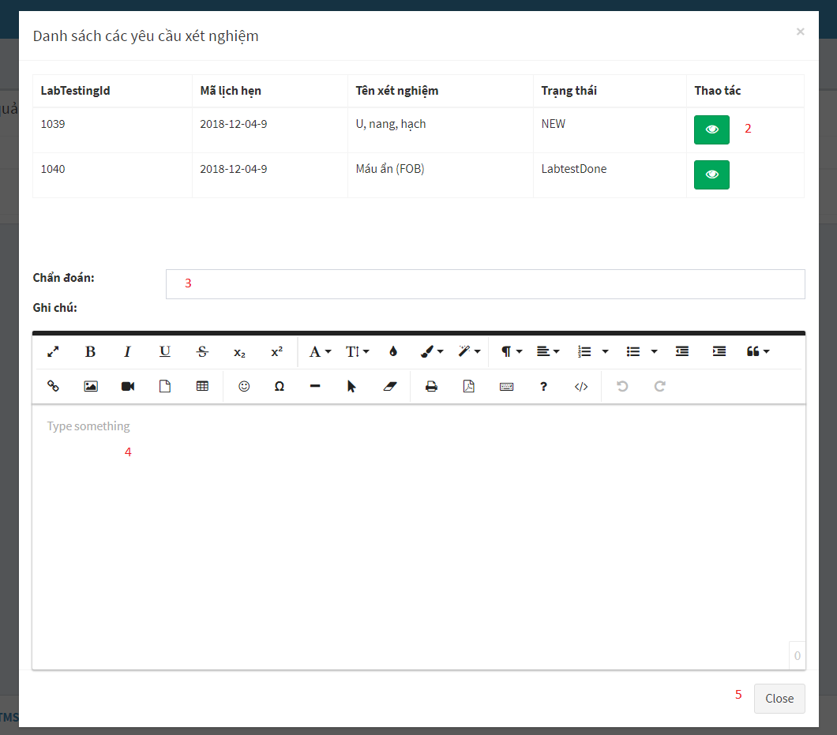

Figure 34 - Admin Web Interface <View Doctor>

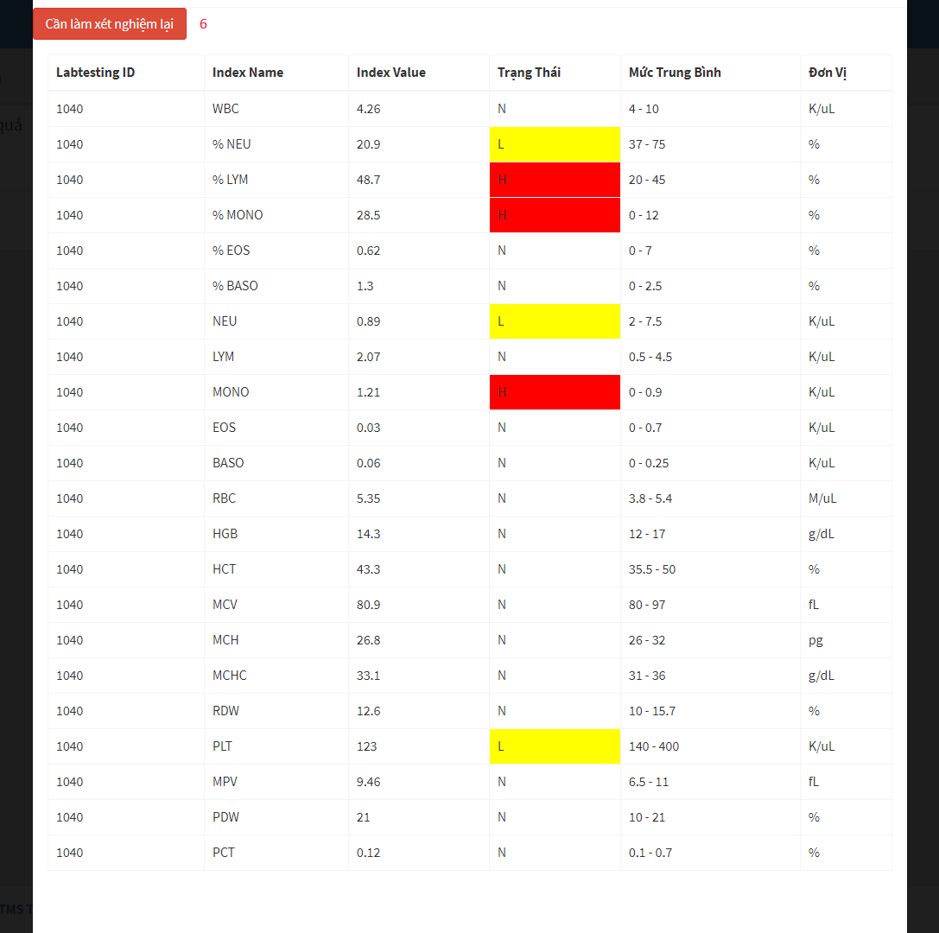

Figure 35 - Admin Web Interface <View Doctor>

**Field**

|  |  |  |  |  |  |  |  |
| --- | --- | --- | --- | --- | --- | --- | --- |
| **No** | **Field Name** | **Description** | **Read only** | **Mandatory** | **Control Type** | **Data Type** | **Length** |
| 3 | Chẩn đoán | Conclusion of doctor | No | Yes | Textbox | String |  |
| 4 | Ghi chú | Note of doctor | No | Yes | Textbox | String |  |

**Buttons/Hyperlinks**

|  |  |  |  |  |
| --- | --- | --- | --- | --- |
| **No** | **Function** | **Description** | **Validation** | **Outcome** |
| 1 | Check for disease | View testing result, write note and conclusion | N/A | Show popup with testing result, space to write note and conclusion |
| 2 | View testing result | View testing result | N/A | Show popup with the details of testing result |
| 5 | Close popup | Close popup | N/A | Popup is closed |
| 6 | Request re-testing | Request re-testing when doctor see something wrong about testing result | N/A | Send request re-testing to patient |

### Web application user interface

#### Login



Figure 36 - Web Interface <Login>

**Field**

|  |  |  |  |  |  |  |  |
| --- | --- | --- | --- | --- | --- | --- | --- |
| **No** | **Field Name** | **Description** | **Read only** | **Mandatory** | **Control Type** | **Data Type** | **Length** |
| 1 | Phone | Phone to login | No | Yes | Textbox | String |  |
| 2 | Password | Password to login | No | Yes | Textbox | String |  |
| 3 | Remember me | Auto log in | No | No | Checkbox | Boolean |  |

**Buttons/Hyperlinks:**

|  |  |  |  |  |
| --- | --- | --- | --- | --- |
| **No** | **Function** | **Description** | **Validation** | **Outcome** |
| 4 | Sign In | Login into system | Validate all required fields | Navigate to User page |

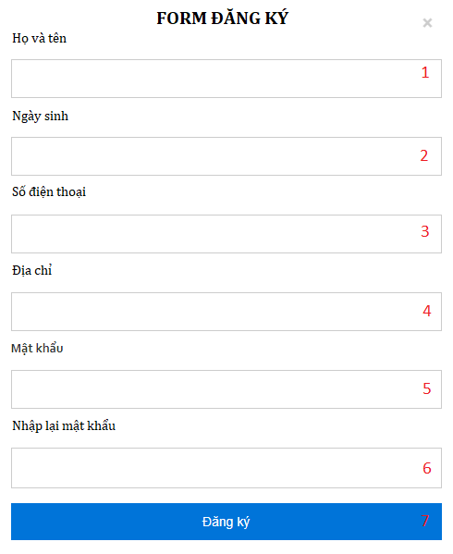

Figure 27 - Web Interface <Register account>

**Field**

|  |  |  |  |  |  |  |  |
| --- | --- | --- | --- | --- | --- | --- | --- |
| **No** | **Field Name** | **Description** | **Read only** | **Mandatory** | **Control Type** | **Data Type** | **Length** |
| 1 | Username | Patient’s information | No | Yes | Text | String |  |
| 2 | DateOfBirth | Patient’s information | No | Yes | Date | Date |  |
| 3 | Phone | Patient’s information | No | Yes | Text | String |  |
| 4 | Address | Patient’s information | No | Yes | Text | String |  |
| 5 | Password | Patient’s information | No | Yes | Password | String |  |
| 6 | PasswordConfirm | Patient’s information | No | Yes | Password | String |  |

**Buttons/Hyperlinks:**

|  |  |  |  |  |
| --- | --- | --- | --- | --- |
| **No** | **Function** | **Description** | **Validation** | **Outcome** |
| 7 | Register | Click to register | N/A | Navigate to Home page |

#### Nav Bar

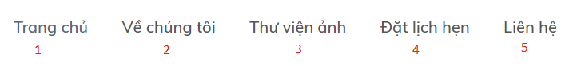

Figure 38 - Web Interface <Menu bar and Categories>

**Buttons/Hyperlinks:**

|  |  |  |  |  |
| --- | --- | --- | --- | --- |
| **No** | **Function** | **Description** | **Validation** | **Outcome** |
| 1 | Navigate to Home Page | N/A | N/A | Navigate to Home Page |
| 2 | Navigate to Introduction Page | Show list of categories as a drop down list | N/A | Navigate to Introduction Page |
| 3 | Navigate to Photo Library Page | N/A | N/A | Navigate to Photo Library Page |
| 4 | Navigate to Book Appointment Page | N/A | N/A | Navigate to Book Appointment Page |
| 5 | Navigate to Contact us | N/A | N/A | Navigate to Contact us |

#### Home Page

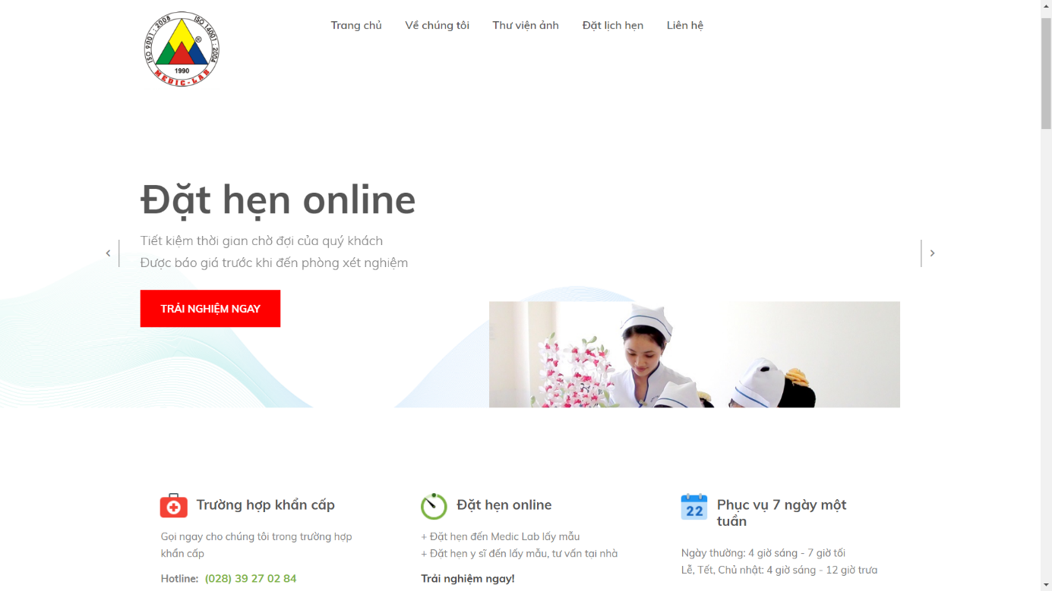

Figure 39 - Web Interface <Home page>

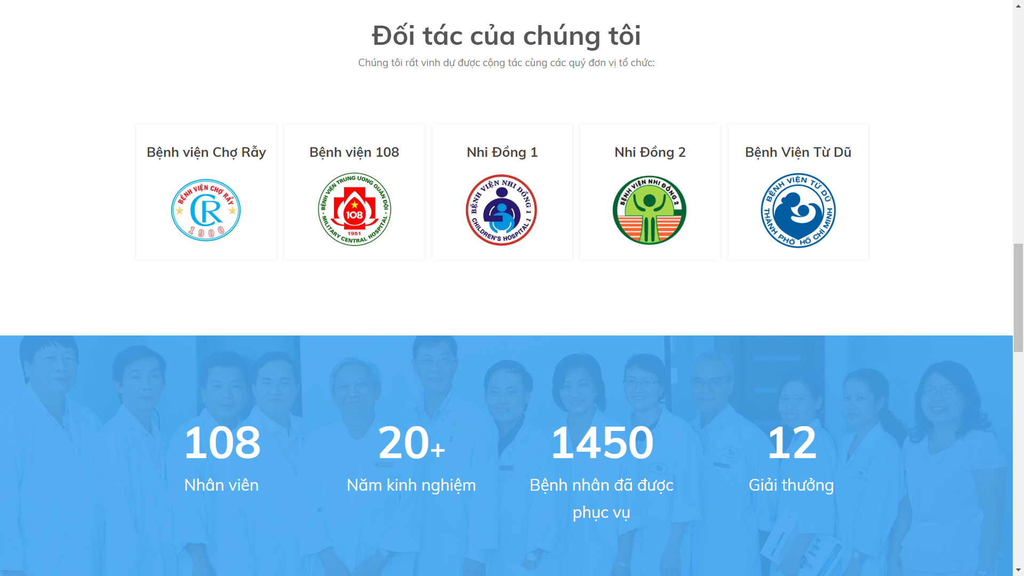

Figure 40 - Web Interface <Home page – Our partner>

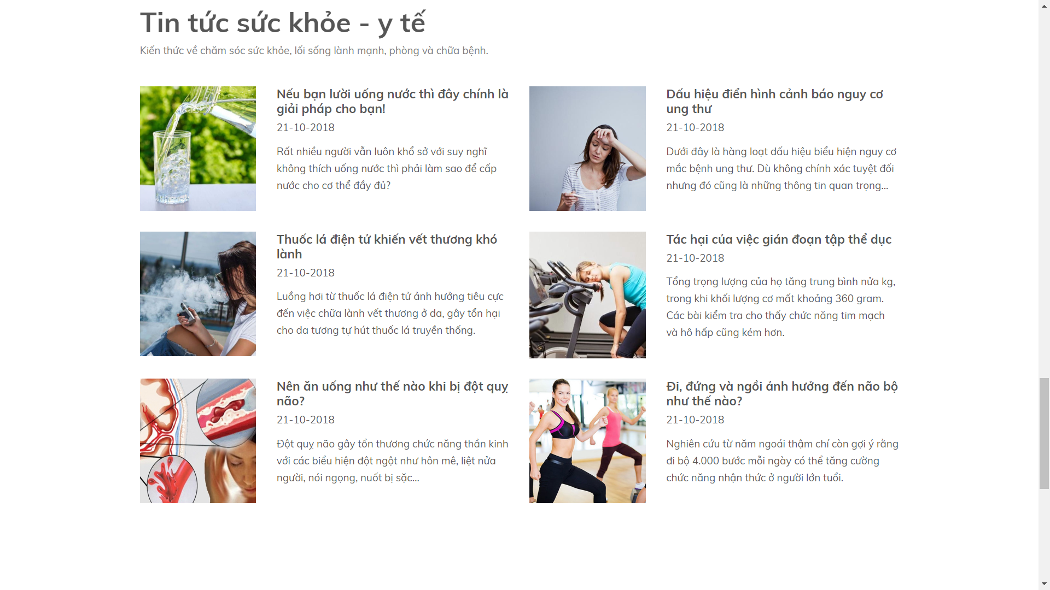

Figure 41 - Web Interface <Home page - News>

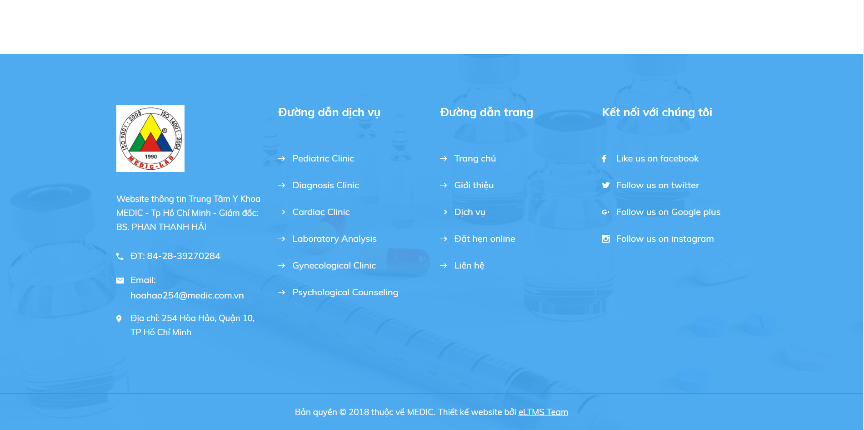

Figure 42 - Web Interface <Home page – Contact us >

#### Book Appointment

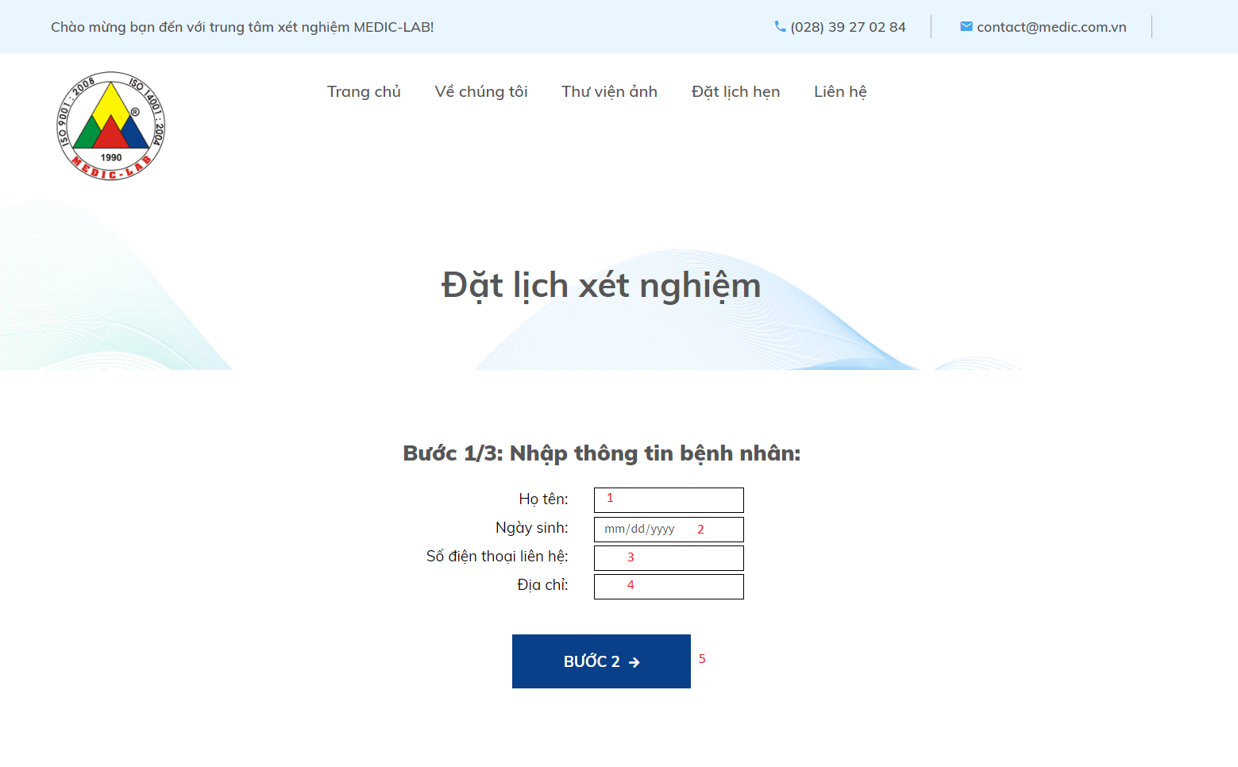

Figure 43 - Web Interface <Book Appointment>

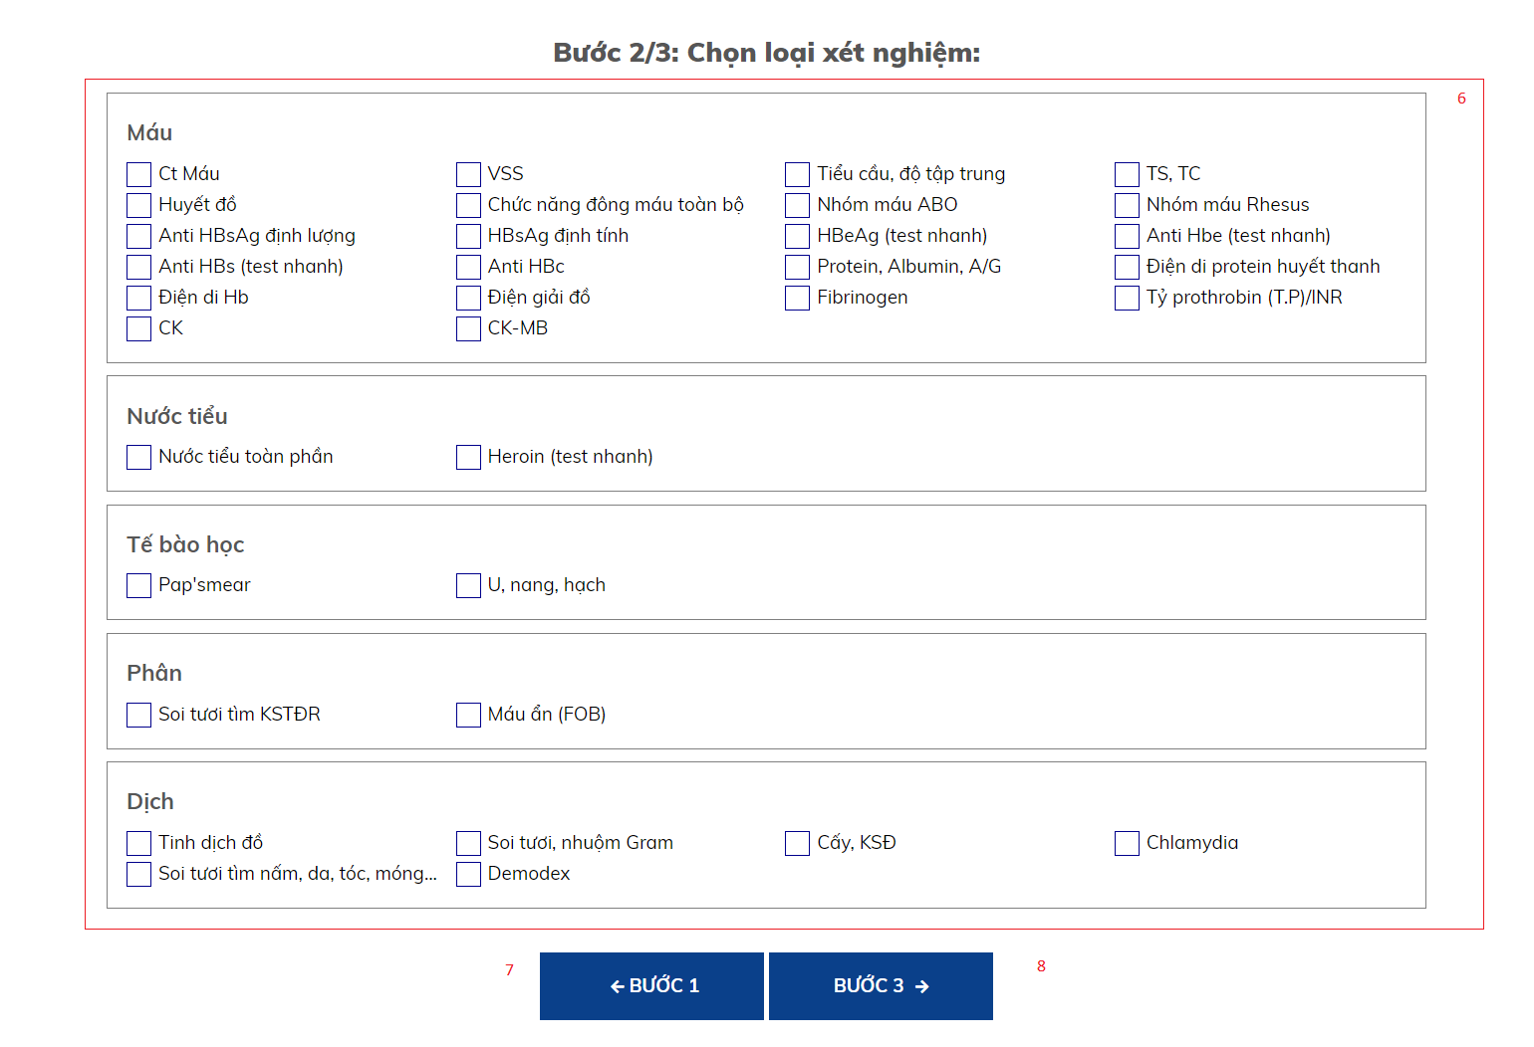

Figure 44 - Web Interface <Book Appointment>

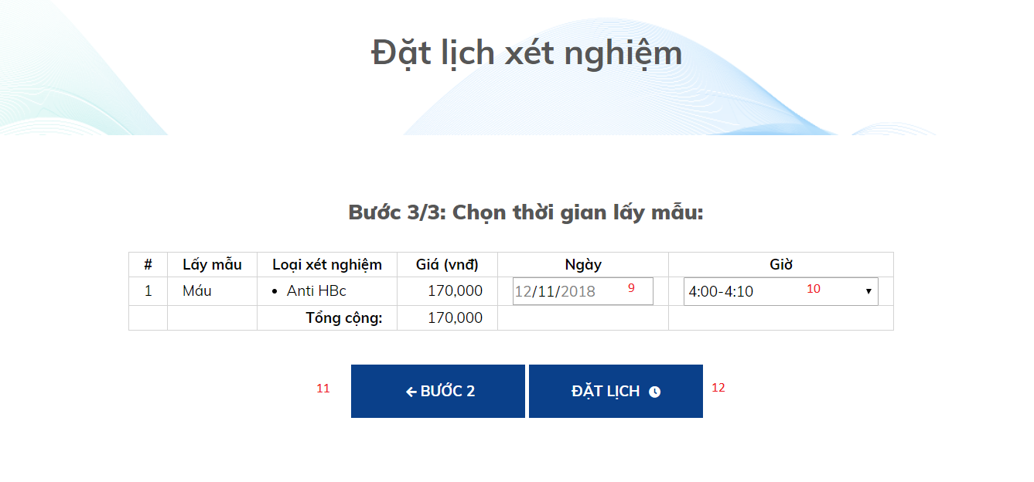

Figure 45 - Web Interface <Book Appointment>

**Field**

|  |  |  |  |  |  |  |  |
| --- | --- | --- | --- | --- | --- | --- | --- |
| **No** | **Field Name** | **Description** | **Read only** | **Mandatory** | **Control Type** | **Data Type** | **Length** |
| 1 | Họ và Tên | Patient’s information | No | Yes | Textbox | String |  |
| 2 | Ngày sinh | Patient’s information | No | Yes | Date | Date |  |
| 3 | Số điện thoại | Patient’s information | No | Yes | Textbox | String |  |
| 4 | Địa chỉ | Patient’s information | No | Yes | Textbox | String |  |
| 6 | Loại xét nghiệm | Choose labtest | No | Yes | Checkbox | Boolean |  |
| 9 | Ngày | Choose approriate time to test | No | Yes | Dropdown list | String |  |
| 10 | Giờ | Choose approriate time to test | No | Yes | Dropdown list | String |  |

**Buttons/Hyperlinks**

|  |  |  |  |  |
| --- | --- | --- | --- | --- |
| **No** | **Function** | **Description** | **Validation** | **Outcome** |
| 5 | Go to step 2 | Click “Bước 2” to go to step 2 | Validate all required fields | Go to step 2 |
| 7 | Go back to step 1 | Click “Bước 1” to go back to step 1 | N/A | Go back to step 1 |
| 8 | Go to step 3 | Click “Bước 3” to go to step 3 | Choose a least one labtest | Go to step 3 |
| 11 | Go back to step 2 | Click “Bước 2” to go back to step 2 | N/A | Go back to step 2 |
| 12 | Submit | Complete booking a new appointment | Validate all required fields | Booking successfully |

#### View list of Booked Appoinments



Figure 46 - Web Interface <View list of booked Appointments>

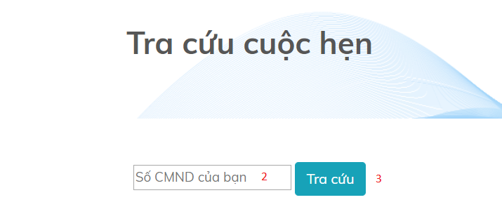

Figure 47 - Web Interface <View list of booked Appointments>

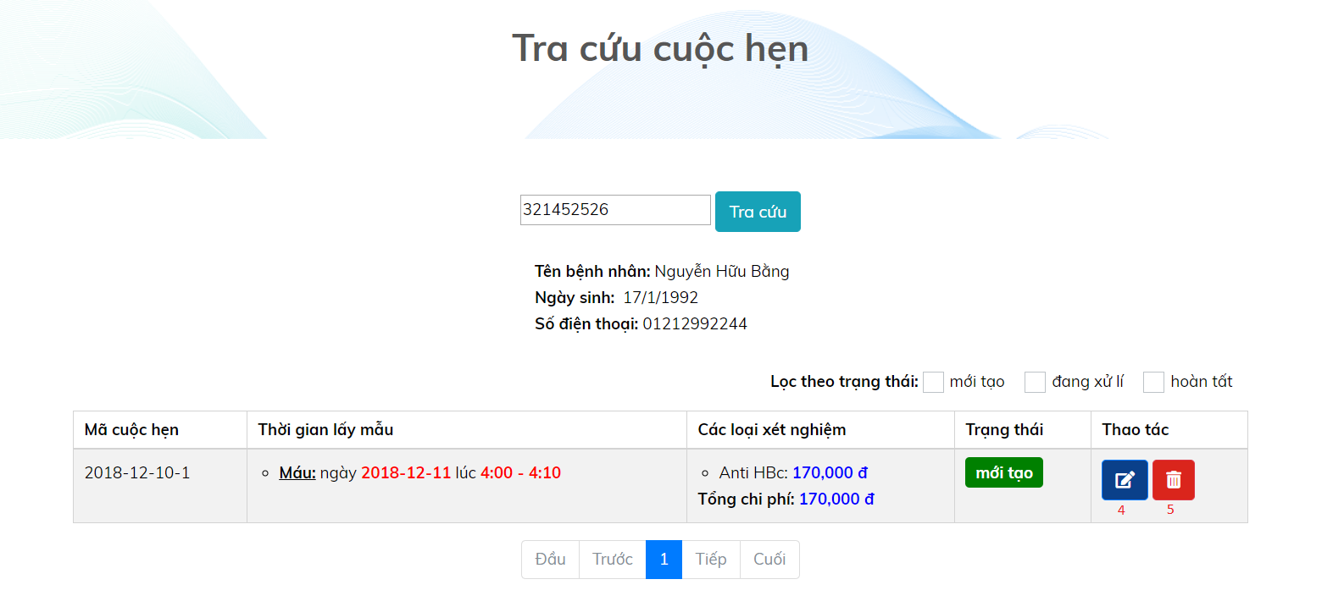

Figure 48 - Web Interface <View list of booked Appointments>

**Field**

|  |  |  |  |  |  |  |  |
| --- | --- | --- | --- | --- | --- | --- | --- |
| **No** | **Field Name** | **Description** | **Read only** | **Mandatory** | **Control Type** | **Data Type** | **Length** |
| 2 | CMND | Input id into textbox area | No | No | Text | String |  |

**Buttons/Hyperlinks**

|  |  |  |  |  |
| --- | --- | --- | --- | --- |
| **No** | **Function** | **Description** | **Validation** | **Outcome** |
| 1 | Navigate to Auctions by View Appointment Page | When user clicks on the link, navigate to a page showing textbox to fill id | N/A | Navigate to a page show textbox to fill id of patient |
| 3 | Search | Click “Tra cứu” to get result from system | N/A | Go to View Appointment Page |
| 4 | Edit appointment | Edit time, sample, labtest for appointment | N/A | Patient’s appointment will be updated |
| 5 | Delete appointment | Delete appointment | N/A | Appointment is deleted |

Figure 36 - Web Interface < Categories bar and sort>

#### View Testing Result

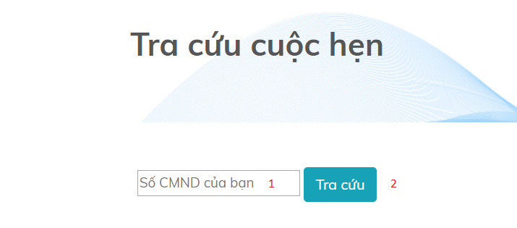

Figure 49 - Web Interface <View Testing Result>

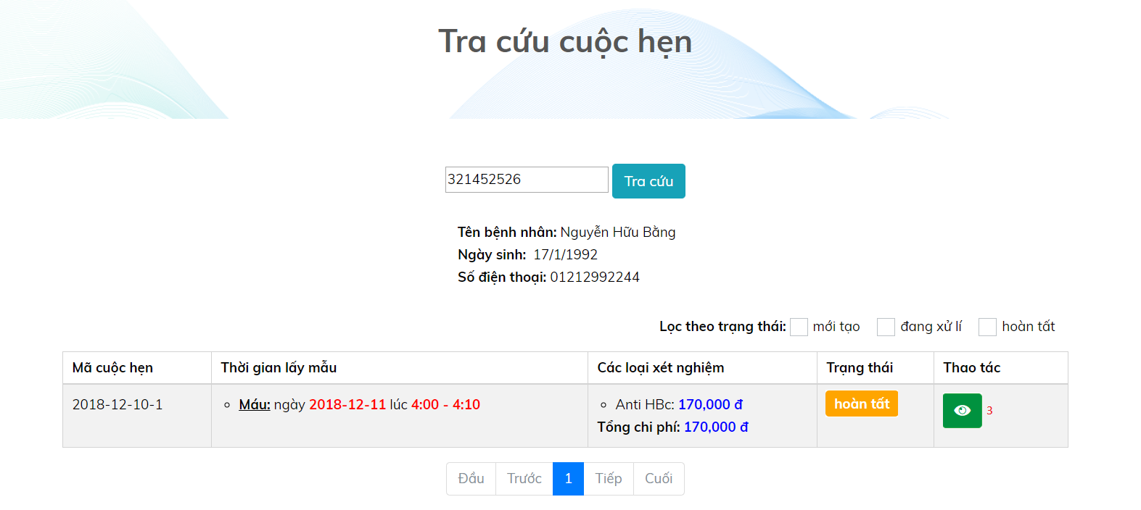

Figure 50 - Web Interface <View Testing Result>

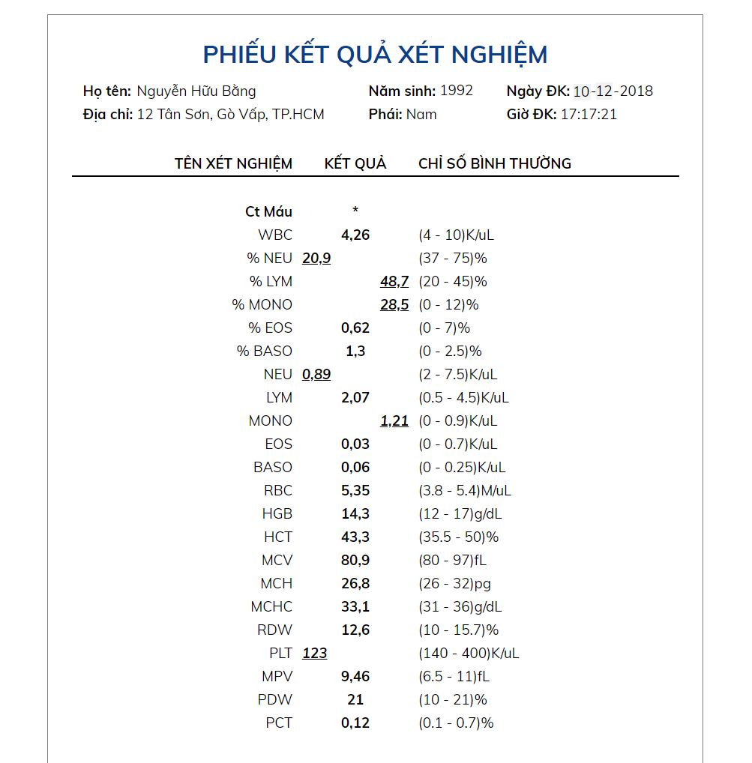

Figure 51 - Web Interface <View Testing Result>

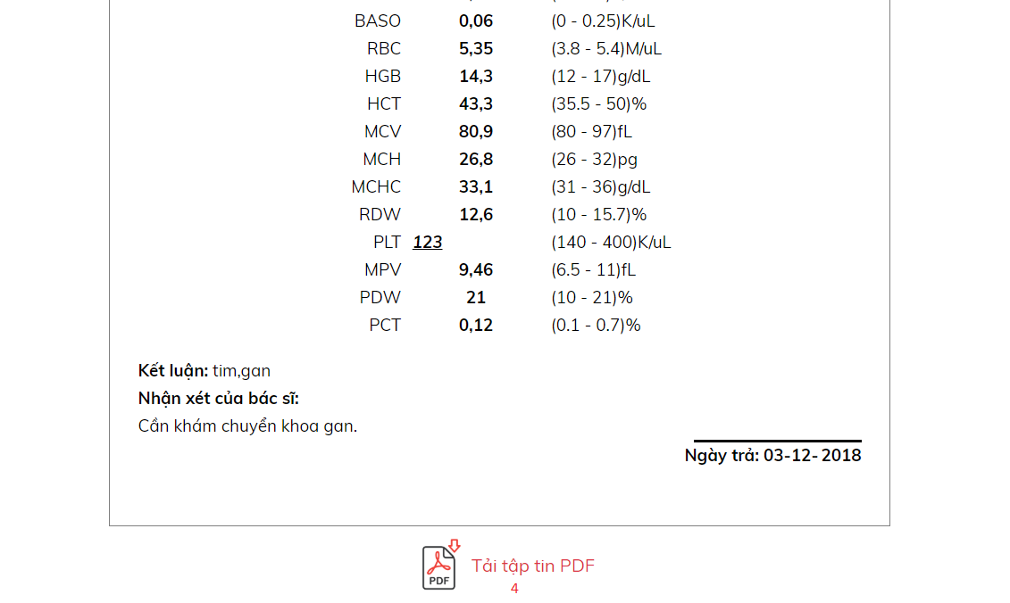

Figure 52 - Web Interface <View Testing Result>

**Field**

|  |  |  |  |  |  |  |  |
| --- | --- | --- | --- | --- | --- | --- | --- |
| **No** | **Field Name** | **Description** | **Read only** | **Mandatory** | **Control Type** | **Data Type** | **Length** |
| 1 | CMND | Input id into textbox area | No | No | Text | String |  |

**Buttons/Hyperlinks**

|  |  |  |  |  |
| --- | --- | --- | --- | --- |
| **No** | **Function** | **Description** | **Validation** | **Outcome** |
| 2 | Search | Click “Tra cứu” to get result from system | N/A | Go to View Appointment Page |
| 3 | View testing result | View testing result | N/A | Go to Result Appointment Page |
| 4 | Download testing result | User can download testing result file as pdf file | N/A | Testing result file will be downloaded |

### Mobile application user interface

#### Login page

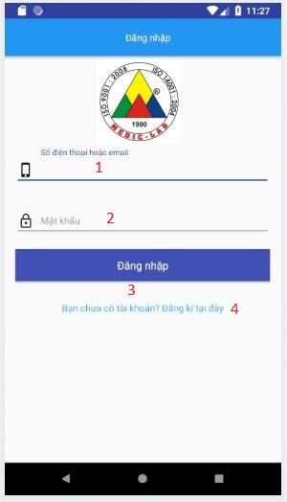

Figure 53 - Mobile Interface <Login>

**Field**

|  |  |  |  |  |  |  |  |
| --- | --- | --- | --- | --- | --- | --- | --- |
| **No** | **Field Name** | **Description** | **Read only** | **Mandatory** | **Control Type** | **Data Type** | **Length** |
| 1 | Phone | Phone to login | No | Yes | Textbox | String |  |
| 2 | Password | Password to login | No | Yes | Textbox | String |  |

**Buttons/Hyperlinks:**

|  |  |  |  |  |
| --- | --- | --- | --- | --- |
| **No** | **Function** | **Description** | **Validation** | **Outcome** |
| 3 | Sign In | Login into system | Validate all required fields | Navigate to Home page |
| 4 | Navigate to Register Page | N/A | N/A | Navigate to Register Page |

#### Register Account page

Figure 55 - Mobile Interface <Register account>

**Field**

|  |  |  |  |  |  |  |  |
| --- | --- | --- | --- | --- | --- | --- | --- |
| **No** | **Field Name** | **Description** | **Read only** | **Mandatory** | **Control Type** | **Data Type** | **Length** |
| 1 | Username | Username to register | No | Yes | Textbox | String |  |
| 2 | Phone | Phone to register | No | Yes | Textbox | String |  |
| 3 | Email | Email to register | No | Yes | Textbox | String |  |
| 4 | Full name | Fullname to register | No | Yes | Textbox | String |  |
| 5 | Date of Birth | D.O.B to register | No | Yes | Datepicker | Date |  |
| 6 | Password | Password to register | No | Yes | Textbox | String |  |
| 7 | Re-Password | Re-Password to confirm password | No | Yes | Textbox | String |  |

**Buttons/Hyperlinks:**

|  |  |  |  |  |
| --- | --- | --- | --- | --- |
| **No** | **Function** | **Description** | **Validation** | **Outcome** |
| 8 | Register | Register into system | Validate all required fields | Navigate to Phone verify page, then navigate to Login Page |
| 9 | Navigate to Login Page | N/A | N/A | Navigate to Login Page |

## **Database Design**

### Entity relationship diagram (ERD)

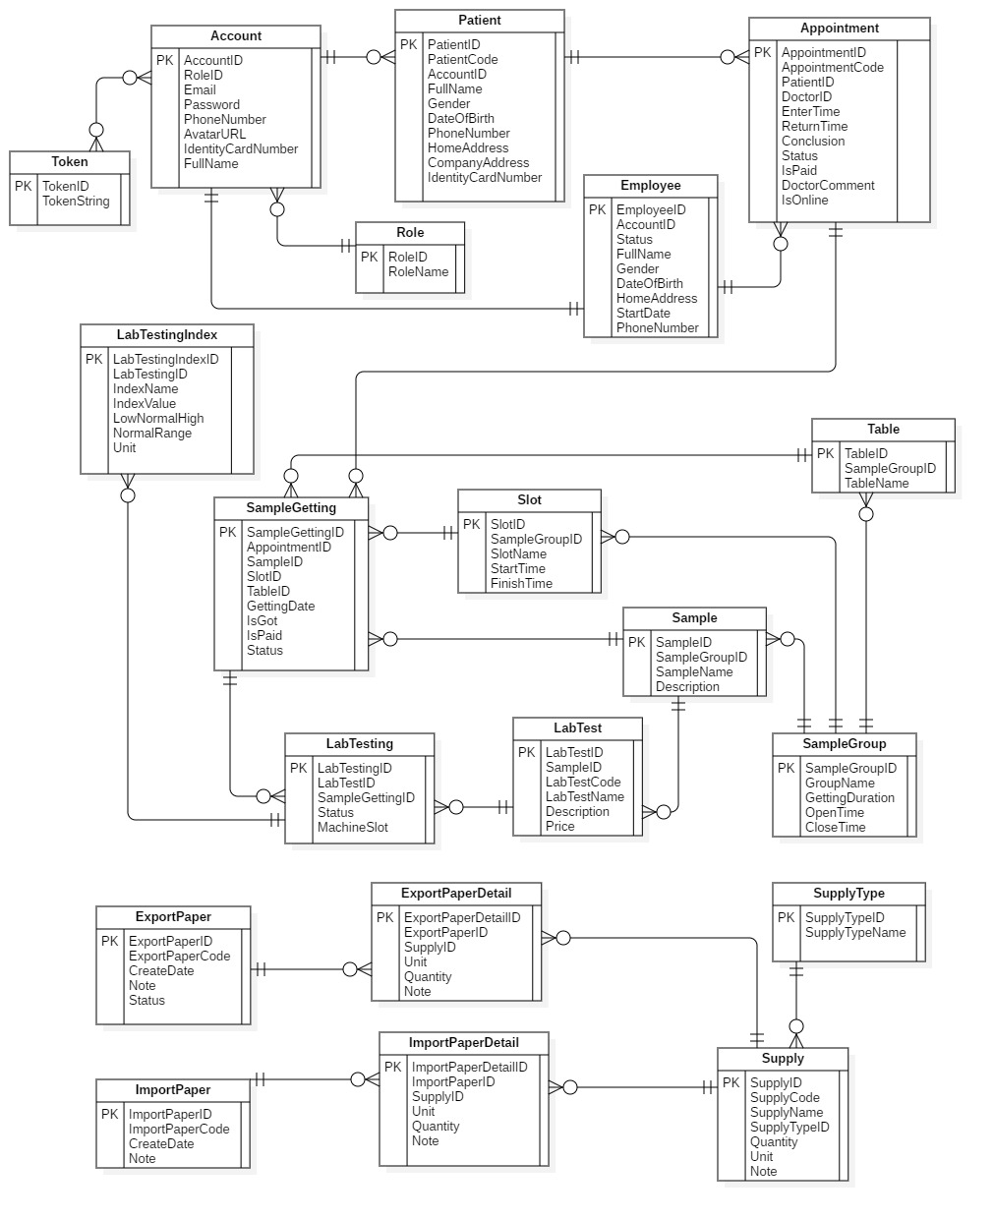

Figure 67 - Entity relationship diagram (ERD)

### Entity dictionary

|  |  |
| --- | --- |
| Entity Data Dictionary: describe content of all entities | |
| **Entity name** | **Description** |
| Account | Contain account information |
| Appointment | Contain Appointment information |
| Employee | Contain staff’s information |
| ExportPaper | Contain ExportPaper information |
| ExportPaperDetail | Contain ExportPaperDetail information |
| ImportPaper | Contain information about ImportPaper |
| ImportPaperDetail | Contain ImportPaperDetail information |
| LabTest | Contain LabTest information |
| LabTesting | Contain information about LabTesting |
| LabTestingIndex | Contain transaction information of LabTestingIndex |
| Patient | Contain Patient information |
| Role | Contain Role information |
| Sample | Contain Sample information |
| SampleGetting | Contain SampleGetting information |
| SampleGroup | Contain SampleGroup information |
| Slot | Contain Slot information |
| Supply | Contain Supply information |
| SupplyType | Contain SupplyType information |
| Table | Contain Table information |
| Token | Contain Token information |

Table 14 - Entity dictionary

## **Algorithms**

### Slot Suggestion

#### Definition

Generate the set of samples getting slots which has minimum total time.

#### Define problem

- When create a new appointment, user often have to spend a lot of effort to choose the suitable slots. Then, there is a need for an automatic solution using algorithms.

- There are N sample-gettings that the patient needs to perform. (blood getting, urine getting, are sample-gettings)

- Each room has a set of slots which have the same durations. Different sample getting rooms can have different slot durations.

- Assume that patients need to do all sample-gettings that they chosed in ONE day, so that the total time is minimum.

#### Solution

We use permutation recursive permutation and dynamic programming (DP) to solve this problem. We follow 2 steps:

* Step 1: Consider each permutation of N sample getting rooms in order, we use DP to calculate the optimized set of slots in the order of sample-gettings.
* Step 2: DP Formula:
* Assume that T[i][j].StartTime: the start time of the j-slot in the i-th slot set. (the i-th slot set belongs to the i-th sample getting).
* Assume that T[i][j].FinishTime: the finish time.
* Assume that dp[i][j] is the minimum waiting time (between slots of sample gettings) if the last sample-getting is the i-th one and the it’s chosed slot is the j-th slot. i is from 0 to N-1, j is from 0 to Length of i-th slot set – 1. Because the sample-gettings’ duration is fixed, the order, which has the minimum waiting time, has the minimum total time.
* dp[i][j] = min {dp[i-1][k] + (T[i-1][k].StartTime – T[i][j].FinishTime) | T[i-1][k].StartTime – T[i][j].FinishTime > 0}.
* Base: dp[0][j] = T[0][j] – comingTime. (comingTime: the time that the patient arrives at the hospital).
* The result of problem is min {dp[n-1][j]}.
* Step 3: Trace to get the optimized order of slots.

#### Complexity

The complexity of this algorithm is **O(N! * N3). In which, N is the number of selected Samples of a patient on a day.**

#### Flowchart

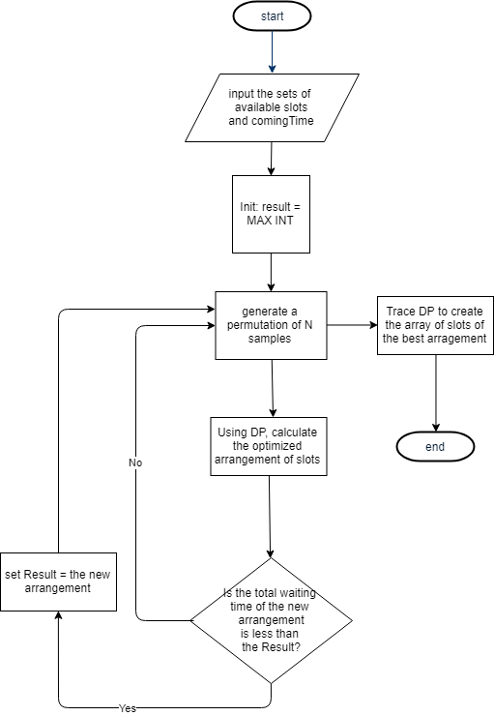

# **System Implementation & Test**

**Details Description**

**Overview**

This section describes the approach and methodologies used by group to plan, organize and manage the testing of eLTMS system. It provides in detail all necessary information about the implementation and testing procedure of the system included test plans, test cases, test result, test environments, pass/fail criteria and risks estimations as well as a checklist to cover all possible cases.

**Test approach**

* Goal: Test all features in the whole eLTMS system based on the core flow.
* Method: black-box testing
* Technique: check list

The testing for this project will consists of Integration System test level. Testing the program which was integrated and as a complete system to ensure that the software requirements have been met.

* Integration testing would be performed by all member of team and approved by team leader.

System testing is focused on assessing the system’s reliability. This process is concerned with finding errors that result from unanticipated interactions between components and component interface problems.

**Database Relationship Diagram**

**Physical diagram**



*Figure 1 – Physical Database Diagram*

**System Testing Test Case**

**User Web Application Test Case**

**<User> Register Account**

|  |  |  |  |  |  |
| --- | --- | --- | --- | --- | --- |
| ID | Test Case Description | Test case procedure | Expected output | Result | Test Date |
| RA01 | Register | 1. Enter “Nguyễn Hoàng Bách” into “Họ và tên” required field.  2. Choose “1/8/1995” into “Ngày sinh” required field.  3. Enter “0943689690” into “phone” required field.  4. Enter “1A Hoàng Diệu” into “Địa chỉ” required field.  5. Enter “123456” into “Mật khẩu” required field. | 1. System shows popup “Đăng kí thành công”. | Pass | 16/11/18 |

*Table 3 - Web Application Test Case <Register Account>*

**<User/Admin> Login**

|  |  |  |  |  |  |
| --- | --- | --- | --- | --- | --- |
| ID | Test Case Description | Test case procedure | Expected output | Result | Test Date |
| L01 | Test login | 1. Enter “0943689690” into “Số điện thoại” required field.  2. Enter “123456” into “Mật khẩu” required field.  3. Click on “Đăng nhập” button. | 1. System reloads page and, shows username “Hoàng Bách“ and “Đăng xuất” Button on top of the page. | Pass | 16/11/18 |
| L02 | Test login with a blank text box | 1. Input a blank in field “Số điện thoại”.  2. Click on “Đăng nhập” button. | 1. System shows error message “Vui lòng kiểm tra lại thông tin đăng nhập!”. | Pass | 16/11/18 |
| L03 | Test login with a blank text box | 1. Input a blank in field “Mật khẩu”.  2. Click on “Đăng nhập” button. | 1. System shows error message “Vui lòng nhập mật khẩu!”. | Pass | 16/11/18 |

*Table 4 - Web Application Test Case <Login>*

**<User> Book Appointment**

|  |  |  |  |  |  |
| --- | --- | --- | --- | --- | --- |
| ID | Test Case Description | Test case procedure | Expected output | Result | Test Date |
| BA01 | Book appointment without login | 1. Choose “ Đặt lịch hẹn“ in menu bar. | 1. System navigate to create appointment page. | Pass | 16/11/18 |
| BA02 | Book appointment with validated input in step 1 | 1. Enter “Nguyễn Hoàng Bách” into “Họ và tên” required field.  2. Choose “1/8/1995” into “Ngày sinh” required field.  3. Enter “0943689690” into “phone” required field.  4. Enter “1A Hoàng Diệu” into “Địa chỉ” required field. | 1. Go to step 2 | Pass | 16/11/18 |
| BA03 | Book appointment with a blank text box in step 1 | 1. Input a blank in one of the field “Họ và tên”,”Ngày sinh”, “Số điện thoại”, “Địa chỉ”.  2. Click on “Bước 2” button. | 1. System shows error message “Vui lòng điền đầy đủ thông tin” | Pass | 16/11/18 |
| BA04 | Book appointment with validated input in step 2 | 1. Check labtest in checkbox area  2. Click on “Bước 3” button | 1. Go to step 3 | Pass | 16/11/18 |
| BA05 | Book appointment with a blank text box in step 2 | 1. Not check any labtest in checkbox area  2. Click on “Bước 3” button | 1. System shows error message “Vui lòng chọn loại xét nghiệm”. | Pass | 16/11/18 |
| BA06 | Book appointment with validated input in step 3 | 1. Select a date and time in the future  2. Click on “Đặt lịch” button. | 1. System shows popup “Đặt lịch thành công”. | Pass | 16/11/18 |
| BA07 | Book appointment with a wrong input in step 3 | 1. Select a date and time in the past  2. Click on “Đặt lịch” button. | 1. System shows error message “Vui lòng chọn lại ngày”. | Pass | 16/11/18 |

*Table 5 - Web Application Test Case <Book Appointment>*

**<Patient> View Booked Appointment/Result**

|  |  |  |  |  |  |
| --- | --- | --- | --- | --- | --- |
| ID | Test Case Description | Test case procedure | Expected output | Result | Test Date |
| VA01 | View booked appointment (after login) | 1. Choose “Tra cứu cuộc hẹn“ in menu bar. | 1. System navigate to view appointments page. | Pass | 16/11/18 |
| VA02 | View booked appointment without login | 1. Choose “Tra cứu cuộc hẹn“ in menu bar | 1. System naviagte to login page and shows “Vui lòng đăng nhập để xem thông tin chi tiết” | Pass | 16/11/18 |

*Table 6 - Web Application Test Case <View Booked Appointment/Result>*

**Mobile Application Test Case**

**<Guest> Login**

|  |  |  |  |  |  |
| --- | --- | --- | --- | --- | --- |
| ID | Test Case Description | Test case procedure | Expected output | Result | Test Date |
| RA_1 | Test “Số điện thoại” guest input. | 1. User inputs a blank in field “Số điện thoại”.    2. User enters the “Số điện thoại” outside the allowed range from 10 to 12 number.    3. User enters “01692106611” into “Số điện thoại” required field. | 1. System shows error message “Vui lòng nhập đầy đủ thông tin!”.    2. System shows error message “Số điện thoại không hợp lệ!”.    3. System allows user to login. | Pass | 10/12/2018 |
| RA_2 | Test “Nhập mật khẩu” guest input. | 1. User inputs a blank in field “Nhập mật khẩu”.  2. User enters "Nhập mật khẩu " more than 200 characters.  3. User enters “12345678” into “Nhập mật khẩu” required field. | 1. System shows error message “Vui lòng nhập đầy đủ thông tin!”.  2. System shows error message “Mật khẩu không hợp lệ!”.  3. System allows user to login. | Pass | 10/12/2018 |
| RA_3 | Test “Đăng nhập” button | 1. User clicks “Đăng nhập” button. | 1. System show message if validation failed.  2. System navigate to mainpage if sucessfully. |  |  |

**<Guest> Register Account**

|  |  |  |  |  |  |
| --- | --- | --- | --- | --- | --- |
| ID | Test Case Description | Test case procedure | Expected output | Result | Test Date |
| RA_1 | Test “Họ và tên” guest input. | 1. User inputs a blank in required field “Họ và tên”. | 1. System shows error message “Vui lòng nhập đầy đủ thông tin”. | Pass | 10/12/2018 |
| RA_2 | Test “Số điện thoại” guest input. | 1. User inputs a blank in field “Số điện thoại”.  2. User enters “Số điện thoại” already exists.  3. User enters the “Số điện thoại” outside the allowed range from 10 to 12 number.    4. User enters “01692106611” into “Số điện thoại” required field. | 1. System shows error message “Vui lòng nhập đầy đủ thông tin!”.  2. System shows error message “Số điện thoại đã được sử dụng!”.  3. System shows error message “Số điện thoại không hợp lệ!”.    4. System shows “Đăng ký thành công”. | Pass | 10/12/2018 |
| RA_3 | Test “Email” guest input. | 1. User inputs a blank in field “Email”.  2. User inputs “Email” already exists.  3. User inputs “Email” wrong syntax.  4. User enters “[ducbm@gmail.com](mailto:ducbm@gmail.com)” into “Email” required field. | 1. System shows error message “Vui lòng nhập đầy đủ thông tin!”.  2. System shows error message “Email đã được sử dụng!”.  3. System shows error message “Email không hợp lệ!”.  4. System allows user to register. | Pass | 10/12/2018 |
| RA_4 | Test “Nhập mật khẩu” guest input. | 1. User inputs a blank in field “Nhập mật khẩu”.  2. User enters "Nhập mật khẩu " more than 200 characters.  3. User enters “12345678” into “Nhập mật khẩu” required field. | 1. System shows error message “Vui lòng nhập đầy đủ thông tin!”.  2. System shows error message “Mật khẩu không hợp lệ!”.  3. System allows user to register. | Pass | 10/12/2018 |
| RA_5 | Test “Chứng minh nhân dân” guest choose. | 1. User does not choose “Chứng minh nhân dân”.  2. User enters “251036695” to textbox “Chứng minh nhân dân”. | 1. System shows error message “Vui lòng nhập đầy đủ thông tin!”.  2. System allows user to register. | Pass | 10/12/2018 |

*Table 9 - Mobile Application Test Case <Register Account>*

**<Patient> Book Appointment**

|  |  |  |  |  |  |
| --- | --- | --- | --- | --- | --- |
| ID | Test Case Description | Test case procedure | Expected output | Result | Test Date |
| BA_1 | Test “Đặt lịch” screen. | 1. User “Đặt lịch” button on main screen.  2. User checks “Loại xét nghiệm” checkbox. | 1. System shows “Đặt lịch” screen and “Chọn loại xét nghiệm” section below the title.  2. Checkbox item is checked. | Pass | 10/12/2018 |
| BA_2 | Test “bước 2” button. | 1. User clicks “Bước 2” button on “Chọn loại xét nghiệm” screen.  2. Users selects “Ngày”.  3. Users selects time slot. | 1. System navigates to “Chọn ngày” screen.  2. System shows datepicker dialog.  3. System shows dropdownlist of time slots. | Pass | 10/12/2018 |
| BA_3 | Test “Bước 1” button. | 1. User clicks “Bước 1” button. | 1. System navigates to “Chọn loại xét nghiệm” screen. | Pass | 10/12/2018 |
| BA_4 | Test “Chọn ngày” screen. | 1. User not select “Ngày”.  2. User does not select time slots. | 1. System shows error message “Vui lòng nhập đầy đủ thông tin!”.  2. System shows error message “Vui lòng nhập đầy đủ thông tin!”. | Pass | 10/12/2018 |

*Table 10 - Mobile Application Test Case <Submit Auction>*

**<Patient> View Appointment**

|  |  |  |  |  |  |
| --- | --- | --- | --- | --- | --- |
| ID | Test Case Description | Test case procedure | Expected output | Result | Test Date |
| VA_1 | Test “Danh sách cuộc hẹn” screen. | 1. User clicks “Danh sách cuộc hẹn” button on main screen. | 1. System navigates to “Danh sách cuộc hẹn” page.  1.1 System show loading dialog.  1.2 System display “Cuộc hẹn” list on the screen.  1.3 When the list is empty, system shows “Không có dữ liệu” message. | Pass | 10/12/2018 |
| VA_2 | Test “Xóa” button. | 1. User clicks “Xóa” button on the appointment item. | 1. System call api to delete appointment and reloads page.  2. System displays “Có lỗi xảy ra” message when an error is occurred during deleting. | Pass | 10/12/2018 |
| VA_3 | Test “Sửa” button. | 1. User clicks “Sửa” button on the appointment item. | 1. System navigates to edit appointment screen with the selected appointment. | Pass | 10/12/2018 |
| VA_4 | Test “Xem chi tiết” button. | 1. User clicks “Xem chi tiết” button on the appointment item. | 1. System navigates to appointment detail page. | Pass | 10/12/2018 |
| VA_5 | Test “Xem kết quả khám” button. | 1. User clicks “Xem kết quả khám” button on the appointment item. | 1. System navigates to “Kết quả khám” page. | Pass | 10/12/2018 |

*Table 11 - Mobile Application Test Case <Place a Bid >*

**<Patient> View Appointment Detail**

|  |  |  |  |  |  |
| --- | --- | --- | --- | --- | --- |
| ID | Test Case Description | Test case procedure | Expected output | Result | Test Date |
| VAD_1 | Test “Xem chi tiết cuộc hẹn” screen. | 1. User clicks “Xem chi tiết cuộc hẹn” button on appointment item in the appointment history screen. | 1. System navigates to “Chi tiết cuộc hẹn” screen.  2. System display appointment detail on the screen. | Pass | 10/12/2018 |

*Table 12 - Mobile Application Test Case <View Selling History >*

**<Patient> Edit Appointment**

|  |  |  |  |  |  |
| --- | --- | --- | --- | --- | --- |
| ID | Test Case Description | Test case procedure | Expected output | Result | Test Date |
| EA_1 | Test “Sửa lịch” screen. | 1. User clicks “Sửa lịch” button on appointment item in the appointment history screen.  2. User checks “Loại xét nghiệm” checkbox. | 1. System shows “Sửa lịch” screen and auto check the “Loại xét nghiệm” checkbox.  2. Checkbox item is checked. | Pass | 10/12/2018 |
| EA_2 | Test “bước 2” button. | 1. User clicks “Bước 2” button on “Chọn loại xét nghiệm” screen.  2. Users selects “Ngày”.  3. Users selects time slot. | 1. System navigates to “Chọn ngày” screen.  2. System shows datepicker dialog.  3. System shows dropdownlist of time slots. | Pass | 10/12/2018 |
| EA_3 | Test “Bước 1” button. | 1. User clicks “Bước 1” button. | 1. System navigates to “Chọn loại xét nghiệm” screen. | Pass | 10/12/2018 |
| EA_4 | Test “Chọn ngày” screen. | 1. User not select “Ngày”.  2. User does not select time slots. | 1. System shows error message “Vui lòng nhập đầy đủ thông tin!”.  2. System shows error message “Vui lòng nhập đầy đủ thông tin!”. | Pass | 10/12/2018 |

**<Patient> View Appointment Result**

|  |  |  |  |  |  |
| --- | --- | --- | --- | --- | --- |
| ID | Test Case Description | Test case procedure | Expected output | Result | Test Date |
| VAR_1 | Test “Xem kết quả cuộc hẹn” screen. | 1. User clicks “Xem kết quả cuộc hẹn” button on appointment item in the appointment history screen. | 1. System navigates to “Kết quả cuộc hẹn” screen.  2. System display appointment result on the screen with:  - Name  - Birth year  - Gender  - Address  - Date register  - List result index. | Pass | 10/12/2018 |

**Admin Web Application Test Case**

**<Admin-Hospital Receptionist> Change status of appointment**

|  |  |  |  |  |  |
| --- | --- | --- | --- | --- | --- |
| ID | Test Case Description | Test case procedure | Expected output | Result | Test Date |
| CS01 | Hospital Receptionist change status (after login) | 1. Click on checkbox at “Thanh toán” column | 1. System shows “Thực hiện thanh toán” popup to confirm. | Pass | 19/11/2018 |
| CS02 | Hospital Receptionist change status (after login) | 1. Click on “Có” button to perform action | 1. System shows notification with content “Đã thanh toán” and “Thay đổi trạng thái thành công” | Pass | 19/11/2018 |

*Table 14 ­- Admin Web Application <Change status of appointment>*

**<Admin-Department Receptionist> Change status of appointment**

|  |  |  |  |  |  |
| --- | --- | --- | --- | --- | --- |
| ID | Test Case Description | Test case procedure | Expected output | Result | Test Date |
| CS03 | Department Receptionist change status (after login) | 1. Click on checkbox at “Thanh toán” column | 1. System shows “Thực hiện thanh toán” popup to confirm. | Pass | 19/11/2018 |
| CS04 | Department Receptionist change status (after login) | 1. Click on “Có” button to perform action | 1. System shows notification with content “Đã thanh toán” and “Thay đổi trạng thái thành công” | Pass | 19/11/2018 |

*Table 15 - Admin Web Application <Change status of appointment>*

**<Admin-Department Receptionist> Create a new appointment**

|  |  |  |  |  |  |
| --- | --- | --- | --- | --- | --- |
| ID | Test Case Description | Test case procedure | Expected output | Result | Test Date |
| CA01 | Department Receptionist create a new appointment (after login) | 1. Click on “Thêm mới” button | 1. System shows popup with appointment’s information | Pass | 19/11/2018 |
| CA02 | Department Receptionist create appointment with validated input (after login) | 1. Enter “Nguyễn Hoàng Bách” into “Họ và tên” required field.  2. Choose “1/8/1995” into “Ngày sinh” required field.  3. Enter “0943689690” into “phone” required field.  4. Enter “1A Hoàng Diệu” into “Địa chỉ” required field.  5. Check labtest in checkbox area  6. Click on “Lưu” button | 1. System shows notification with content “Tạo mới cuộc hẹn thành công” | Pass | 19/11/2018 |
| CA03 | Department Receptionist create appointment with a blank text box (after login) | 1. Input a blank in one of the field “Họ và tên”,”Ngày sinh”, “Số điện thoại”, “Địa chỉ”.  2. Click on “Lưu” button  . | 1. System shows error message “Vui lòng điền đầy đủ thông tin” | Pass | 19/11/2018 |

*Table 15 - Admin Web Application <Create a new appointment>*

**<Admin-Nurse> Change status of appointment after getting specimen**

|  |  |  |  |  |  |
| --- | --- | --- | --- | --- | --- |
| ID | Test Case Description | Test case procedure | Expected output | Result | Test Date |
| CS05 | Nurse changes status (after login) | 1. Click on checkbox at “Đã lấy mẫu” column | 1. System shows “Bạn có muốn thay đổi” popup to confirm | Pass | 19/11/2018 |
| CS06 | Nurse changes status (after login) | 1. Click on “Có” button to perform action | 1. System shows notification with content “Thay đổi trạng thái thành công” | Pass | 19/11/2018 |

*Table 15 - Admin Web Application <Change status of appointment>*

**<Admin-Lab Technician> Add new labtest**

|  |  |  |  |  |  |
| --- | --- | --- | --- | --- | --- |
| ID | Test Case Description | Test case procedure | Expected output | Result | Test Date |
| AL01 | Lab Technician add a new labtest (after login) | 1. Click on “Thêm mới dịch vụ xét nghiệm” button | 1. System shows popup with labtest’s information form | Pass | 19/11/2018 |
| AL02 | Lab Technician add a new labtest with validated input (after login) | 1. Enter “CTM” into “Mã xét nghiệm” required field.  2. Enter “CT Máu” into “Tên xét nghiệm” required field.  3. Select “Máu” in “Loại” dropdown list required field.  3. Enter “45000” into “Giá” required field.  4. Enter something into “Mô tả” required field.  5. Click on “Lưu” button | 1. System shows notification with content “Thêm mới dịch vụ thành công” | Pass | 19/11/2018 |
| AL03 | Lab Technician add a new labtest with a blank text box (after login) | 1. Input a blank in one of the field “Mã xét nghiệm”, “Tên xét nghiệm”, “Giá” and not select “Loại”  2. Click on “Lưu” button  . | 1. System shows error message “Vui lòng điền đầy đủ thông tin” | Pass | 19/11/2018 |

*Table 15 - Admin Web Application <Add new labtest>*

**<Admin-Lab Technician> Add new sample group**

|  |  |  |  |  |  |
| --- | --- | --- | --- | --- | --- |
| ID | Test Case Description | Test case procedure | Expected output | Result | Test Date |
| ASG01 | Lab Technician add a new sample group (after login) | 1. Click on “Nhóm xét nghiệm” button | 1. System shows popup with list of sample group | Pass | 19/11/2018 |
| ASG02 | Lab Technician add a new sample group (after login) | 1. Click on “Thêm mới nhóm xét nghiệm” button | 1. System shows popup with sample group’s information form |  |  |
| ASG03 | Lab Technician add a new sample group with validated input (after login) | 1. Enter “Tế bào” into “Tên nhóm xét nghiệm” required field  2. Enter “1200” into “Thời gian tiến hành” required field  3. Enter “25200” into “Bắt đầu” required field  4. Enter “63000” into “Kết thúc” required field  5. Click on “Lưu” button | 1. System shows notification with content “Thêm nhóm xét nghiệm thành công” | Pass | 19/11/2018 |
| ASG04 | Lab Technician add a new sample group with a blank text box (after login) | 1. Input a blank in one of the field “Tên nhóm xét nghiệm”, “Thời gian tiến hành”, “Bắt đầu”, “Kết thúc”  2. Click on “Lưu” button  . | 1. System shows error message “Vui lòng điền đầy đủ thông tin” | Pass | 19/11/2018 |

*Table 15 - Admin Web Application <Add new sample group>*

**<Admin-Lab Technician> Add new sample**

|  |  |  |  |  |  |
| --- | --- | --- | --- | --- | --- |
| ID | Test Case Description | Test case procedure | Expected output | Result | Test Date |
| AG01 | Lab Technician add a new sample (after login) | 1. Click on “Loại xét nghiệm” button | 1. System shows popup with list of sample | Pass | 19/11/2018 |
| AG02 | Lab Technician add a new sample (after login) | 1. Click on “Thêm mới loại xét nghiệm” button | 1. System shows popup with sample group’s information form |  |  |
| AG03 | Lab Technician add a new sample with validated input (after login) | 1. Enter “Tế bào” into “Tên loại xét nghiệm” required field  2. Select “Tế Bào” in “Nhóm xét nghiệm” dropdown list required field.  3. Enter something into “Mô tả” required field.  4. Click on “Lưu” button | 1. System shows notification with content “Thêm loại xét nghiệm thành công” | Pass | 19/11/2018 |
| AG04 | Lab Technician add a new sample with a blank text box (after login) | 1. Input a blank in one of the field “Tên loại xét nghiệm” and not select “Nhóm xét nghiệm”  2. User clicks on “Lưu” button | 1. System shows error message “Vui lòng điền đầy đủ thông tin” | Pass | 19/11/2018 |

*Table 15 - Admin Web Application <Add new sample>*

# **Software User’s Manual**

## Installation Guide

### Setting up environment:

#### Hardware requirement

* For server

|  |  |  |
| --- | --- | --- |
| Hardware | Minimum Requirements | Recommended |
| Internet Connection | Cable, Wi-Fi (6 Mbps) | Cable, Wi-Fi (16 Mbps) |
| Operating System | Window Server 2012 | Window Server 2012 |
| Computer Processor | Intel® Core i3-8100 (3.6Ghz/6MB Smart Cache) | Intel® Core  i7-8850H (2.6Ghz/9MB Smart Cache) |
| Computer Memory | 8GB RAM | 16GB RAM |

Table 1 - Hardware requirement for Server

* For web development:

|  |  |  |
| --- | --- | --- |
| * **Hardware** | Minimum Requirements | Recommended |
| Internet Connection | Cable, Wi-Fi (4 Mbps) | Cable, Wi-Fi (8 Mbps) |
| Operating System | Windows 7 or above | Windows 7 or above |
| Computer Processor | Intel® Core  i3-6300 (3.8Ghz/4MB Smart Cache) | Intel® Core i5-6500 (3.6Ghz/6MB Smart Cache) |
| Computer Memory | 4GB RAM | 8GB RAM |

Table 2 - Hardware requirement for web development

* For mobile development:

|  |  |  |
| --- | --- | --- |
| * **Hardware** | Minimum Requirements | Recommended |
| Internet Connection | Wi-Fi (2 Mbps),3G-4G | Wi-Fi (4 Mbps), 3G-4G |
| Operating System | Android 4.4.2 | Android 6.0 |
| Memory | 4GB RAM | 8GB RAM |

Table 3 - Hardware requirement for mobile development

#### Software requirement

|  |  |
| --- | --- |
| Software | Name / Version |
| Operating system | Windows 7 or above |
| Environment | C#.NET, Spring framework, JQuery, Bootstrap |
| Modeling tool | Offline: StarUML  Online: draw.io |
| IDE | Visual Studio 2017, Android studio |
| DBMS | SQL Server 2014 |
| Source control | SourceTree, Git |
| Web browser | Chrome 42 or above |

Table 4 - Software requirement

### Deployment at Server side:

#### Prepare deployment package

* Install JDK 8.0
* Install IntelliJ IDEA, Spring plugin
* Install Visual Studio 2017
* Install Android Studio
* Install SQL Server and restore database “eLTMS”

#### Configure Server before deploy

Open file application.properties in folder eBOS-backend\src\main\resources\  
+ Edit your database’s url at property “spring.datasource.url”.  
+ Edit your username to MySQL “spring.datasource.username”.  
+ Edit your password to MySQL “spring.datasource.password”.

#### Deploy Server

Open terminal in the root of project directory and type *mvn spring-boot:run* or Open project in Intellj IDEA and click  button.

### Deployment at Client side

#### Prepare deployment package

* For mobile: Install JDK 8.0, Android SDK, Gradle, Node.js.
* For web: Install Surge.
* Install Visual Studio 2017.

#### Deploy Mobile Application

* Build apk
  + Open terminal in the root of project directory.
  + Type: *react-native bundle --dev false --platform android --entry-file index.android.js --bundle-output ./android/app/build/intermediates/assets/debug/index.android.bundle --assets-dest ./android/app/build/intermediates/res/merged/debug.*
  + Type: *cd android/ &&* *./gradlew assembleDebug.*
  + Then apk will be generated, type following command to get where apk is: *cd app/build/outputs/apk/*
* Install apk on device
  + Open terminal in the root of project directory.
  + Check that device is the only connected device with: *adb devices.*
  + Install the apk with: *cd android && ./gradlew installDebug.*
* Now, mobile application is installed on the device.

#### Deploy Web Application

* Setup deployment configuration.
  + Open terminal in the root of project directory.
  + Type: *surge.*
  + Type email.
  + Type password*.*
  + Hit Enter when confirming project path.
  + Type domain.
  + Hit Enter when everything is OK, Surge will deploy the web application to the domain.
* Use the web.
  + Open web browser and type the domain on url bar, then hit Enter.

## User Guide

### Admin web application

#### Login



Figure 1 - Admin web application Guide <Login>

|  |  |
| --- | --- |
| **Step** | **Description** |
| 1 | Enter phone number |
| 2 | Enter password |
| 3 | Check “Ghi nhớ tài khoản”checkbox (optional) |
| 4 | Click on “Đăng nhập” button to sign in |

Table 5 - Admin web application Guide <Login>

#### View Hospital Receptionist Page



Figure 2 - Admin web application Guide <View Hospital Receptionist>



Figure 3 - Admin web application Guide <View Hospital Receptionist>

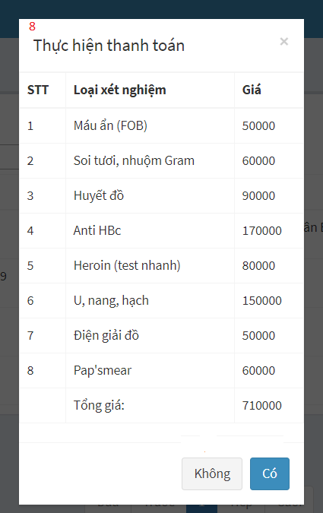

Figure 4 - Admin web application Guide <View Hospital Receptionist>

|  |  |
| --- | --- |
| **Step** | **Description** |
| 1 | Type keyword at textbox area to find patient by keyword |
| 2 | Click on “Search” button to perform action |
| 3 | Click on date area and choose date which you want to show list of patient |
| 4 | Click on blue button at “Xem chi tiết” column to view patient’s details of appointment |
| 5 | Click on switch checkbox at “Thanh toán” column to change status of appointment when patient pay the bill |
| 6 | After clicking on blue button in step 5, the popup will show patient’s details of appointment. You can click red button to delete a appointment |
| 7 | Click “close” button to close popup |
| 8 | After clicking on switch checkbox at “Thanh toán” column, the popup will show the bill. You can click “Có” button to pay the bill or “Không” button to cancel |

Table 6 - Admin web application Guide <View Hospital Receptionist>

#### View Department Receptionist Page

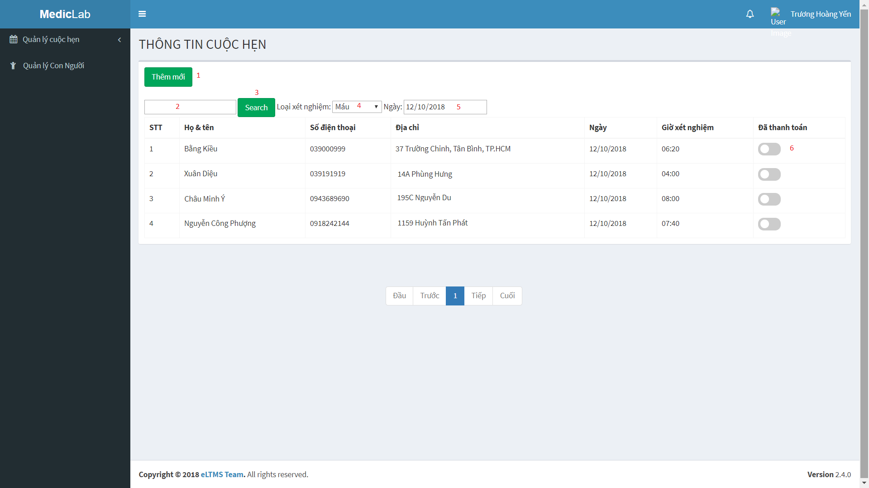

Figure 5 - Admin web application Guide <View Department Receptionist>

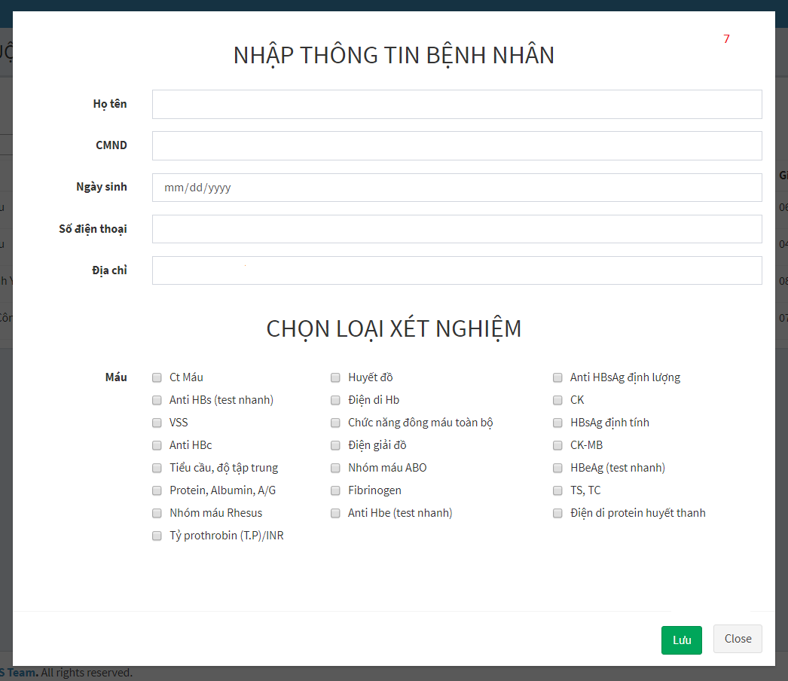

Figure 6 - Admin web application Guide <View Department Receptionist>



Figure 7 - Admin web application Guide <View Department Receptionist>

|  |  |
| --- | --- |
| **Step** | **Description** |
| 1 | Click on “Thêm mới” button to book a new appointment for patient who has no booking before |
| 2 | Type keyword at textbox area to find appointment by keyword |
| 3 | Click on “Search” button to perform action |
| 4 | Click and choose sample name which is used to filter appointment |
| 5 | Click on date area and choose date which you want to show list of appointment |
| 6 | Click on switch checkbox at “Thanh toán” column to change status of appointment when patient pay the bill |
| 7 | After click on “Thêm mới” button in step 1. You have to fill all of patient’s information and choose labtest. Then, click on “Lưu” button to create a new appointment or “Close” to cancel. |
| 8 | After clicking on switch checkbox at “Thanh toán” column, the popup will show the bill. You can click “Có” button to pay the bill or “Không” button to cancel |

Table 7 - Admin web application Guide <View user management>

#### View Nurse Page



Figure 8 - Admin web application Guide <View Nurse>

x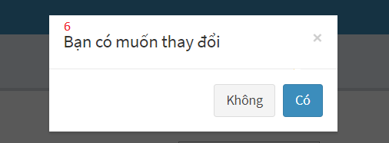

Figure 9 - Admin web application Guide <View Nurse>

|  |  |
| --- | --- |
| **Step** | **Description** |
| 1 | Type keyword at textbox area to find appointment by keyword |
| 2 | Click on “Search” button to perform action |
| 3 | Click and choose sample group which is used to filter appointment |
| 4 | Click on date area and choose date which you want to show list of appointment |
| 5 | Click on switch checkbox at “Đã lấy mẫu” column to change status of appointment when nurse got specimen |
| 6 | After clicking on switch checkbox at “Đã lấy mẫu” column, the popup to confirm action. You can click “Có” button to change status of appointment or “Không” button to cancel |

Table 8 - Admin web application Guide <View Nurse>

#### View Laboratory Technician Page



Figure 10 - Admin web application Guide <View Laboratory Technician>

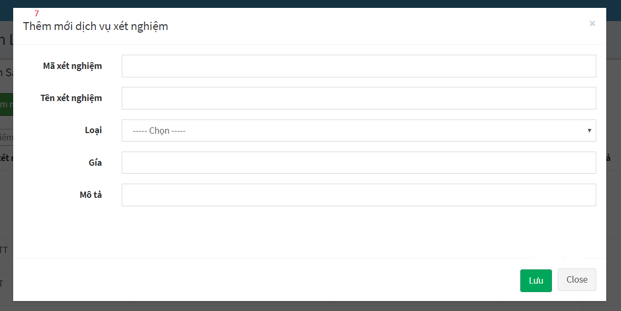

Figure 11 - Admin web application Guide <Laboratory Technician>

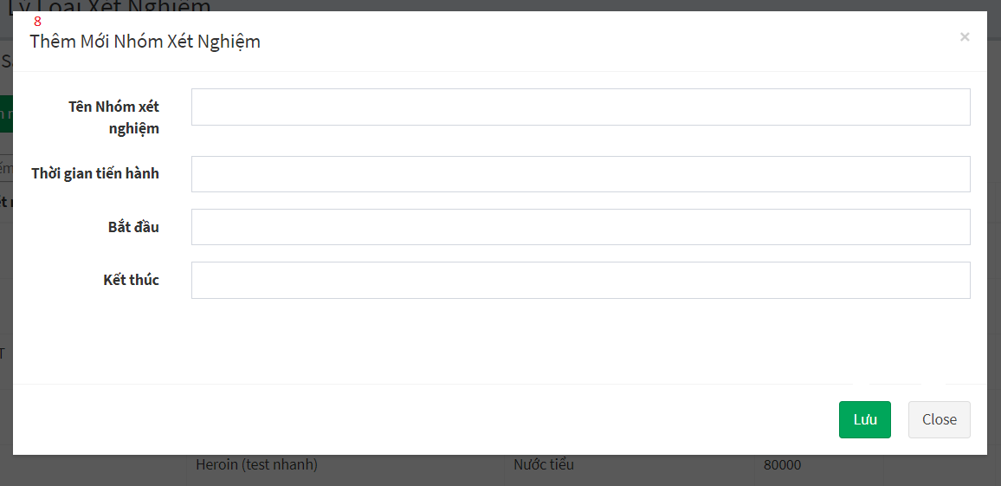

Figure 12 - Admin web application Guide <View Laboratory Technician>

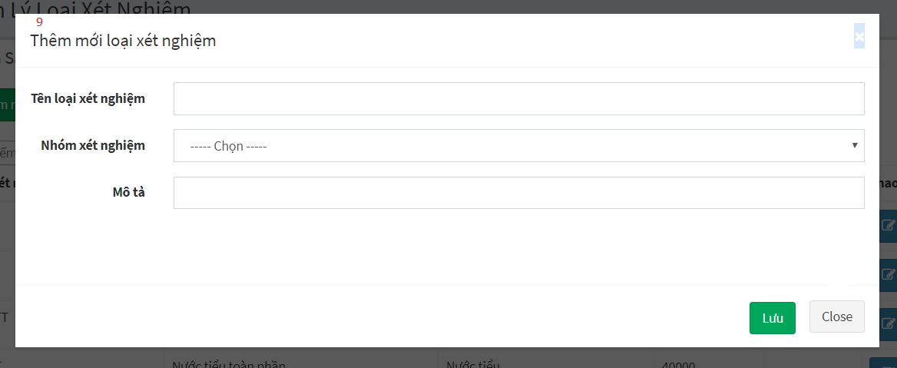

Figure 13 - Admin web application Guide <View Laboratory Technician>

|  |  |
| --- | --- |
| **Step** | **Description** |
| 1 | Click on “Thêm mới dịch vụ xét nghiệm” button to add new labtest |
| 2 | Click on “Nhóm xét nghiệm” button to add new sample group |
| 3 | Click on “Loại xét nghiệm” button to add new sample |
| 4 | Type keyword at textbox area to find labtest by keyword |
| 5 | Click on blue button at “Thao tác” column to edit labtest’s information |
| 6 | Click on red button at “Thao tác” column to delete a labtest |
| 7 | After clicking on “Thêm mới dịch vụ xét nghiệm” button in step 1, you have to fill all of labtest’s information. Then, click on “Lưu” button to add a new labtest or “Close” button to cancel |
| 8 | After clicking on “Nhóm xét nghiệm” button in step 2, you have to fill all of sample group’s information. Then, click on “Lưu” button to add a new sample group or “Close” button to cancel |
| 9 | After clicking on “Loại xét nghiệm” button in step 3, you have to fill all of sample’s information. Then, click on “Lưu” button to add a new sample or “Close” button to cancel |

Table 9 - Admin web application Guide <Laboratory Technician>

#### View Doctor Page



Figure 14 - Admin web application Guide <View Doctor>



Figure 15 - Admin web application Guide <View Doctor>



Figure 16 - Admin web application Guide <View Doctor>

|  |  |
| --- | --- |
| **Step** | **Description** |
| 1 | Click on green button at “Thao tác” column to view testing result, write note and conclusion |
| 2 | Click on green button at “Thao tác” column to view details of testing result |
| 3 | Type text conclusion at textbox area |
| 4 | Write note (Advise for patient) at textbox area |
| 5 | Click on “Close” button cancel |
| 6 | After clicking on green button at “Thao tác” column to view details of testing result in step 2, you can request re-testing when you see something wrong about testing result |

Table 10 - Admin web application Guide <View Doctor>

### User web application

#### Login



Figure 17 – User web application Guide <Login>

|  |  |
| --- | --- |
| **Step** | **Description** |
| 1 | Enter phone number |
| 2 | Enter password |
| 3 | Check “Ghi nhớ tài khoản”checkbox (optional) |
| 4 | Click on “Đăng nhập” button to sign in |

Table 11 – User web application Guide <Login>

#### Sign up

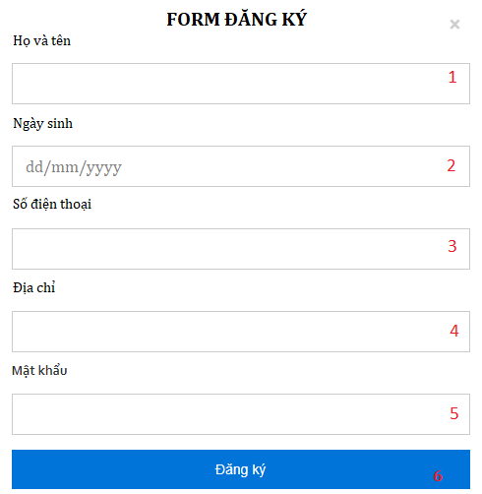

Figure 18 – User web application Guide <Sign up>

|  |  |
| --- | --- |
| **Step** | **Description** |
| 1 | Fill username into field: “Họ và tên”. |
| 2 | Pick birthdate from field: “Ngày sinh”. |
| 3 | Fill phone in field: “Số điện thoại”. |
| 4 | Fill full address in field: “Địa chỉ”. |
| 5 | Fill password in field: “Mật khẩu”. |
| 6 | Click on “Đăng ký” button to sign up. |

Table 12 – User web application Guide <Sign up>

#### Logout

Figure 19 - User web application Guide <Log out>

|  |  |
| --- | --- |
| **Step** | **Description** |
| 1 | Click on username on top right of the page. |
| 2 | Click on button “Đăng xuất ” to log out. |

Table 13 - User web application Guide <Log out>

#### Home page



Figure 20 - User web application Guide <Home page>



Figure 21 - User web application Guide <Home page - Menu bar and Categories>

|  |  |
| --- | --- |
| **Step** | **Description** |
| 1 | Click to navigate to “Trang chủ” to load Home page |
| 2 | Click to navigate to “Về chúng tôi” to view our information |
| 3 | Click to navigate to “Thư viện ảnh” to go to Photo Library Page |
| 4 | Click to navigate to “Đặt lịch hẹn” to book appointment |
| 5 | Click to navigate to “Liên hệ“ to view our contact |

Table 14 - User web application Guide <Home page>

#### View Book Appointment



Figure 22 - User web application Guide <Book appointment>



Figure 23 - User web application Guide <Book appointment>



Figure 24 - User web application Guide <Book appointment>

|  |  |
| --- | --- |
| **Step** | **Description** |
| 1 | Fill username into field: “Họ tên”. |
| 2 | Pick birthdate from field: “Ngày sinh”. |
| 3 | Fill phone in field: “Điện thoại liên hệ”. |
| 4 | Fill full address in field: “Địa chỉ”. |
| 5 | Click on “Bước 2” button to go to step 2 |
| 6 | Choose labtest which you want to test |
| 7 | Click on “Bước 1” button to go back to step 1 |
| 8 | Click on “Bước 3” button to go to step 3 |
| 9 | Choose appropriate time that you want to test |
| 10 | Choose appropriate time that you want to test |
| 11 | Click on “Bước 2” button to go back to step 2 |
| 12 | Click on “Đặt lịch” button book appointment |

Table 15 - User web application Guide < Submit Auction >

#### View list of Booked Appoinments

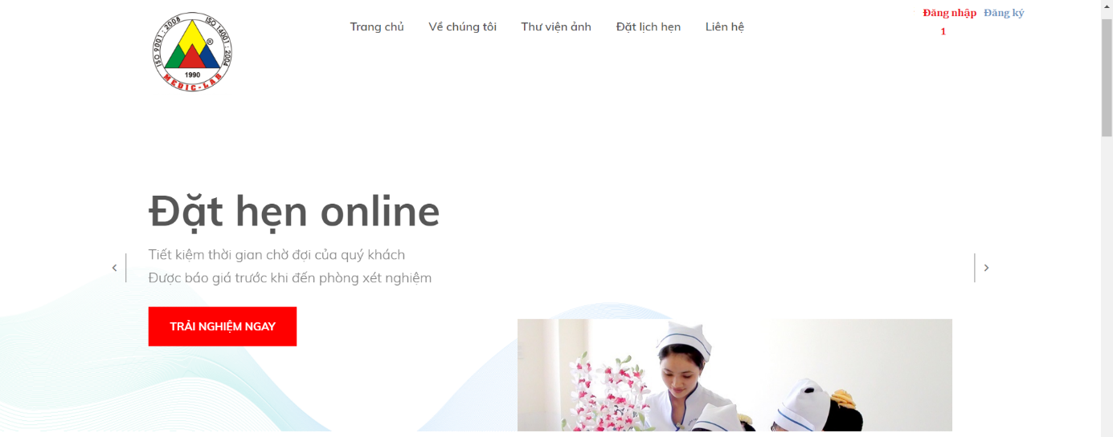

Figure 25 - User web application Guide <View list of Booked Appoinments>

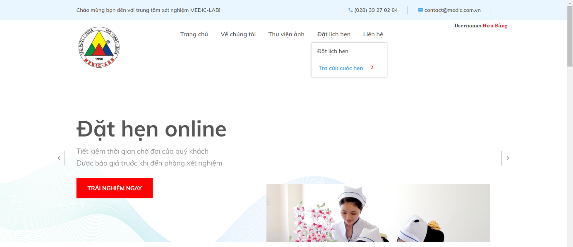

Figure 26 - User web application Guide <View list of Booked Appoinments>

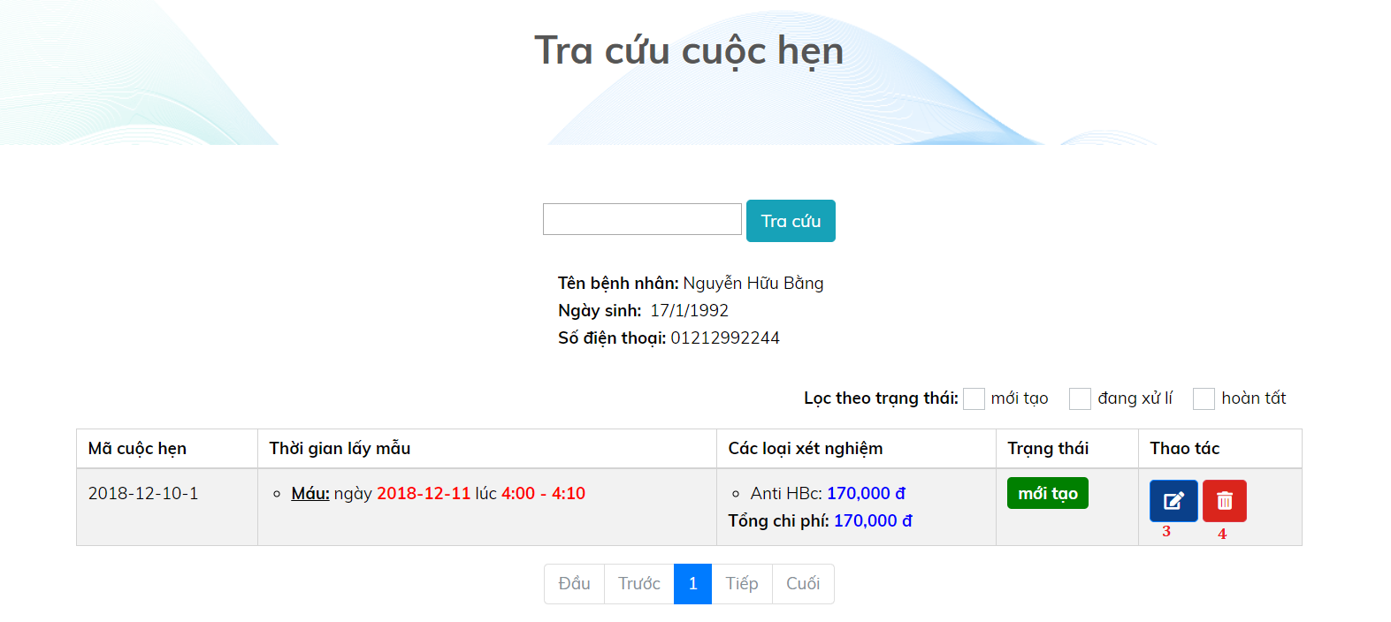

Figure 27 - User web application Guide <View list of Booked Appoinments>

|  |  |
| --- | --- |
| **Step** | **Description** |
| 1 | At the Home page, click “Đăng nhập” button to login into the system |
| 2 | After login, you can “Tra cứu cuộc hẹn” option in “Đặt lịch hẹn” at the Home page |
| 3 | At View Appointment page. You can click on blue button at “Thao tác” column to edit time, sample, labtest for your appointment |
| 4 | After clicking on “Tra cứu” button, you will go to View Appointment page. You can click on red button at “Thao tác” column to delete your appointment |

Table 16 - User web application Guide <View list of Booked Appoinments>

#### View Testing Result



Figure 28 - User web application Guide <View Testing Result>



Figure 29 - User web application Guide <View Testing Result>

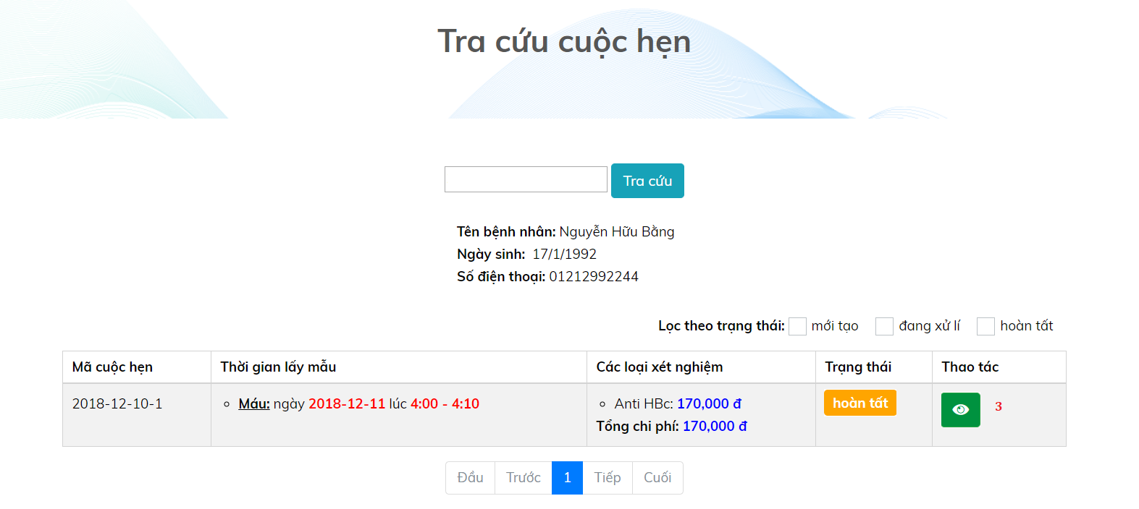

Figure 30 - User web application Guide <View Testing Result>



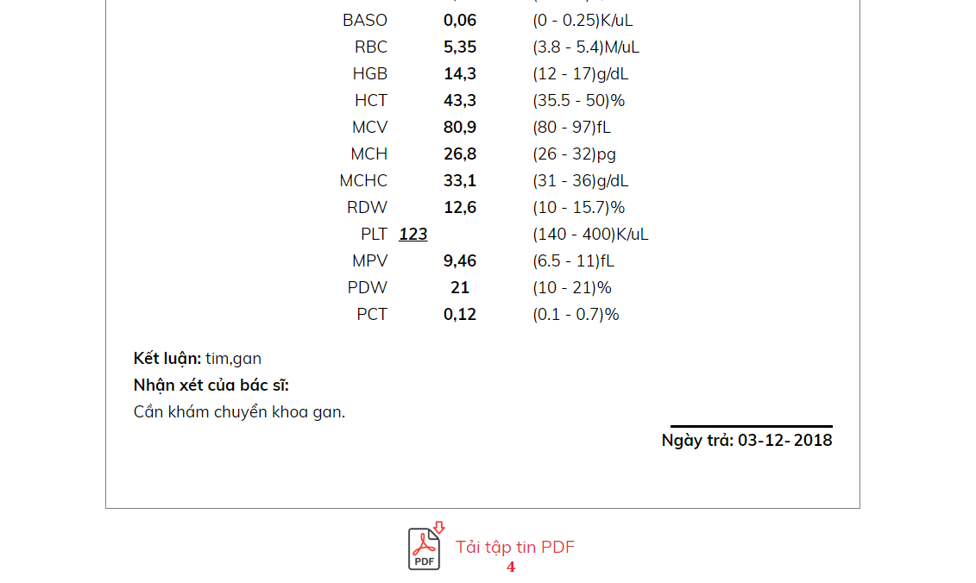

Figure 31 - User web application Guide <View Testing Result>

|  |  |
| --- | --- |
| **Step** | **Description** |
| 1 | At the Home page, click “Đăng nhập” button to login into the system |
| 2 | After login, you can “Tra cứu cuộc hẹn” option in “Đặt lịch hẹn” at the Home page |
| 3 | At View Appointment page. When status of appointment is “Hoàn tất”, you can click on green button at “Thao tác” column to view testing result |
| 4 | At the Result Appointment page, you can view details of testing result. If you want to download this form, you can click on “Tải tập tin PDF” button below the form |

Table 17 - User web application Guide <View Testing Result>

### Mobile application for all user

#### View Login Page



Figure 32 - User mobile application Guide <Login>

|  |  |
| --- | --- |
| **Step** | **Description** |
| 1 | Enter your phone |
| 2 | Enter your password |
| 3 | Click on “Đăng nhập” to login |
| 4 | Click on “Đăng kí tại đây’ to go to Register page |

Table 18 – User mobile application Guide <Login>

#### View Register Page



Figure 33 - User mobile application Guide <View Register>

|  |  |
| --- | --- |
| **Step** | **Description** |
| 1 | Enter your fullname |
| 2 | Pick your birthday |
| 3 | Enter your phone number |
| 4 | Enter your address |
| 5 | Enter your password |
| 6 | Click on “Đăng kí” to create new account |

Figure 19 - User mobile application Guide <View Register>

#### View Home Page

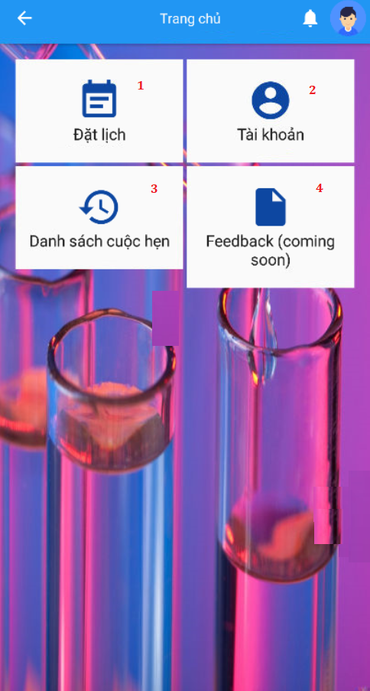

Figure 34 - User mobile application Guide <Home page>

|  |  |
| --- | --- |
| **Step** | **Description** |
| 1 | Click on “Đặt lịch” tab to book appointment |
| 2 | Click on “Tài khoản” tab to view or edit profile |
| 3 | Click on “Danh sách cuộc hẹn“ tab to view appointment history and testing result |
| 4 | Click on “Feedback” tab to write feedback (Coming soon) |

Table 20 – User mobile application Guide <Home page>

#### View Book Appointment Page

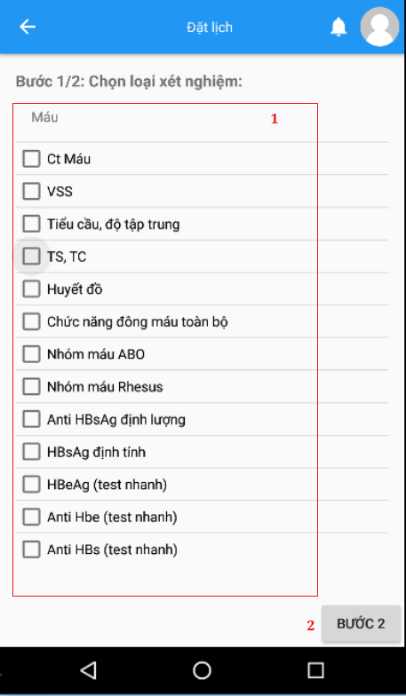

Figure 35 - User mobile application Guide <View Book Appointment>

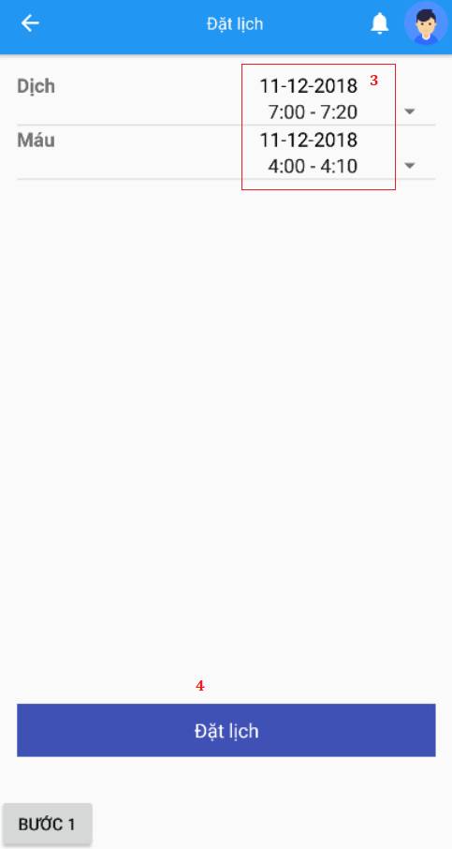

Figure 36 - User mobile application Guide <View Book Appointment>

|  |  |
| --- | --- |
| **Step** | **Description** |
| 1 | After clicking “Đặt lịch” tab at Home page, choose labtest which you want to test |
| 2 | Click on “Bước 2” button to go to step 2 |
| 3 | Choose appropriate time that you want to test |
| 4 | Click on “Đặt lịch” button book appointment |

Table 21 – User mobile application Guide <View Book Appointment>

#### View Testing Result Page

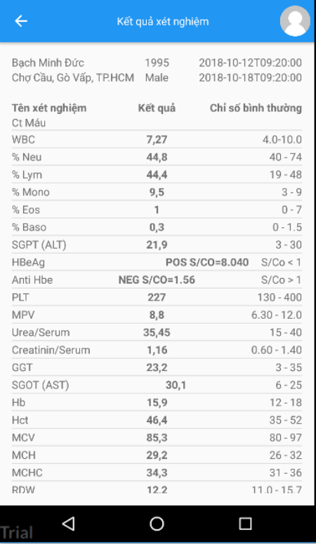

Figure 37 - User mobile application Guide <View Testing Result>

|  |  |
| --- | --- |
| **Step** | **Description** |
| 1 | After clicking “Kết quả xét nghiệm” tab at Home page, choose an appointment you want to view testing result |

Table 22 – User mobile application Guide <View Testing Result>